Rhynchostylis retusa AM/AOS 82 Points
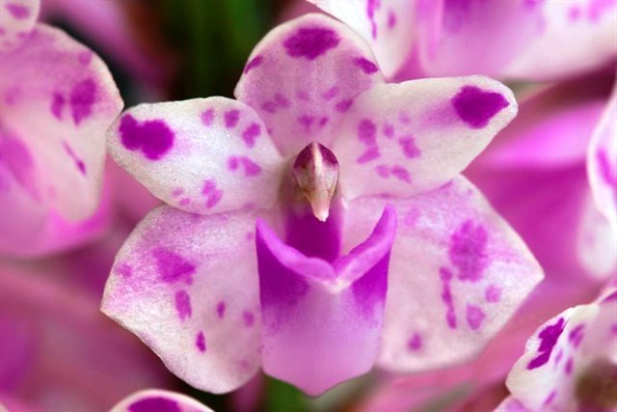
One hundred ninety seven flowers arranged spirally on one pendant inflorescence; flowers white, spotted light lavender; dorsal sepal and petals with a single medium lavender apical spot; lip white, heavily overlaid medium lavender; column lavender, anther cap brown; substance medium firm; texture crystalline.

Renantanda Sunrise CCM/AOS 83 Points
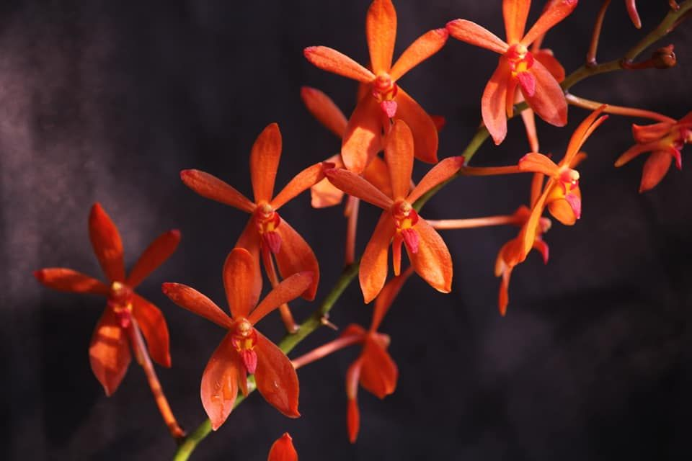
One hundred seventy-one flowers and eight buds on 9 branched inflorescences on a 45-cm by 70-cm robust plant grown on a slatted box on bark mix; sepals and petals orange; lip red-orange, white medially; anther cap yellow; substance medium firm; texture matte.

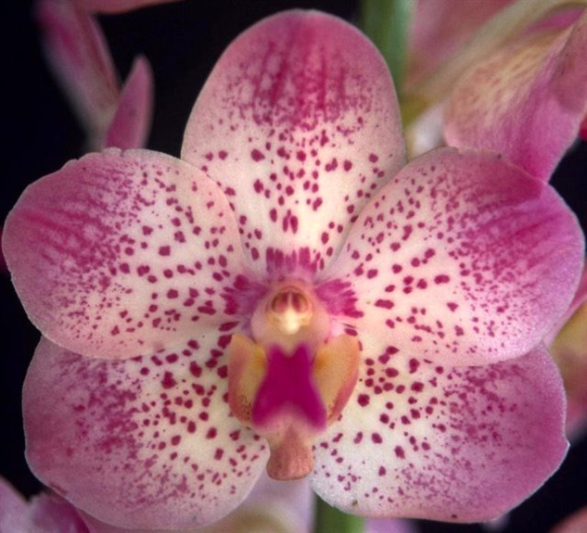
Aeridovanda Renee Gerber HCC/AOS 78 Points
Seventeen flowers and fourteen buds well arranged on one inflorescence; flowers cream, basal half of sepals and petals finely spotted magenta, distal half solid magenta with darker reticualte pattern; lip dark magenta, side lobes golden yellow; substance firm; texture matte.

Papilionanthe vandarum HCC/AOS 76 Points
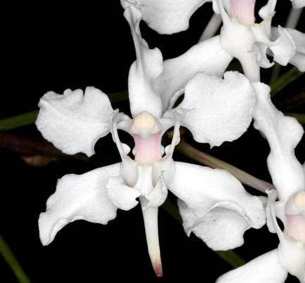
Four relatively flat flowers on one inflorescence; sepals and petals white, margins undulate; lip white, blushed pink basally, spur white, dark rose apically; column white, blushed pink, anther cap pale yellow; substance firm; texture crystalline.

Perrieraara Bangkok Sunset AM/AOS 83 Points
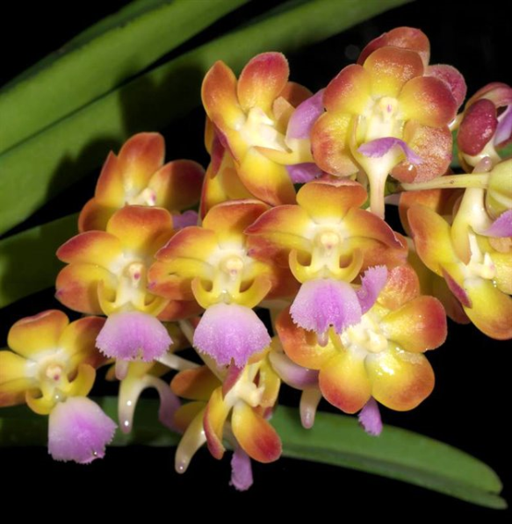
Thirty-two flowers and six buds well arranged on one inflorescence; sepals and petals golden yellow, suffused brick red distally; lip white, suffused pink, darker medially, distal margin finely serrate; column white; substance firm; texture diamond dust.

