Grove’s Ascocenda Qualities
By far, color and texture are the key qualities that Ascocenda brings to Vanda hybridization
Color: Orange, yellow and red are the colors Ascocentrum brings to the table. These colors are most often rich, intense and saturated. Grove implies intense colors are a must for awarding these hybrids.
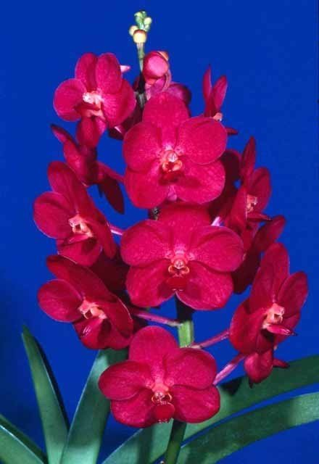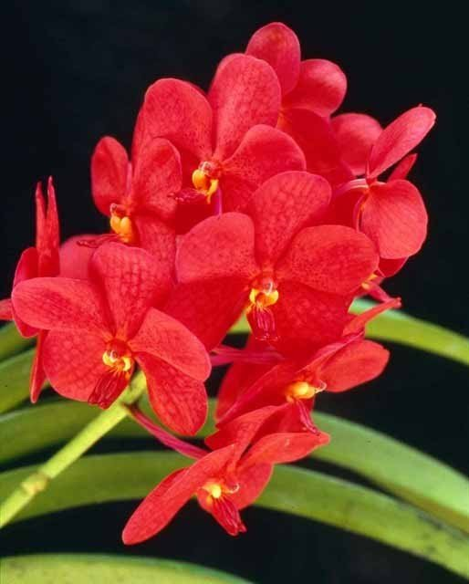
Vanda (Ascocenda) John de Biase ‘Lava Flow’ Vanda (Ascocenda) Araya “Octavio’
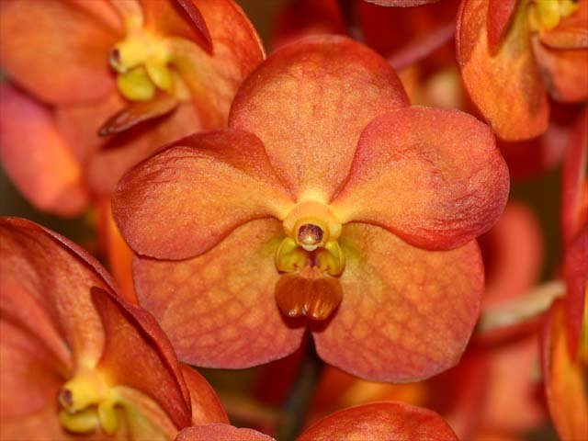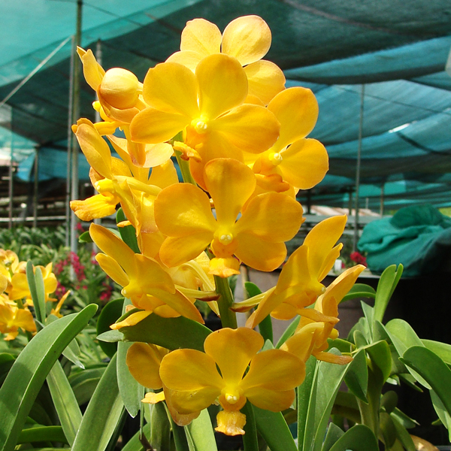
Vanda (Ascocenda) Candace’s Sunshine Vanda (Ascocends) Fuchs Gold

Spotting and Speckling: Ascocenda is also responsible for the addition of “more pronounced” spotting and speckling to its hybrids. This contributes “further excitement in several respects”.

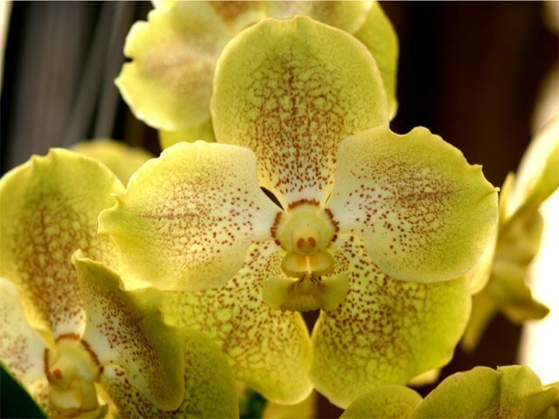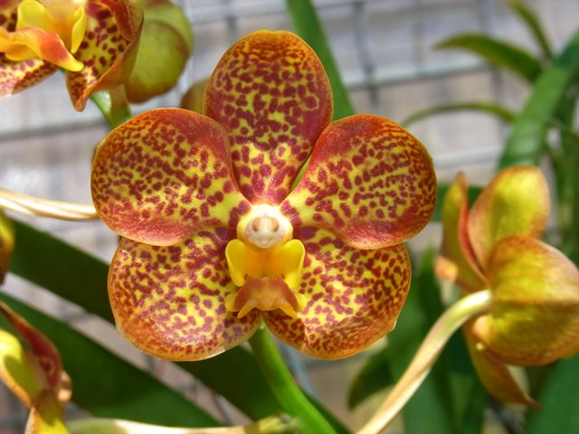
Vanda (Ascocenda) Jukkich Gold Vanda (Ascocenda) Crownfox Golden Dawn
Texture: A sparkling, crystalline texture is a must for Ascocendas. Grove states that the texture in Award descriptions as “sparkling” or “glistening”.
Flower Number and Size: A general rule stated by Grove is the fewer the number of flowers, the larger they should be and vise versa. Although the median size of the flowers in the 1990’s was 6.2 cm natural spread, the size can vary a lot. In general it is expected that Vandas of Ascocenda lineage should have more flowers than the run of the mill Vandas.
Flower Arrangement: Even in large Ascocendas, “superiority” is expected in the arrangement of the flowers on the stalk and the inflorescence should be erect.
In closing, Grove reiterates that “the color of the flowers should be bright and the texture cyrstalline”.

