Rhynchostylis Species

SPECIES PROGENY AWARDS AWARD TYPE RANGE TEMP/LHT BLOOM TIME
F-1/Total AOS Peak
coelestis | 157/630 | 63 | 30 AM, 2 AQ, 3 CBM, 1 CCE, 9 CCM, 1 CHM, 1 FCC, 12 HCC, 4 JC | Thailand, Cambodia, Laos, Vietnam | Warm/Hi | August
gigantea | 171/226 | 184 | 96 AM, 2 AQ, 4 CBM, 4 CCE, 19 CCM, 1 CHM, 7 FCC, 42 HCC, 9 JC | Southeast Asia | Warm/Hi | January
retusa | 40/50 | 19 | 9 AM, 2 CBM, 4 CCM, 4 HCC | South and East Asia | Warm/Hi | July
Type species: Rhynchostylis retusa Judging Scale – Vanda Building Block Species

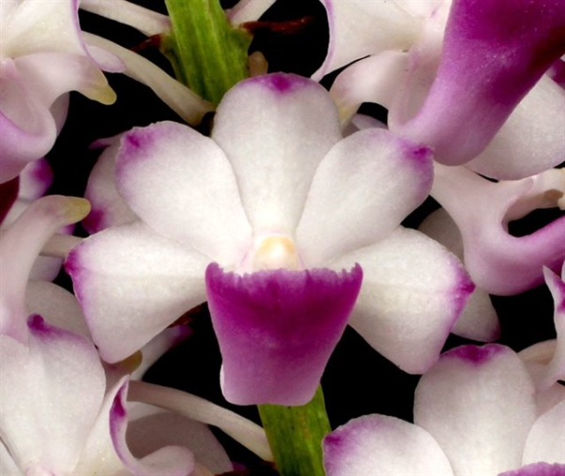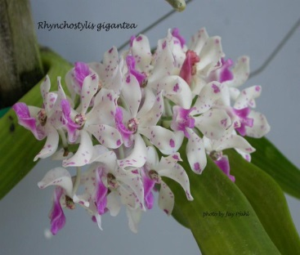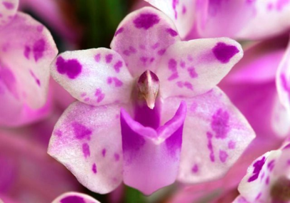
Rhynchostylis coelestis Rhynchostylis gigantea Rhynchostylis retusa

