Aeridovanda Memoria Lillian Arnold AM/AOS 85 Points
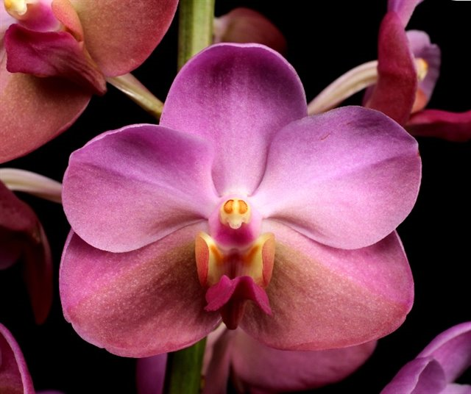
Thirty-seven round, flat flowers and three buds on one erect, arching inflorescence; sepals and petals pink, lateral sepals overlaid yellow-brown on inferior half; lip fuchsia, side lobes yellow, suffused pink on exterior margin; column fuchsia, anther cap yellow, spotted yellow apically; substance firm; texture matte.

Arachnis flos-aeris HCC/AOS 76 Points
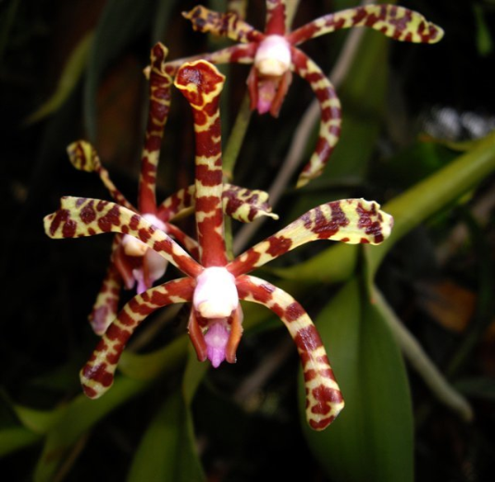
Ten flowers and nine buds on one, branched inflorescence; sepals and petals chartreuse, spotted and barred oxblood; lip rose-pink, side lobes brick-red; column white; substance firm; texture waxy.

Aranda Razzmatazz HCC/AOS 78 Points
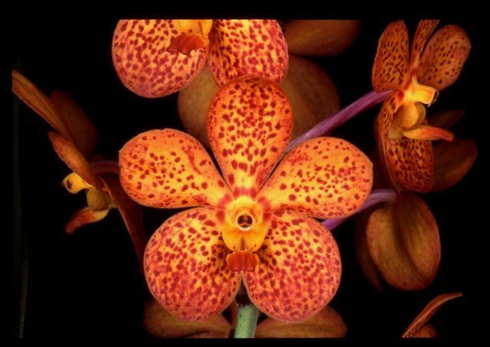
Six flowers and four buds well arranged on one upright inflorescence; sepals and petals golden yellow, suffused red orange marginally, spotted dark red orange; lip red orange, side lobes golden yellow; substance firm; texture waxy.

Chiloschista lunifera CCM/AOS 83 Points
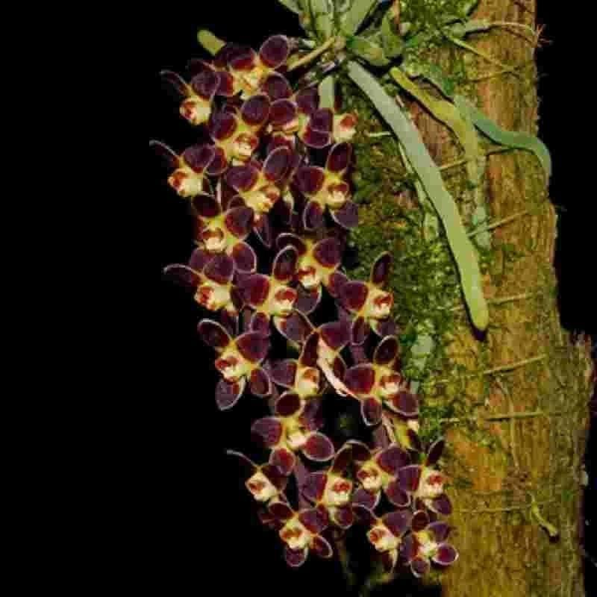
Twenty-five flowers and two buds on one pendant inflorescence on a 5-cm by 25-cm plant grown on wood; sepals and petals cream-white, overlaid purple-brown centrally; lip yellow, side lobes brown; substance firm; texture matte.

Gastrochilus calceolaris AM/AOS 80 Points
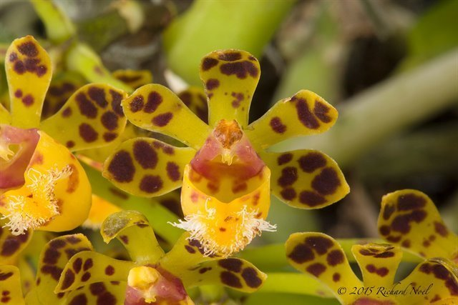
Twenty two flowers and seven buds on four full inflorescences; sepals chartreuse, boldly spotted mahogany: petals chartreuse, distal half spotted mahogeny; lip bright yellow, lightly spotted oxblood, side lobes suffused oxblood, distal lip margin ciliate; substance firm; texture waxy.

