BUILDING BLOCK DATA
Vanda sanderiana Rchb.f 1882
SECTION Lamellaria Lindley 1853

Description:

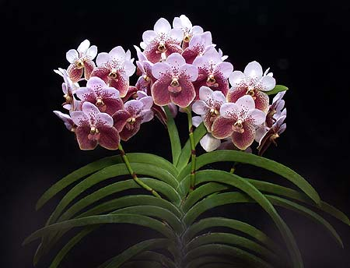
It is a large sized, monopodial, hot grower with an elongate stem, covered by imbricating sheathing bases carrying distichous, curved, coriaceous, ligulate, unequally bilobed or truncate apically leaves articulated to the persistent leaf sheaths below that blooms in the fall on 1 to 2, ascending, axillary, stout, to 12" [30 cm] long, 7 to 10 flowered raceme with long-lasting, fragrant flowers usually shorter than the leaves..³
Tall-growing, erect plant with closely spaced, wide, stiff leaves of 30-38 cm (12-15 in) in length. The racemes also are erect and stout, and ordinarily bear 7-10 flowers, 9-10 cm (3.5-4 in) across. The flowers of Vanda sanderiana differ from those of other Vanda species in several respects. They are flat, and the petals and sepals are wider in relation to their length (the flowers of some V. coerulea plants are another exception in this latter respect). The underside of the basal portion of the lip of V. sanderiana is balloon-shaped, with no spur whatsoever-a critical distinguishing feature. The petals and dorsal sepal are pale lilac or pinkish white, with some cinnamon-colored speckling on their inner halves. The lateral sepals are larger than the dorsal sepal and are tawny yellow, with prominent veining of dark cinnamon or reddish brown. The lip is broad and usually is a dull tawny color streaked with brownish red. There is a so-called alba form that has white petals and dorsal sepal, often with some light apple-green speckling basally. The lateral sepals are apple-green, with faint reticulation. As with Vanda coerulea, selective artificial propagation of V. sanderiana has produced vastly superior forms.¹

Distribution/Habitat:

In its natural location Euanthe grows on trees at elevations of sea level to 500 meters close to the sea, often hanging over the water, and often fully exposed to the sun as well. A major player in vandaceous breeding programs because of its two tone look is found in the Philippines on Mindanao Island. ³
The Philippine Islands, where it is endemic to Mindanao Island in the provinces of Davao, Cotabato, and Zamboanga. Plants are normally found on the trunks of dipterocarp trees at low elevations, usually below 1650 ft. (500 m). This species has been over-collected and is considered rare in nature. However, plants are available from the many improved, line-bred strains in cultivation. -- Source: Charles Baker⁴
Synonyms:

Esmeralda sanderiana [Rchb.f] Rchb.f 1882; Euanthe sanderiana [Rchb.f] Schlechter 1914; Euanthe sanderiana f. albata (Rchb.f.) M.Wolff & O.Gruss 2007; Euanthe sanderiana f. immaculata (Golamco) Cootes 2007; Vanda sanderiana var albata Rchb.f 1887; Vanda sanderiana var froebelliana Cogn. 1903; Vanda sanderiana var. immaculata Golamco 2002; Vanda sanderiana var labello-viridi Linden & Rodig. 1885
Awards:

Origin | HCC | AM | FCC | JC | CCM | CHM | Total
 | 44 | 53 | 10 | 0 | 17 | 0 | 141
Years | 1958-2012 | 1948-2016 | 1952-1991 |  | 1963-2015

Hybrids: F-1

Before  1940 | 1940-49 | 1950-59 | 1960-69 | 1970-79 | 1980-89 | 1990-99 | After 1999
6 | 16 | 59 | 75 | 60 | 31 | 20 | 44

Hybrids: Total Progeny
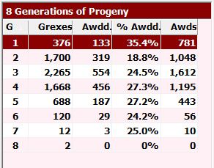
With almost 7,000 progeny, the table was unmanageable. The Generations table from Orchid Wiz shows the majority of hybridization takes place in the 1st through 4th generations although the percent awarded remains consistent through Gen 7. Vanda sanderiana and its progeny have received over 5,000 AOS awards, an amazing feat.

Outstanding progeny and reason they are considered outstanding:

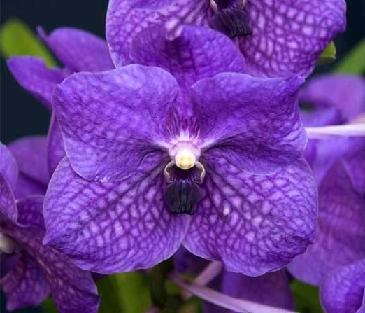
Vanda Rothschildiana FCC/AOS

This primary with V. coerulea was registered in 1931 and has been in continuous use as a parent since, most recently in 2019. It has 254 F-1’s and 5,340 progeny in 8 generations. Grove calls it a cross “made in Heaven” All of the faults of sanderiana are cancelled out bu coerulea. This formative cross is the basis of blue-purple pigmentation and tesselation in most Vanda breeding lines.

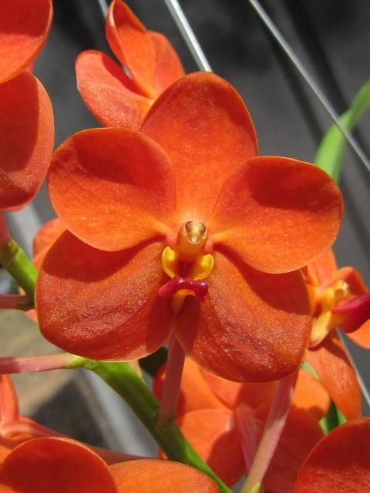
Vanda Yip Sum Wah FCC/AOS

This hybrid is a cross with V Pukele and is 50% curvifolia and 37% sanderiana. Along with Meda Arnold, it is the basis of the smaller flowered Ascocends type Vandas. It is noted for its brilliant color and sparkling texture. Sibling crosses and selfings have produced some great tetraploid specimens, one of which went on to produce Vanda John De Biase, a highly awarded brillient red.

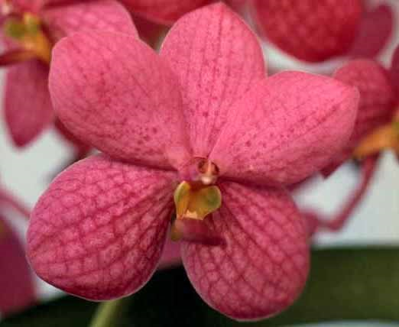
Vanda Meda Arnold AM/AOS

With 207 F-1, 1,657 progeny and 66 AOS awards, Meda Arnold is a significant hybrid of sanderiana.It is a nice blend of tesselated flat standard breeding species with the smaller flowers, saturated color and sparkling texture of the Ascocends type breeding from curvifolium.

Desirable characteristics which can be passed to progeny:
Vanda sanderiana is the base upon which most Vanda breeding relies. The flowers are naturally large, round and flat with relatively wide segments. The plants are relatively floriferous with 8 – 12 flowers on an inflorescence. The flowers have good substance and last for several weeks. The flowers are held above the foliage and are well arranged in a cylinder around the stem. The strong pedicels are long enough so that the flowers are not too crowded nor too dispersed. It breeds easily and grows vigorously and grows well in warm conditions.¹

Undesirable characteristics which can be passed to progeny:
The petals are small in relation to the lateral sepals. The petals tend to slant upwards and are longer that wide. The species blooms only once a year and blooms only when the plant is six or seven years old. The flowers bunch at the top of the inflorescence rather than being evenly spaced. Colors are dull and lack saturation and the color range is narrow.

References:

Aldridge, Peggy. 2008. An Illustrated Dictionary of Orchid Genera. Selby Botanical Garden Press.
¹ Grove, David L. 1995. Vandas and Ascocendas.Timber Press.
² Cribb, CJ. 2014. Epidendroidae. In: Pridgeon AM, Cribb PJ, Chase MW, Rasmussen F, eds. Genera Orchidacearum, Vol. 6. Oxford: Oxford University Press, 344-349.

³Jay Pfahl's IOSPE at www.orchidspecies.com
⁴OrchidWiz.Database X6.2
http://apps.kew.org/wcsp/qsearch.do

https://secure.aos.org/aqplus/SearchAwards.aspx

