Vanda coerulescens Griffith 1851
The Sky Blue Vanda
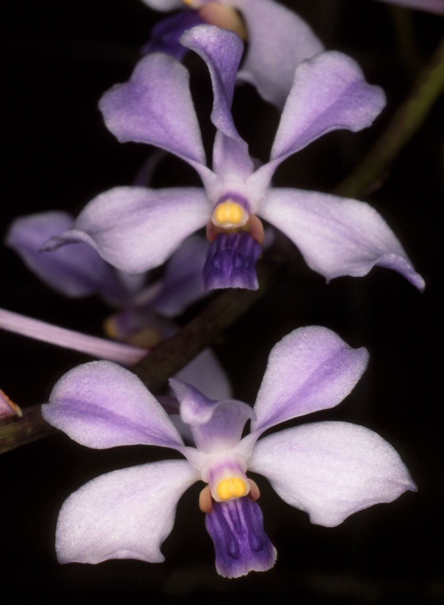
SECTION Longicalcarata
Synonyms
Vanda coerulescens var. hennisiana Schltr. 1914 ; Vanda coerulescens var. lowiana Rchb.f. 1877 ³
Description
A small sized, hot to cool growing epiphyte at elevations of 300 to 1200 meters with a terete stem carrying ligulate, channeled above, keeled below, bilobed apically leaves, and as in all Vandas grow best in wooden slat baskets with no media. The later winter and spring flowers have a pleasing scent of grape and are borne on an axillary erect or drooping, to 2' [60 cm] long, longer than the leaves, many [15 or more] flowered inflorescence with many long-lasting flowers. ³
A compact plant, 0.3-0.6 m (1-2 ft) tall, with leaves 13-18 cm (5-7 in) long. Flowers are 2.5-3.8 cm (1-1.5 in) across, on almost upright inflorescences bearing many flowers. The pedicels are about 3.8 cm (1.5 in) long. The sepals and petals are very pale bluish violet; the petals twist backwards, like those of Vanda coerulea. The small lip has a darker blue-violet midlobe. The side lobes are light purple. ²
Range
This monopodial species comes from Assam India, eastern Himalayas, Yunnan China, Myanmar and Thailand. ³ Northeast India, Burma, northern Thailand, and southwest China. In Burma, Vanda coerulescens has been found north of Rangoon near Pegu and on the hills near Prome at 1500 ft. (460 m). In Thailand, collections have been made on Doi Suthep, south of Denchai, near Mae Hong Song, and near Pang Mapha at (800 m). In China, this orchid is found in tropical southern and southwest Yunnan Province where it grows as an epiphyte on trees at 3600-4900 ft. (1100-1500 m). -- Source: Charles Baker ⁵

Awards
AM | HCC | JC | CCM | CBM | CHM | FCC |  | Total
1 | 2 | 2 | 2 | 0 | 1 | 0 |  | 8

Hybrids

Forty-five F-1 primaries have been registered since 1956, the latest in 2019. Fourteen have been awarded. A cross with Vanda falcata named V. Blaupunkt has 5 awards There are 82 progeny in 3 generations

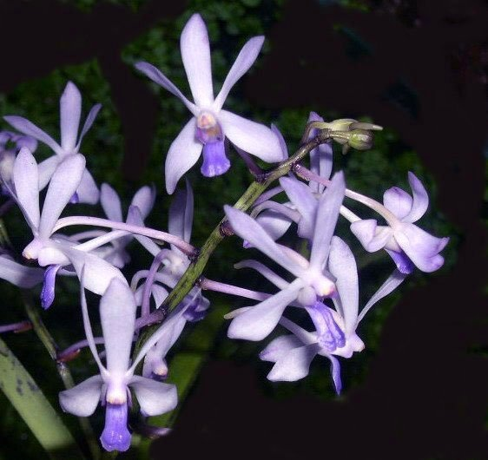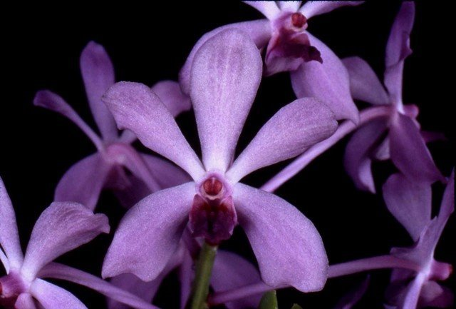

Vanda Blaupunkt HCC/AOS Vandaenopsis Sweet Viola AM/AOS

V. coerulescens x V. falcata Phalaenopsis lobbii x Vanda Ben Berliner

References
Aldridge, Peggy. 2008. An Illustrated Dictionary of Orchid Genera. Selby Botanical Garden Press.
¹la Croix, Isobyl. 2008. The New Encyclopedia of Orchids. Timber Press
²Grove, David L. 1995. Vandas and Ascocendas.Timber Press.
³ Jay Pfahl's IOSPE at www.orchidspecies.com
⁴Cribb, CJ. 2014. Epidendroidae. In: Pridgeon AM, Cribb PJ, Chase MW, Rasmussen F, eds. Genera Orchidacearum, Vol. 6. Oxford: Oxford University Press, 344-349.

⁵OrchidWiz.Database X6.3
http://apps.kew.org/wcsp/qsearch.do
https://secure.aos.org/aqplus/SearchAwards.aspx

