Vanda denisoniana Bens. & Rchb.f. 1869
The Lady Denison Vanda
SECTION Longicalcarata
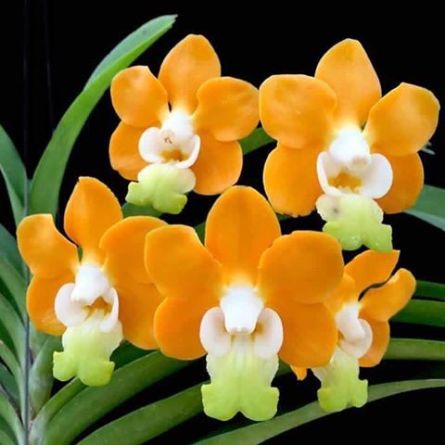
Synonyms
Vanda denisoniana var. tessellata Guillaumin 1933 ³
Description
This is a large sized, clumping, hot to cool growing epiphyte with lorate to ligulate, recurved leaves that blooms in the late winter and spring on an axillary, erect, 6" [15 cm] long, few [4 to 6] flowered inflorescence and carries waxy flowers that have a sweet scent in the day and strong vanilla scent in the early evening. ³
A medium-size plant with a twisting growth habit. The inflorescences are about 15-18 cm (6-7 in) long, arching or horizontal in habit, with up to 8 waxy, long-lasting flowers measuring about 5-6.5 cm (2-2.5 in) vertically (see Plate 3). The flowers are delightfully fragrant at dusk. The color of the sepals and petals ranges from pale creamy yellow to greenish yellow. The lip is broad and yel-low-green, with rounded side lobes. The shape of the flower also varies considerably. Some varieties have round and quite flat petals while others, especially the darker colored varieties, have elongated, recurved petals and sepals. Some varieties have spots, short bars, or tessellation on the petals and sepals (e.g., the variety hebraica). ¹
Range

Burma, Thailand, and China. In Burma, Vanda denisoniana was originally found at 2000-2500 ft. (610-760 m) in the Arracan Mountains of southwestern Burma and near Ta-ok in the Tenasserim region. In northern Thailand, plants occur near Mae Hong Song, Khuntan, Chiengmai, Mae Tun, Lampun, Phu Langka, Chiengrai, Doi Phu Ka, Nan, Doi Saket, Mae Sot, Phu Luang, and Loei, where they grow in the mountains at high-elevations. In China, plants grow in southwestern Yunnan Province . -- Source: Charles Baker ⁴

Awards
AM | HCC | JC | CCM | CBM | CHM | FCC |  | Total
21 | 13 | 2 | 2 | 1 | 0 | 2 |  | 41

Hybrids F-1
Before  1940 | 1940-49 | 1950-59 | 1960-69 | 1970-79 | 1980-89 | 1990-99 | After 1999
1 | 1 | 3 | 10 | 24 | 12 | 20 | 40

Thirteen F-1 primaries have been registered since 1921. The latest two were registered in 2019.

Progeny

There are 694 progeny of denisoniana in 7 generations. The following are the most awarded.

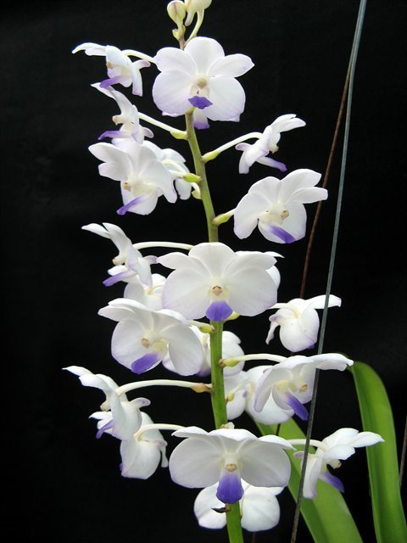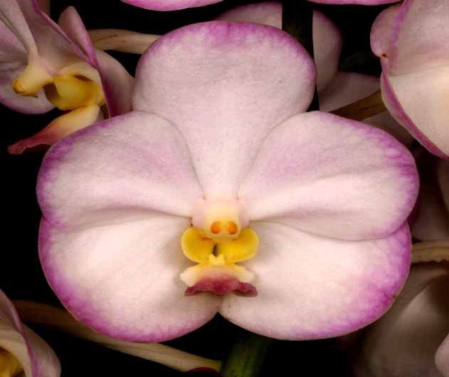

Vandachostylis Viboon Velvet AM/AOS Vandachostylis Crownfox Magic AM/AOS

Culture

Light:
Lady Denison Londesborough's Vanda needs a light level of 30000-40000 lux. Plants require moderately bright, diffused light, but they should not be exposed to the direct sunlight of the midday sun. Strong air movement should be ensured all the time.

Temperature:

Vanda denisoniana orchid is a thermophilic plant. In summer, the average day temperature is 27-29 ° C, and the night 19-20 ° C, which gives a daily difference of 7-9 ° C. In spring, the average day temperature is 31-32 ° C, 17-19 ° C night, with a daily amplitude of 9-15 ° C. In winter, the average day temperature is 25-28 ° C, at night 9-10 ° C, which gives a daily difference of 15-18 ° C.

Humidity:
This Vanda species needs about 80-85% of humidity in summer, while at the end of winter and early spring it drops to around 60-65%.

Substrate and growing media:
Plants are usually grown in hanging pots or slatted baskets, filled with loose, coarse-grained, quickly drying ground. Sometimes plants are grown with only a small amount of charcoal, wine corks, or large pieces of bark of the cork oak, so that only keep them in the right position until the roots stick to the container. You can not cut roots that should grow and hang freely as it suits them. Even a slight cut of the roots can reverse the plant in development by 2-3 years. The continuous and strong air movement around the roots is very important for proper growth.

Watering:
The cultivated plants should be abundantly watered during active growth, but excellent drainage should be ensured. When new growths reach maturity at the end of autumn, the amount of water should be reduced.

Fertilizer:
During the active growth of the plants should be fertilized every week 1/4-1/2 of the recommended dose of fertilizer for orchids. You also can use sustainable fertilizer throughout the year or use nitrogen-enriched fertilizer from spring to mid-summer, switching to phosphorus-enriched fertilizer in late summer and autumn.

Rest period and repotting:
In winter, Vanda denisoniana orchid need much less water, but they should not be completely deprived of it for a longer period. In general, the plants need only light morning fogging every few days, especially when the humidity is high. Fertilization should be reduced or eliminated until new growths appear and a more abundant spring watering begins. ⁵

References
Aldridge, Peggy. 2008. An Illustrated Dictionary of Orchid Genera. Selby Botanical Garden Press.
¹ Grove, David L. 1995. Vandas and Ascocendas.Timber Press.
²Cribb, CJ. 2014. Epidendroidae. In: Pridgeon AM, Cribb PJ, Chase MW, Rasmussen F, eds. Genera Orchidacearum, Vol. 6. Oxford: Oxford University Press, 344-349.

³ Jay Pfahl's IOSPE at www.orchidspecies.com
⁴OrchidWiz.Database X6.3
⁵https://travaldo.blogspot.com/care-and-culture.html
http://apps.kew.org/wcsp/qsearch.do
https://secure.aos.org/aqplus/SearchAwards.aspx

