Vanda insignis (Kraenzl.) Blume 1849

The Grand Vanda
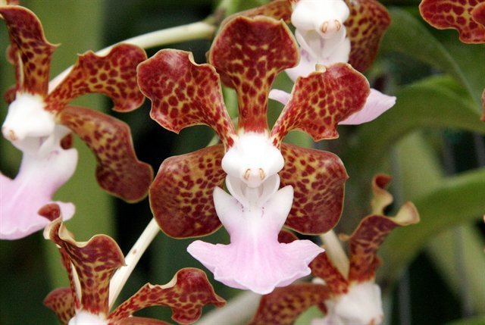
Synonyms
Vanda insularum (Christenson) L.M.Gardiner 2012³
Description
A medium sized, hot to warm growing, monopodial epiphyte with suberect stems carrying linear-ligulate, recurved leaves that blooms in the summer on a pendant, to 7 1/4" [18 cm] long, sometimes branched, shorter to as long as the the leaves, few [8] flowered inflorescence carrying sweetly scented flowers. ³
The inflorescences bear 4-7 flowers, measuring 5-6.5 cm (2-2.5 in) across. The sepals and petals are much recurved. Their color is tawny yellow with brown blotches that coalesce toward the sepal and petal edges. The lip is one of the largest in the genus. It has two white side lobes; the midlobe is mauve or rose-purple, broad and almost flat, though somewhat upcurved near the rounded tip, giving it the appearance of the blade of a shovel. According to Holttum (1972, 724), it flowers well in both the mountains and lowlands of Java, but not so well in the uniform climate of Singapore. ¹

Range

Moluccas, Timor, Malayan Archipelago, Java, at low elevations, on small trees with little shade. ¹

Indonesia in the Mulches Islands and Timor. Although this species reportedly grows on Java, Comer (1990) did not indicate its occurrence on that island. Plants are found at low elevations on small trees with little shade. -- Source: Charles Baker ⁴

Awards
AM | HCC | JC | CCM | CBM | CHM | FCC |  | Total
1 | 1 | 0 | 0 | 2 | 0 | 0 |  | 4

Hybrids

Seventy-one F-1 hybrids have been registered since 1936, the most recent 3 in 2019. Vanda insignis has 538 progeny in 6 generations.

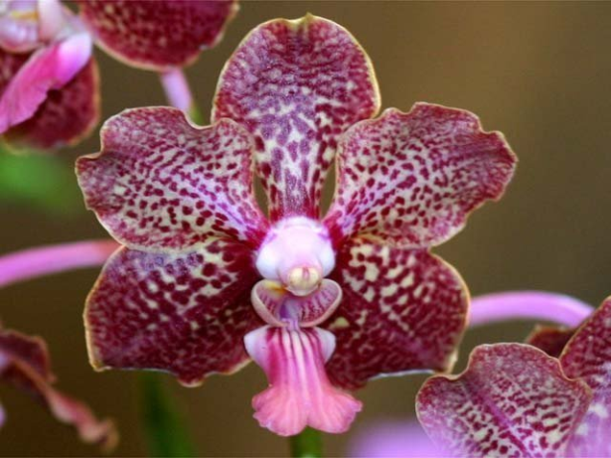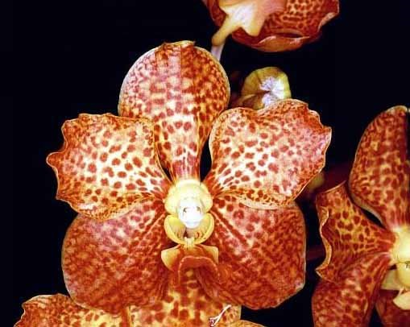

Vanda YolandaUlrich AM/AOS Vanda Happy Smile AM/AOS

2 AM, 3 HCC 2 AM, 3 HCC

References
Aldridge, Peggy. 2008. An Illustrated Dictionary of Orchid Genera. Selby Botanical Garden Press.
¹Grove, David L. 1995. Vandas and Ascocendas.Timber Press.
²Cribb, CJ. Orchidacearum, Vol. 6. Oxford: Oxford University Press, 344-349.2014. Epidendroidae. In: Pridgeon AM, Cribb PJ, Chase MW, Rasmussen F, eds. Genera

³ Jay Pfahl's IOSPE at www.orchidspecies.com
⁴OrchidWiz.Database X6.3
http://apps.kew.org/wcsp/qsearch.dohttps://secure.aos.org/aqplus/SearchAwards.aspx

