Vanda Jones 1820
SUBFAMILY Epidendroideae, TRIBE Vandeae, SUBTRIBE, Aeridinae ₁
ETYMOLOGY: From Sanskrit referring to mistletoe found on oak trees of the genus Vandaka.⁴
TYPE SPECIES: Vanda tessellata
DESCRIPTION: There are 65 some species in this Asian Genus that are mostly epiphytic, although there are some lithopytic and terrestrials that exist, but they are all monopodial in growth habit and are Asiatic in origin. There are two distinct leaf forms the strap leaf and the terete leaf. Typically the terete leafed species appreciate much more direct sunlight than the strap leafed plants do. The tepals are more or less similar and are wide spreading with wavy or crisped margins. The smaller than the sepals, lip is three lobed, saccate to spurred basally, spur short, conical, often laterally compressed without a callus and sidelobes on the edges of the spur close to the column and has various apical lobes that are large and fleshy and has a disc with low rounded longitudinal swellings and keels. There is a short column that has an indistinct foot or none at all, a 2 chambered anther with 2, large pollina with short, broad stipes.₁
Epiphytic or occasionally lithophytic herbs. Roots usually emerging from nodes near base or lower portion of stem. Stem usually stiffly erect, completely enclosed by distichously arranged persistent leaf-sheaths. Leaves distichous, rigid, usually decurved or held erect, linear or oblong, adaxial surface channelled shallowly to deeply, jointed and sheathing at base, deciduous, apex premorse. Inflorescence axillary, racemose, few- to many-flowered, floral bracts triangular. Flowers resupinate, usually widely open-ing, exhibiting a wide range of colours and patterning. Sepals and petals free, similar, elliptic-obovate, twisted or undulate, often tessellated, margins often reflexed, often narrowed at base. Labellum usually rigidly attached but occasionally articulate, trilobed, side lobes orbicular to pointed, midlobe simple, deltoid or bibbed to fimbriate, usually shortly spurred but occasionally no spur or with an elongate, nectiferous spur; spur often with thickenings at entrance. Column usually lacking a foot; pollinia two, waxy, spherical, grooved; rostellum shelf-like. ³
Fifty-seven monopodial epiphytes or lithophytes are found in low to upper elevation, evergreen or deciduous forests and rocky cliffs from southern China (Xizang to Guangdong), northern India (Kashmir to Assam), Nepal, southern Japan (Ryukyu Islands), Sri Lanka, Myanmar to Vietnam, the Philippines, Indonesia, New Guinea, the Solomons and northeastern Australia. These large to tiny plants, often forming large, scrambling clumps, have semi-rigid, strap-like to pencil-like, channeled leaves produced from the stem's tip, with the lower leaves eventually being shed. Thus, after a few years, the plants become leggy with a length of bare stem that has numerous, stout aerial roots formed along the base of the stem. The erect, numerous to few-flowered inflorescence, borne from the leaf base, has comparatively large, showy, fleshy, heavily textured, fragrant flowers with strong color variations. They will last from several days to nearly two months in perfection. The trilobed lip has a short, oblong to cone-like spur firmly attached to the short, rather stout, wingless column that has a short foot or is footless. The lip has erect side lobes; the often keeled midlobe is forward pointing, and has cone-like to oblong, sometimes recurved spur.²
CULTURE
Success with vandaceous orchids requires attention to five elements of their growing conditions:
Temperature. Vandaceous orchids grow best under daytime conditions of 65ºF (18ºC) or higher, but they can withstand long spells of hot weather and short spells of cold. They will continue in active growth anytime of the year if given warm temperatures and bright light. Night temperatures should not generally be lower than 55ºF (12ºC) for extended periods. We’ve seen some vandaceous plants withstand temperatures as low as 38ºF (4ºC) for 23 hours with damage to root tips and flower buds, but not to the plant itself, but you should protect your vandaceous orchids from those temperatures if at all possible. During a period of extreme cold, the most important thing you can do is to protect the plants from air movement (wind). For the most part, vandaceous orchids fall into the “warm-growing” group mentioned in most books and publications about growing orchids.
Light. If the humidity is high, maximum sunlight should be given with only enough shade to keep the temperature within the appropriate range and protect the foliage of strap-leaf plants during the middle part of the day. For our greenhouses in South Florida we use 46% shade cloth covered with 6 mil clear plastic on the top and sides of greenhouses, producing about 50% shade. Outdoors, the plants want maximum light without burning the leaves. They will benefit from full sun in the morning and late afternoon, but need some shade during the middle part of the day.
Terete vandas and their semi-terete hybrids are sun lovers. Not only will they flower year round in tropical areas, they are also floriferous in the subtropics. They can be grown in the full sun and are ideal for tropical landscape use.
Air Movement. Vandaceous orchids are epiphytes and need good air circulation. Air movement also reduces the incidence of leaf-spotting fungal and bacterial infestations. However, as noted above it is important to restrict air movement under colder temperatures.
Water. Vandaceous orchids in slat baskets should be watered daily, preferably early in the morning. Give them a good drink with the hose, or a dunk in a bucket or sink if you only have a few plants, and let them dry. High daytime humidity is essential, especially on sunny days, and additional misting once or twice a day in bright weather will be helpful. On hot, sunny days around 80% humidity is appropriate. Water more sparingly in winter, during long cloudy spells, or after repotting. In any season, avoid watering plants late in the afternoon. Vandaceous plants should be dry before nightfall.
In addition to the natural ingredients of temperature, air and water, good culture also requires some help from manmade supplies: containers, potting media, insecticides, fungicides, and fertilizers.
Fertilizing. Vandaceous orchids are heavy feeders. Once a week during the growing season, give the plants a solution of a complete, balanced fertilizer. High-nitrogen fertilizers will inhibit flowering and are not recommended for these orchids. All plants should be flushed thoroughly with plain water once a week to remove built-up salts. If you use an automatic proportioner, plants may be fertilized as often as daily with a more dilute solution. Whatever feeding plan you follow, remember, it is important to be faithful to the regimen you have established.
We use Peter’s 20-20-20 (All Purpose with micronutrients; Jack’s Classic All-Purpose is packaged for consumer sales) fertilizer weekly during the growing season. Inside the greenhouse, under a controlled environment, we use the standard, recommended concentration of 1 teaspoon per gallon. During the winter (non-growing season), we apply the same proportions every two weeks rather than weekly. In addition, at every third feeding we substitute Peter’s (or Jack’s Classic) 10-30-20 (Bloom Booster). This substitution applies to plants in all seasons of the year. And once a month we add 1/4 teaspoon of SUPERthrive, a concentrated vitamin and hormone solution for plants, to each gallon of fertilizer solution. SUPERthrive is a root stimulant, not a fertilizer.
Potting. Vandaceous plants will grow well in any porous medium if properly aerated. Tree-fern chunks, coarse bark or charcoal are good choices. The base of the plant and roots should not be smothered by tight potting or soggy medium. We prefer wooden or plastic baskets with little or no additional growing medium, but pots can be used if drainage is good. Teakwood is the best choice for wood baskets, as it lasts the longest. If teakwood is not available redwood is a good second choice, and cedar a third option. We use 3″ teakwood or plastic baskets for the first two years after seedling size, 6″ baskets for the next two years, and 8″ baskets for mature plants. Plants should be suspended so that the aerial roots are free; otherwise, the roots attach themselves to the bench or wall and are damaged when the plants are moved. Recently potted plants should be maintained under slightly more shaded conditions until they are established.
Because vandaceous plants have large aerial roots, they don’t like to be disturbed. So instead of removing them from their smaller, older baskets at repotting time, we “elevate” plants from smaller to larger baskets. We soak the roots briefly in water until they become pliable, and then work the roots through the slats in the larger basket so that we can place the old smaller basket and plant intact in the larger basket. Never coil the roots around the old basket because vandaceous plants will feed better with an unrestricted root system. A few large pieces of charcoal can be added to hold the smaller basket securely within the larger; wiring the smaller basket into the larger will accomplish the same result. This method minimizes shock to the plant and permits continued, uninterrupted growth. Adding SUPERthrive to the water used to soak the plant will further minimize its shock and seems to encourage faster growth of new roots.
There are occasions, however, when disturbing the roots cannot be avoided, e.g. a rotten basket, or repotting of pot-grown plants. Soak these plants in plain water for a few minutes, and then remove from the old container as carefully as possible. It may be necessary to dismantle the old basket by cutting its wire fasteners. Clean debris from the roots and soak in a solution of vitamins/hormones and fungicide for about 5 minutes, and then pot in a new basket. If you must trim roots or leaves, be sure your cutting tool is sterilized. Late spring to early summer is the best season for potting or repotting vandaceous plants, but these orchids may be repotted at almost anytime of the year.
Since vandaceous orchids grow rapidly with good light, water and regular fertilizing, seedlings should be grown in 3″ pots, loosely potted in a mix of fine charcoal and tree-fern fiber. Keep seedlings in slightly more shaded conditions than mature plants, but include them in the same water and fertilizer programs. Maintain humidity and good air movement.
© 2016, R.F. Orchids, Inc. All rights reserved.
DISTRIBUTION: Vanda comprises 74 species collectively distributed from India, Nepal, Bhutan, Burma, Thailand, Indochina, southern China, Taiwan, Japan, Korea, the Philippines, and Indonesia, to New Guinea, northern Australia, and the Solomon Islands. Many species appear to be narrow (island) endemics, with the highest species diversity in the Southeast Asian archipelagos and the Himalayan - Indochinese region. ³

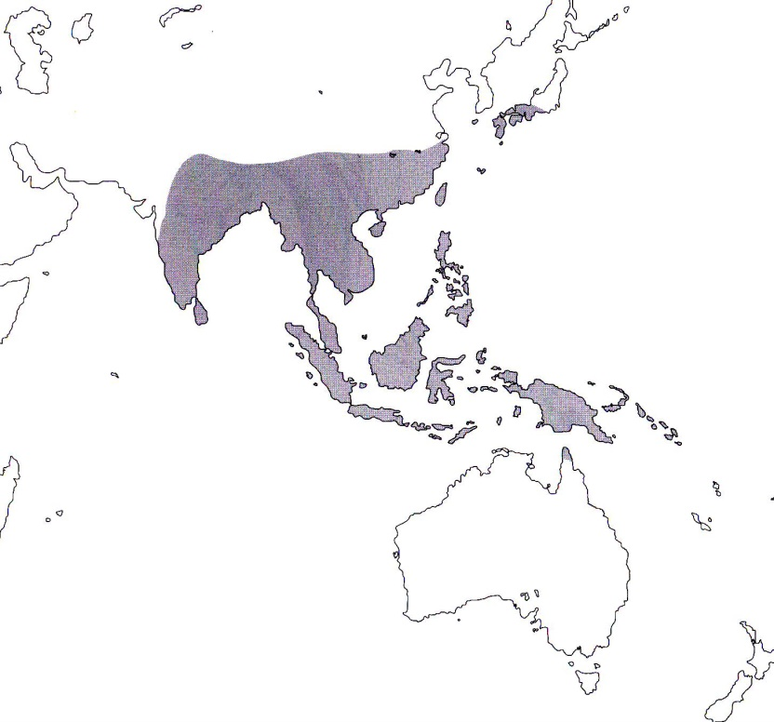

References
¹ Jay Pfahl's IOSPE at www.orchidspecies.com
²Aldridge, Peggy. 2008. An Illustrated Dictionary of Orchid Genera. Selby Botanical Garden Press.
³Cribb, CJ. 2014. Epidendroidae. In: Pridgeon AM, Cribb PJ, Chase MW, Rasmussen F, eds. Genera Orchidacearum, Vol. 6. Oxford: Oxford University Press, 344-349.

⁴Grove, David L. 1995. Vandas and Ascocendas.Timber Press.

