Vanda Species

SPECIES PROGENY AWARDS AWARD TYPE RANGE TEMP/LHT BLOOM TIME
F-1/Total AOS Peak
coerulea | 337/6,020 | 53 | 18 AM, 2 CC, 1 CCE, 10 CCM, 3 CHM, 5 FCC, 12 HCC, 2 JC | India, Burma, Thailand, SW China | Hi/Cool-Warm | November
curvifolia | 169/3,261 | 23 | 6 AM, 6 CCM, 1 CHM, 9 HCC, 1 JC | Burma & Thailand | Hi/Cool-Warm | May
denisoniana | 129/660 | 40 | 21 AM, 1 CBM, 2 CCM, 2 FCC, 12 HCC, 2 JC | Burma, Thailand, China | Lo/Cool-Warm | May
falcata | 98/208 | 101 | 27 AM, 5 CCE, 21 CCM, 15 CHM, 1 FCC, 20 HCC, 12 JC | NE Asia | Lo/Cool-Warm | June-July
lamellata | 101/288 | 40 | 15 AM, 1 AQ, 1 CCE, 8 CCM, 3 CHM, 1 FCC, 10 HCC, 1 JC | Philippines, Borneo, Taiwan | Hi/Warm | February
miniata | 115/644 | 21 | 5 AM, 1 CBM, 1 CCE, 9 CCM, 1 CHM, 2 HCC, 2 JC | Thai, Laos, Vietnam, Malaya | Hi/Cool-Warm | April-May
sanderiana | 372/6,678 | 141 | 68 AM, 1 CBM, 17 CCM, 10 FCC, 44 HCC | Philippines | Hi/Warm-Hot | October
tessellata | 191/688 | 30 | 21 AM, 1 CCE, 1 CCM, 2 CHM, 2 FCC, 3 HCC | India, Nepal, Burma | Hi/Warm-Hot | June
tricolor | 135/5,145 | 25 | 10 AM, 7 CCM, 1 CHM, 1 FCC, 3 HCC, 3 JC | Indonesia | Hi/ Cool-Warm | May
Type species: Vanda tessellata Judging Scale – Vanda Building Block Species

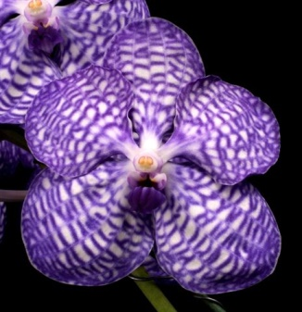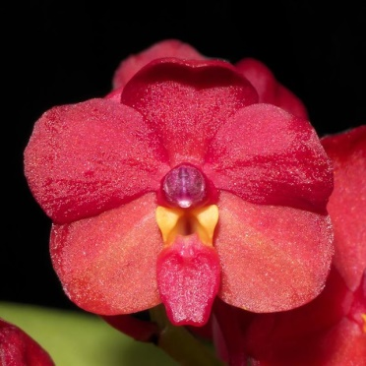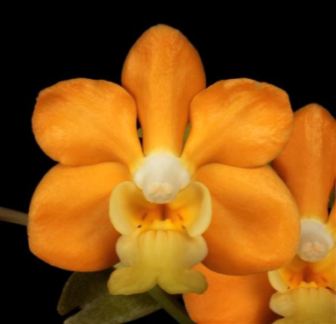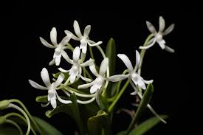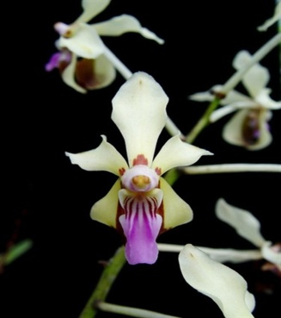
Vanda coerulea Vanda curvifolia Vanda denisoniana Vanda falcata Vanda lamellata

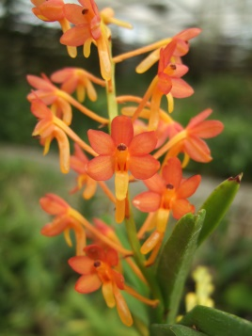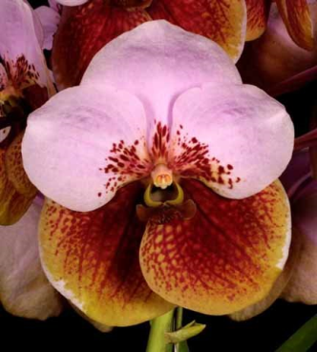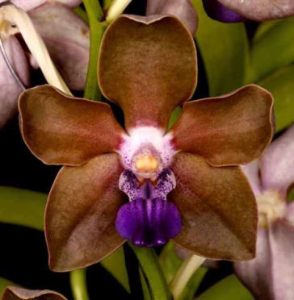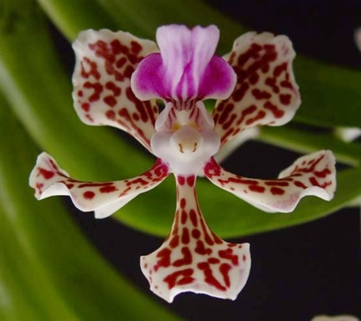
Vanda miniata Vanda sanderiana Vanda tessellata Vanda tricolor

