Holcoglossum wangii CCM/AOS 80 Points
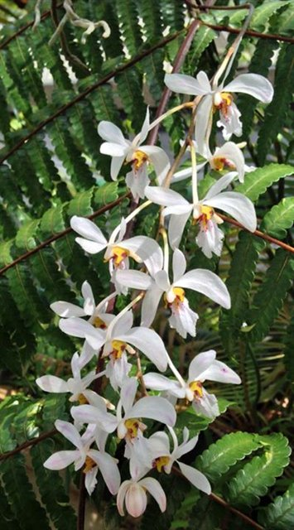
Thirty-three flowers and nineteen buds on eight pendant inflorescences on a 20-cm by 50-cm plant grown on tree fern; sepals and petals white, lip white, blushed magenta medially, spotted magenta basally, side lobes and throat yellow; column white, anther cap magenta; substance firm; texture ctystalline

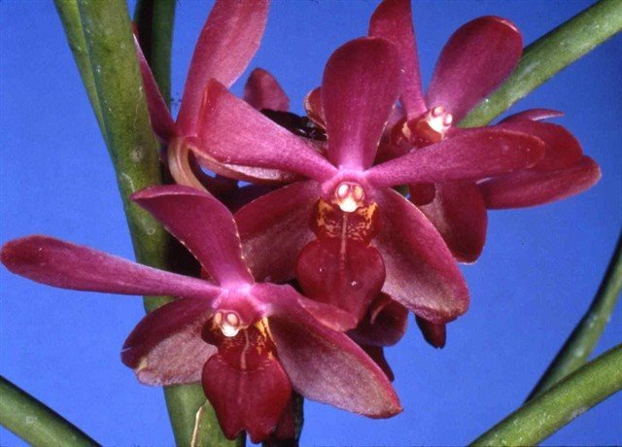
Luisanda Rasberry Dream HCC/AOS 85 Points
Six flowers and two buds tightly clustered on one inflorescence; sepals and petals red-violet, lateral sepals inferior half lighter red-violet; lip red, spotted yellow basally; column white, anther cap spotted red-violet; substance firm; texture diamond dust.

Arachnostylis Chorchalood AM/AOS 82 Points
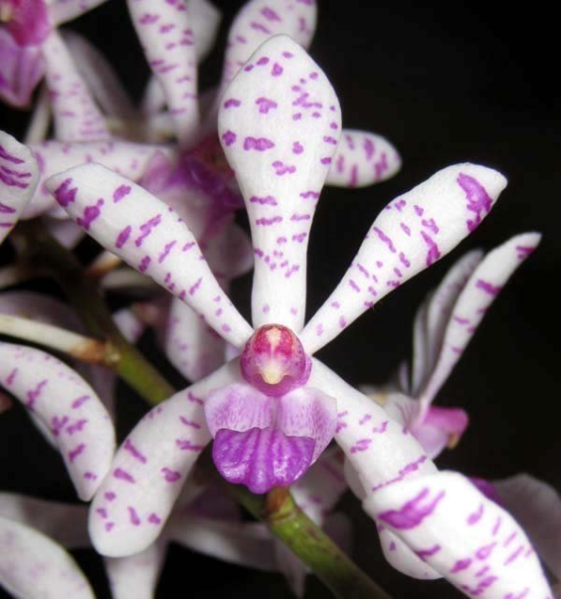
One hundred seventeen flowers and thirty-seven buds on five upright inflorescences; sepals and petals white, spotted and barred fushsia; lip white, midlobe distal half overlaid deep fushsia, proximal half lighter fushsia; column red-violet, anther cap yellow; substance firm; texture matte.

Chuanyenara Sompol AM/AOS 82 Points
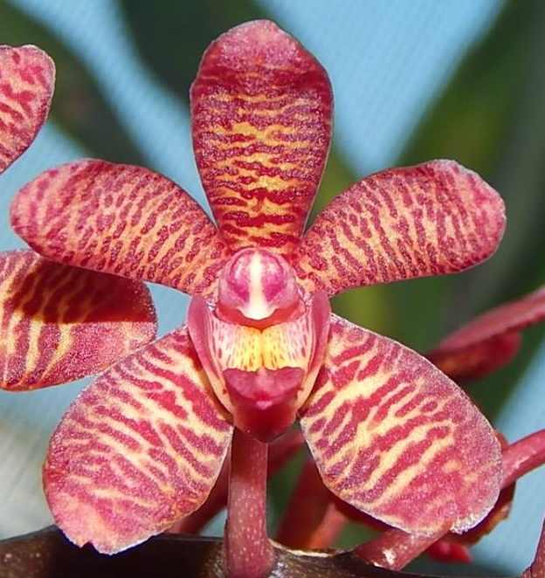
Seventy-nine flowers and three buds on one branched inflorescence; flowers chartreuse, heavly overlaid with violet red barring; lip white, solidly overlaid violet red, side lobes white, margins violet red, crest yellow; substance firm; texture crystalline.

Cleisocentron merrillianum HCC/AOS 77 Points
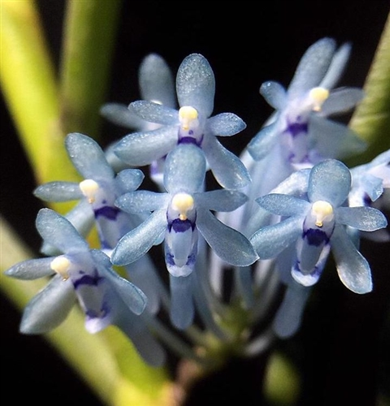
Forty five flowers and seventeen buds on three clustered inflorescences; flowers light blue, translucent; lip blue, distal margin of throat spotted blue-purple, side lobes blue-purple; column blue, anther cap white; substance soft; texture sparkling.

