Dimorphorchis lowii AM/AOS 86 Points
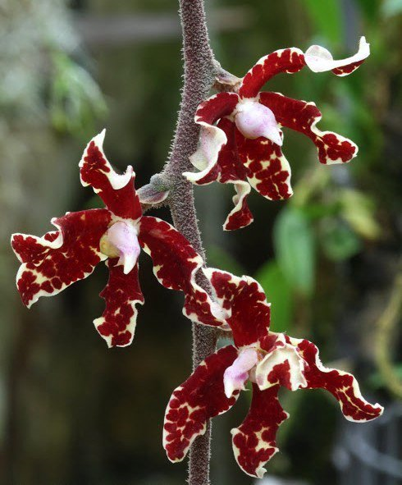
Forty-one flowers and twelve buds and two female flowers on two pubescent, pendant inflorescences, male flowers white, undulate, heavily overlaid burgundy; lip hinged, white, blushed pink, throat yellow; substance firm; texture matte; female flowers yellow, spotted burgundy; lip pale yellow, spotted rust-red; substance hard; texture glossy.
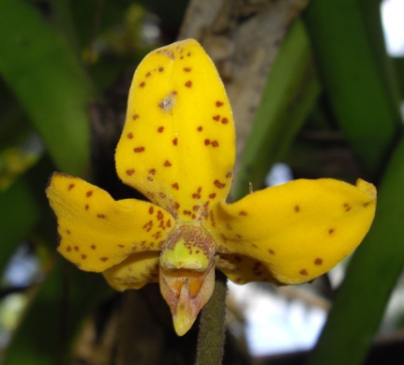
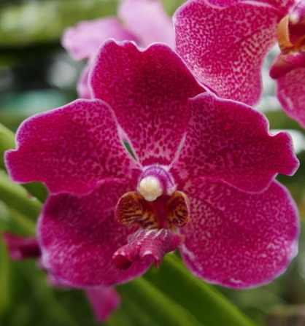
Papilionanda Nellie Morley HCC/AOS 78 Points
Twenty-one flowers and three buds on two inflorescences; sepals and petals red-violet, spotted; lip midlobe red-violet, side lobes gold-yellow, striped burgundy; column red-violet, anther cap white; substance firm; texture matte.

Plectochilius Richard Jost HCC/AOC 78 Points
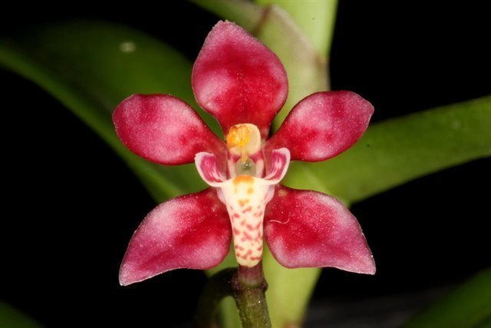
Forty flowers and two buds on four pendent inflorescences; sepals and petals red; lip saccate, cream, spotted red, apex margin gold, side lobes white, red centrally; column red, anther cap yellow; substance firm; texture waxy.

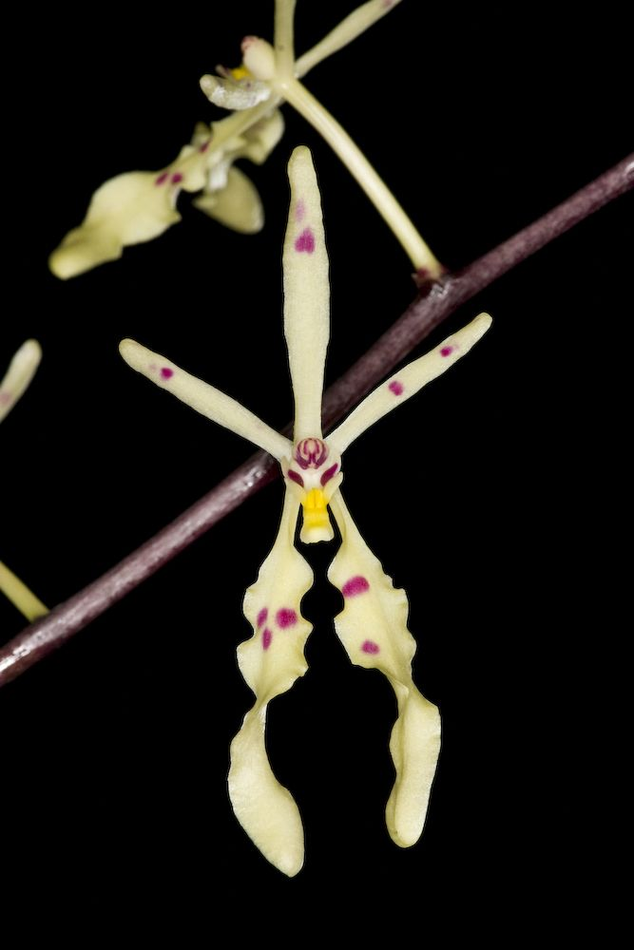
Renanthera citrina AM/AOS 82 Points
Twenty-seven flowers, well presented on one branched inflorescence; flowers creamy-yellow, sparsley spotted magenta, lip creamy-yellow, callus lemon-yellow; column yellow, anther cap magenta; substance soft, texture matte.

Robiquetia cerina CCM/AOS 82 Points
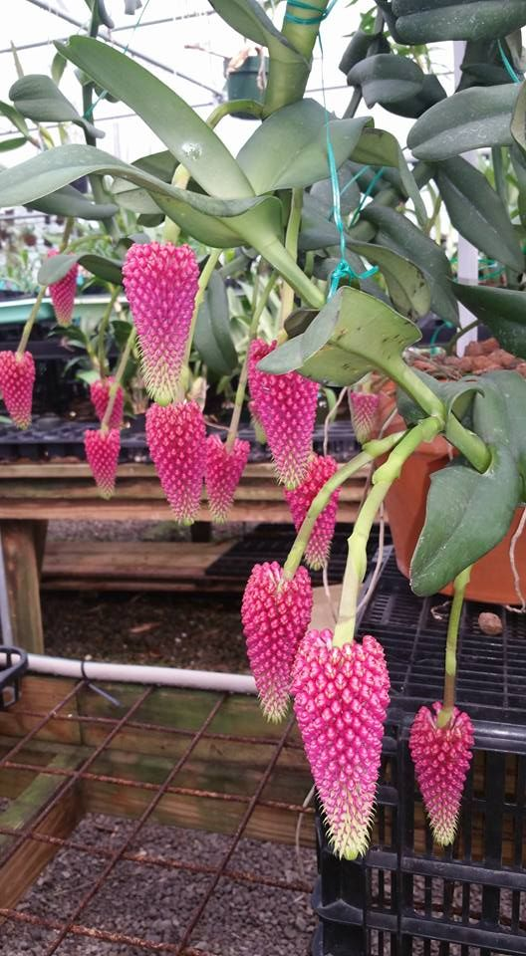
Eight thousand nine hundred flowers and seven thousand two hundred buds on thirteen inflorescences on a 110 cm tall plant grown in clay pellets in a clay pot; flowers rose red arranged tightly in pendent racemes; column white, spotted rose laterally; substance firm; texture matte.

