Vanda Yip Sum Wah is arguably the best Vanda hybrid ever created. Not only is it a stunningly beautiful grex, but it is a great breeder with 304 F-1 offspring and 1209 progeny in six generations. It is a combination of great form from Vanda sanderiana and Vanda coerulea with the color enhancing genes from Vanda tricolor and Vanda luzonica. My notable progeny were chosen based on both awards received and breeding ability. Both the red and yellow/orange progeny are presented.

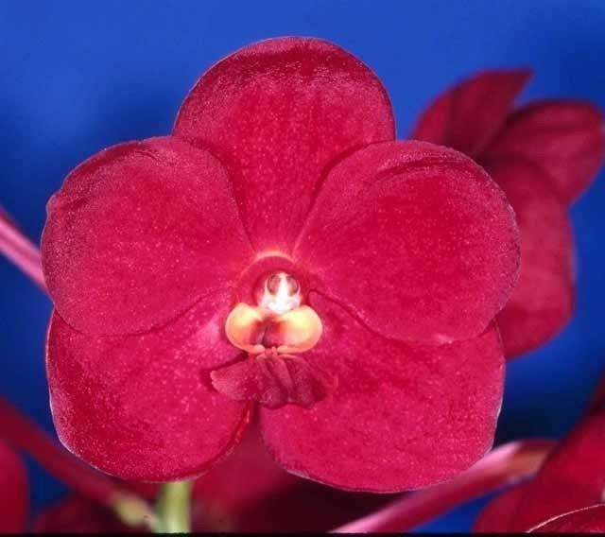
Vanda John De Biase 1983 47 International Awards (34 AOS)
26 F-1 Offspring, 30 Progeny in 2 generations 50% of which have been awarded.
Vanda Kasem’s Delight x Vanda Yip Sum Wah

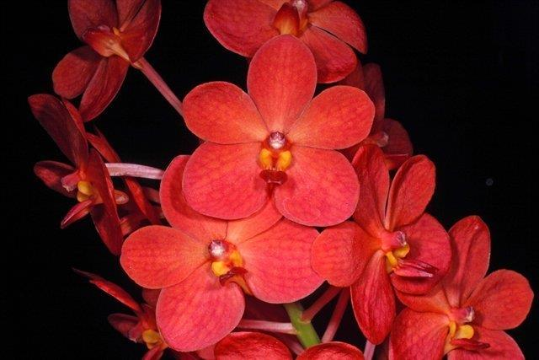
Vanda Fiftieth State Beauty 1970 45 International Awards (38 AOS)
19 F-1 Offspring, 20 Progeny in 2 generations 47% of which have been awarded.
Vanda Yip Sum Wah x Vanda Meda Arnold

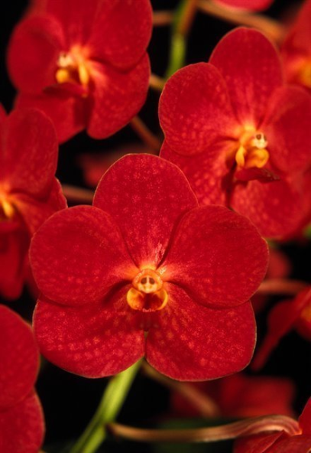
Vanda Suk Sumran Beauty 1983 35 International Awards (29 AOS)
4 F-1 Offspring, 4 Progeny
Vanda Gordon Dillon x Vanda Yip Sum Wah
Another stunning highly awarded red, but not a particularly good breeder.

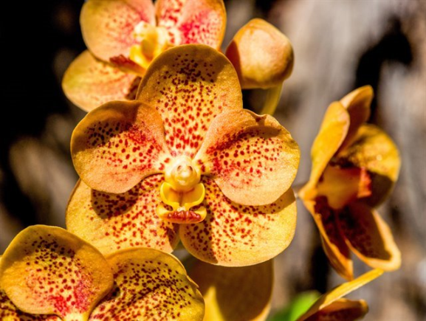
Vanda Guo Chia Long 1970 5 AOS Awards
81 F-1 Offspring, 171 Progeny in 4 generations with a total of 76 awards.
Vanda Memoria Medame Pranerm x Vanda Yip Sum Wah
The yellow is most likely from its ¼ Vanda dearei genes.

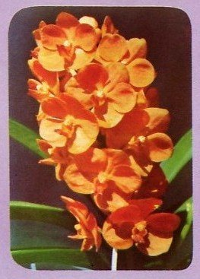
Vanda Madame Kenny 1873 No Awards
35 F-1 Offspring, 362 Progeny in 5 generations with a total of 112 awards.
Vanda Yip Sum Wah x Vanda Boonchoke
Another case of a unawarded grex being a great breeder.

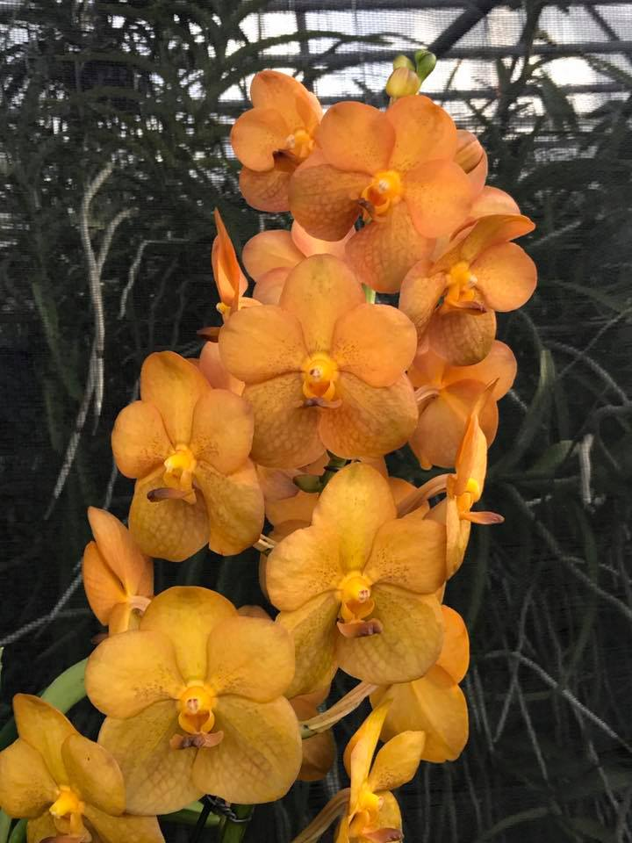
Vanda Duang Porn 1973 7 International Awards ( 4 AOS)
31 F-1 Offspring, 86 Progeny in 5 generations with a total of 33 awards.
Vanda Thananchai x Vanda Yip Sum Wah

