Vanda tricolor AM/AOS 81 Points
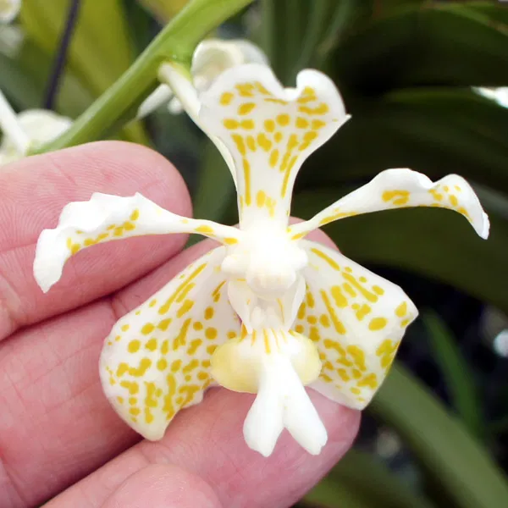
Nine flowers on one erect inflorescence; sepals and petals white, spotted mustard yellow, spots elongating basally; lip white, side lobes pale yellow; column white; substance firm; texture matte.

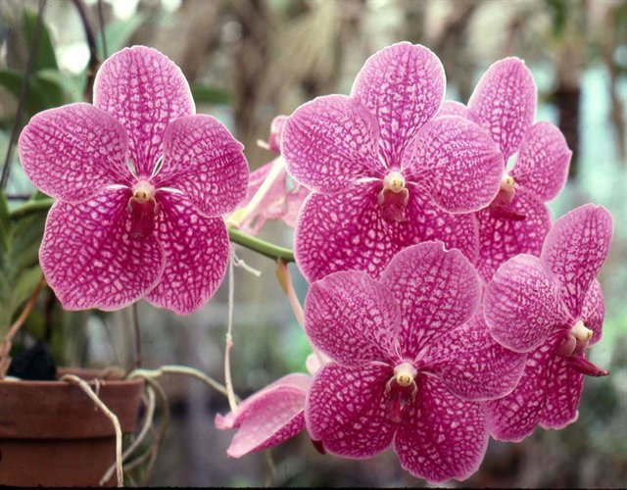
Vanda Rothschildiana AM/AOS 87 Points
Twenty three flat, round flowers and two buds on two inflorescences; flowers magenta, evenly tessellated; lip dark magents; column white; substance firm; texture crystalline.

Vanda luzonica HCC/AOS 75 Points
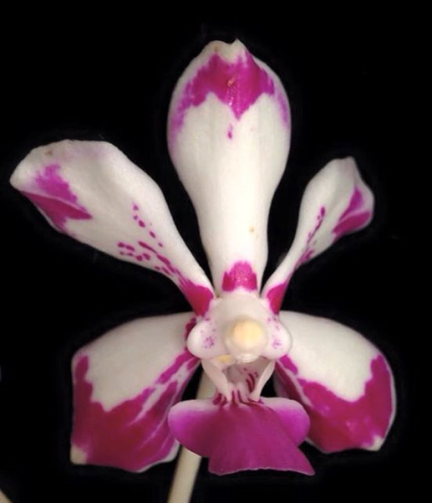
Sixteen flowers and two buds in one inflorescence; sepals and petals white, overlaid magents distally and spotted at base; lip white, overlaid magenta, nectary white; substance firm; texture matte.

Vanda John De Biase HCC/AOS 77 Points
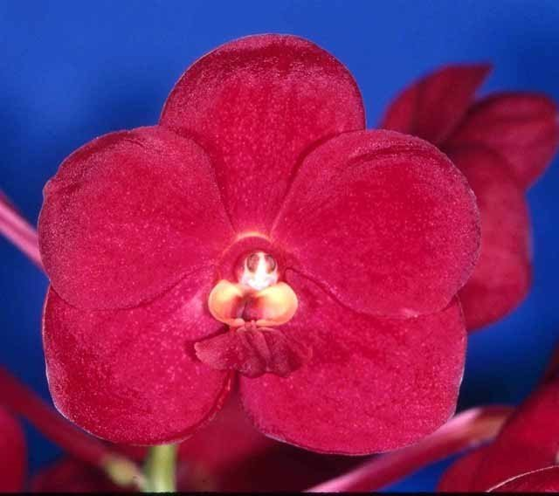
Fifteen round, full flowers on one upright inflorescence; flowers candy apple red, faintly tessellated; lip red, side lobes pale yellow, red medially; column white, anther cap mahogany; substance firm; texture crystalline.

Vanda lamellata CCM/AOS 81 Points
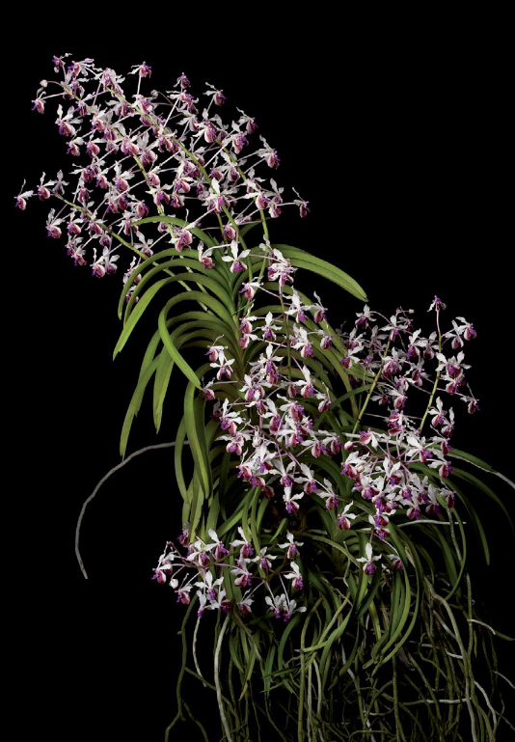
One hundred forty two flowers on eight inflorescences on a 160 cm by 30 cm plant grown in a basket on sphagnum; flowers reflexed; sepals and petals white, spotted oxblood basally; lip magenta, ridged crest chestnut; substance firm; texture crystalline.

