Dendrobium affine HCC/AOS 77 Points
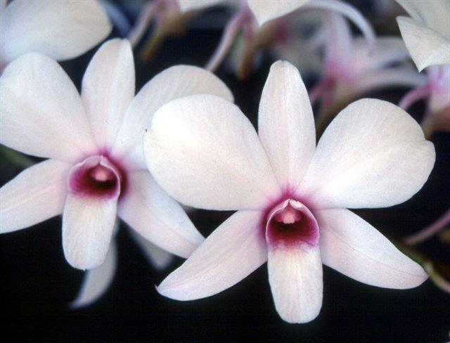
Fourteen flowers and two buds on two arching inflorescences; sepals and petals white, suffused red-violet basally; lip white, throat red-violet; column white, suffused red-violet; substance firm; texture matte.

Dendrobium Theodore Takiguchi CCM/AOS 83 Points
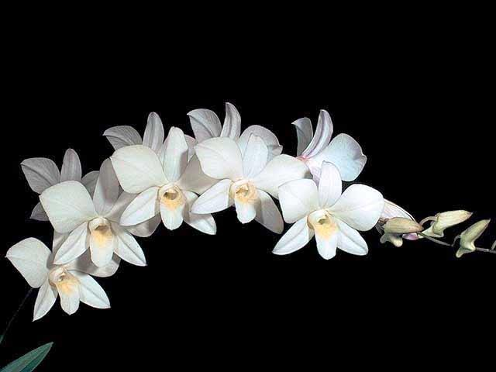
One hundred seventeen flowers and forty three buds on twelve inflorescences averaging55 cm long on a 80 cm by 90 cm plant grown on a treefern slab; sepals and petals white, suffused and veined fuchsia; lip white, midlobe base and throat margin pale yellow; substance firm; texture matte.

Dendrobium bigibbum AM/AOS 85 Points
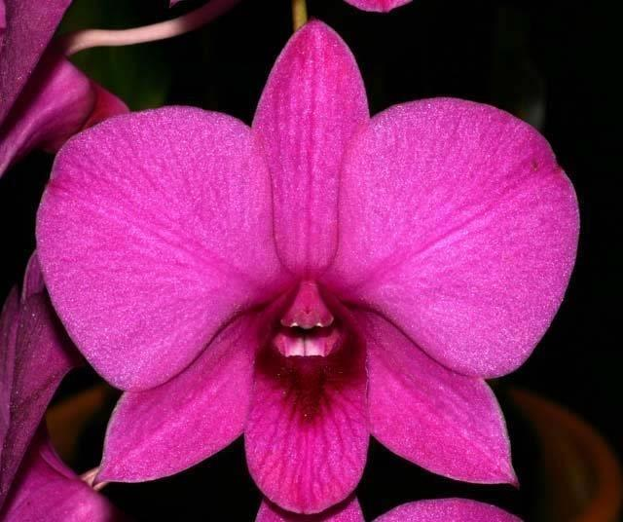
Thirty one flowers and five buds on four upright inflorescences; sepals and petals lavender-rose; lip lavender-rose, slightly veined, throat darker lavender-rose; column white; substance firm;texture crystalline.

Dendrobium Enobi Purple HCC/AOS 77 Points
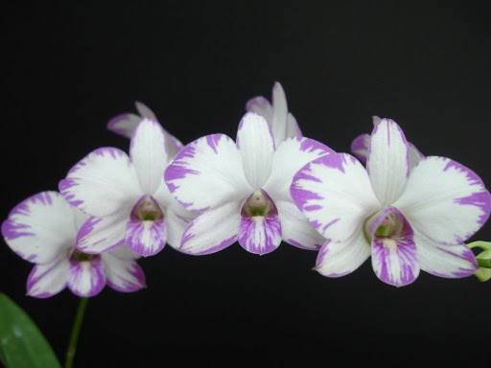
Fifteen flowers and four buds on three arching inflorescences; sepals and petals white, margins feathered lavender; lip white, midlobe and throat feathered lavender; substance firm; texture diamond dust.

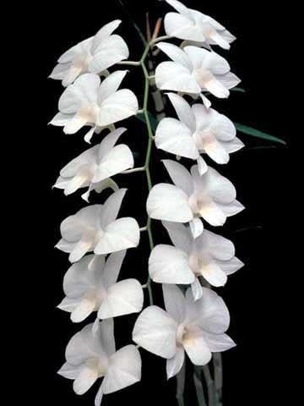
Dendrobium Anna Bibus AM/AOS 81 Points
Seventeen flowers and three buds uniformly shingled on two arched inflorescences; sepals and petals pure white, lip white, throat blushed pale yellow; substance medium firm; texture crystalline.

