Dendrobium Sw. 1799
SUBFAMILY Epidendroideae, TRIBE Dendrobieae, SUBTRIBE Dendrobiinie.
ETYMOLOGY: From the Greek dendron, tree and bios, life referring to the epiphytic habit of most Dendrobium species.³

SYNONYMS: Aclinia Griff. 1851; Amblyanthe Raushert 1983; `Amblyanthus (Schltr.) Brieger 1981; Anisopetala (Kraenzl.) M.A.Clem. 2003; `Aporopsis (Schltr.) M.A.Clem. & D.L.Jones 2002; Aporum Bl. 1825; `Australorchis Brieger 1981; Bolbidium [Lindley] Breiger 1981; `Bouletia M.A.Clem. & D.L.Jones 2002; Callista Lour. 1790; `Cannaeorchis M.A.Clem. & D.L.Jones 1997 publ. 1998; `Cepobaculum M.A.Clem. & D.L.Jones 2002; `Ceraia Lour 1790; `Ceratobium (Lindl.) M.A.Clem. & D.L.Jones 2002; ~Chromatotriccum M.A.Clem. & D.L.Jones 2002; `Coelandria Fitzg. 1882; Conostalix [Kraenzl.] Breiger 1981; `Dendrobates M.A.Clem. & D.L.Jones 2002; `Dendrocoryne [Lindley]Breiger 1981; `Dichopus Bl. 1856; Distichorchis M.A.Clem. & D.L.Jones 2002; `Ditulima Raf. 1836[1838]; Durabaculum M.A.Clem. & D.L.Jones 2002; `Eleutheroglossum (Schltr.) M.A.Clem. & D.L.Jones 2002; `Endeisa Raf. 1837; `Euphlebium Breiger 1981; Eurycaulis M.A.Clem. & D.L.Jones 2002; Exochanthus M.A.Clem. & D.L.Jones 2002; `Froscula Raf. 1838; `Gersinia Néraud 1826; `Goldschmidtia Dammer 1910; Grastidium Bl. 1825; Herpetophyllum [Schltr.] Breiger 1981; `Kinetochilus [Schltr.] Breiger 1981; `Latourea Bl. 1849; `Latouria 1848; `Latourorchis Brieger 1981; `Leioanthum M.A.Clem. & D.L.Jones 2002; `Maccraithea M.A.Clem. & D.L.Jones 2002; Macrostomium Bl. 1825; `Microphytanthe (Schltr.) Brieger 1981; Monanthos [Schltr] Breiger 1981; Onychium Bl. 1825; `Ormostema Raf. 1836[1838]; `Orthoglottis Breda 1830; Oxyglossellum M.A.Clem. & D.L.Jones 2002; Oxystophyllum Bl. 1825; Pedilonum Bl. 1825; `Pierardia Raf. 1836 [1838]; Phyllorchis Thou. 1822; Sayeria Krzl. 1894; `Schismoceras Presley 1827; Stachyobium Rchb.f 1869; `Tetrabaculum M.A.Clem. & D.L.Jones 2002; Thelychiton Endl. 1833; `Thicuania Raf. 1836 [1838]; `Trachyrhizum (Schltr.) Brieger 1981; Tropilis Raf. 1836 [1837]; Vappodes M.A.Clem. & D.L.Jones 2002; `Winika M A Clem, Dl Jones & Molloy 1997; ¹

TYPE SPECIES: Dendrobium moniliforme (L) Sw., 1799

DESCRIPTION: Epiphytic, lithophytic, or rarely terrestrial herbs, sympodial but individual shoots sometimes with indeterminate apical growth (D. sections Grastidium, Hetpethophytum, and others). Roots terete, glabrous or papillose-warty. Stems cane-like or having pseudobulbs, glabrous to hirsute. Cane-like stems fleshy or not, branch-ing or not, long-lived, entirely or partially covered by leaf sheaths if present. Pseudobulbs consisting of one to many internodes, one- to many-leaved. Leaves conduplicate, usually articulate, with or without a tubular leaf sheath, distichous (rarely quaquaversal in D. section Grastidium), dorsiventrally flattened, bilaterally flattened or terete, margins entire. Inflorescence lateral or terminal, usually arising from a mature shoot, one-flowered or racemose, rarely paniculate, sometimes fasciculate. Flowers resupinate or not, ephemeral to long-lasting, distichous, secund or helically arranged, sometimes fragrant. Sepals entire, free or variously connate, lateral sepals similar or dissimilar to the dorsal sepal and usually forming a mentum together with column foot, mentum sometimes slender and spur-like. Petals entire, free, similar to the dorsal sepal or strongly dissimilar. Labellum adnate to sides of column foot, or only attached to apex of column foot and then rigidly attached (will break off when bent downwards), flexibly attached (can be bent downwards without breaking off), or rarely hinged and highly mobile, entire or lobed, with or with-out keels and/or callosities, not spurred but often forming a spur-like structure with column foot. Column usually straight, without lateral wings, rarely with apical stelidia; column foot well-developed, often with a cavity or a shallowly concave area at apex; anther helmet-shaped, two-locular, glabrous or papillose-hairy, pollinia 4, oblong, triangular in cross-section, hard-waxy, strongly cohering in two subequal pairs, without caudicles, usually yellow, sometimes brown, purplish or grey; stigma a ventral concavity on the column, sometimes raised and callus-like;
rostellum simple or sometimes bibbed, usually swollen and forming a reservoir containing a sticky, often white and opaque, sometimes hyaline or purple liquid, which rapidly dries out to a soft, putty-like substance; viscidium usually absent but, when present, shapeless and formed instead of (or in addition to) rostellar liquid on the underside of the rostellum ['diffuse viscidium' as used by Rasmussen (1982) and Freudenstein and Rasmussen (1999)], often with a downwardly projecting, rigid, truncate or emarginate lamella between rostellum and stigma (the 'scrape?). Ovary and pedicel terete or winged, sometimes papillose or hairy. Capsule ellipsoid, oblong, obovoid to subglobose, unilocular, sometimes winged or triangular in cross-section, usually opening along three longitudinal slits, sometimes with a single opening near the apex, without endocarpic elaters. ³

ECOLOGY: Dendrobium species are predominantly epiphytes, less often lithophytes, and are rarely exclusively terrestrial. Throughout their large area of occurrence they may be encountered wherever epiphytic orchids occur. The greatest concentration of species is found in primary forests between 800 and 1500 m above sea level, with few species occurring above 2200 m anywhere, except in New Guinea. On Mount Kinabalu in Sabah, North Borneo, only six out of 70 locally occurring species of Dendrobium are found above 1800 m with none above 2400 m (Wood et al. 2011). In the Himalayas, D. fimbriatum Hook. has been reported from as high as 3660 m (Pearce and Cribb 2002), but this is exceptional, as only a handful of Dendrobium species occur there above2500 tn. In New Guinea, around 30 species of Dendrobium occur at or above 3000 m (Schuiteman, unpublished). At lower elevations, species are common in rain forest, for example in New Guinea, whereas in tropical areas with a strongly seasonal cli-mate relatively few Dendrobium species occur in the lowlands and then usually in localities with a more humid microclimate, such as river valleys, gorges, and hill tops. In general, Dendrobium species are not found in deep shade. Even in the relatively dry, semi-deciduous forests of continental Asia, most species occur high up in the trees in relatively exposed positions. They mainly grow on the larger branches and the upper part of tree trunks. However, in areas with a pronounced dry climate combined with low humidity, as in much of Australia, they are more often found in shaded locations. Specialized twig epiphytes are uncommon in the genus and are almost limited to species of D. section Stacobium in continental Asia and of D sects. Calyptrochilus (e.g. D. masarangense Scharr.) and Cadetia ir. New Guinea and neighbouring areas. The latter may even °CCU] as epiphytes on other orchids. Open grassy forests and woodlands support few species with frequent fires limiting populations. Some lithophytic species (e.g. D. *eciosum Sm.) in fire-prone, drier areas of eastern. Australia have adapted to fire with the capacity to regrow from basal shoots after being burned to ground level. Epiphytes tenc to be more fire-sensitive, with populations re-establishing from surviving pockets of vegetation. Few Dendrobium species are subjected to frost. The feu exceptions are found at the fringe of the distribution, for exam. ple D. falcorostrum Fitzg. in Nothofagus Blume forests of easterr Australia, D. cunninghamii Lindl. in New Zealand, and D. monili forme (L.) Sw. in Japan. In D. sects. Dendrocogne and Rhkobium D. Jpeciosum, D. kingianum Bidwill ex Lindl., and D. striolatun Rchb.f. are sometimes exposed to cold harsh winters and sum. mer temperatures of over 40 °C, close to the lethal limit in hoi summers. In the mountains of New Guinea, a few species of Dendrobium regularly experience brief spells of frost, such as D dekockii J.J.Sm. and D. brevicaule Rolfe. The latter occurs up tc 4000 m above sea level and holds the elevational record in tht genus. Among the more exceptional habitats where species may ocar are: mangrove forests (to which in New Guinea the inconspicuous D. viridifiorum F.M.Bailey is almost restricted); roadside tree: in big cities (D. crumenatum Sw. in Singapore and Palembang) subalpine shrubland between 3000 and 4000 m above sea leve (D. brevicaule in New Guinea); boggy areas with sphagnum mos: (D. lobbii Teijsm. & Binn.); coconut palms along the coast (D bifalce Lindl. in New Guinea); ultrabasic, rocky soil among shrub: (D. verrudjerum Rchb.f. in New Caledonia); bare, vertical sides of large boulders (D. venustum Teijsm. & Binn. in Laos and D sect Dendrocogne species in Australia); and tree-fern trunks in mon tane grassland (D. cuthbertsonii in New Guinea).³

DISTRIBUTION: The genus of about 1450 species ranges from Sri Lanka throughout tropical Asia and the Pacific region, north to Japan, east to Tahiti, and south to New Zealand. ³

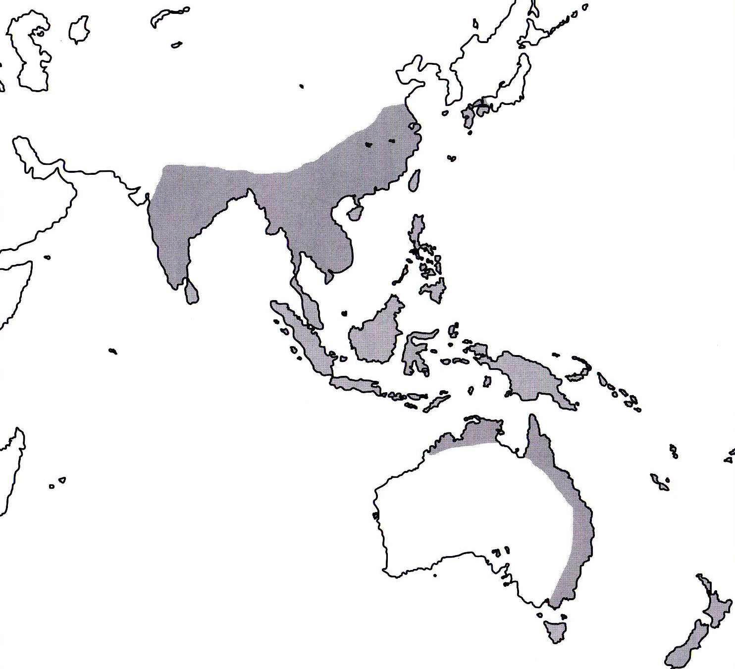
References
¹ Jay Pfahl's IOSPE at www.orchidspecies.com
²Aldridge, Peggy. 2008. An Illustrated Dictionary of Orchid Genera. Selby Botanical Garden Press.
³Cribb, CJ. 2014. Epidendroidae. In: Pridgeon AM, Cribb PJ, Chase MW, Rasmussen F, eds. Genera Orchidacearum, Vol. 6. Oxford: Oxford University Press, 344-349.

⁴la Croix, Isobyl. 2008. The New Encyclopedia of Orchids. Timber Press
⁵Lavarack, Bill et. al. 2006. Dendrobium and its Relatives. Timber Press

