Dendrobium Section Phalaenanthe Species

SPECIES PROGENY AWARDS AWARD TYPE RANGE TEMP/LHT BLOOM TIME
F-1/Total AOS Peak
bigibbum | 633/7906 | 45 | 17 AM, 12 CCM, 16 HCC, 2 JC | Australia | Warm/Hi | October
affine | 77/772 | 4 | 1 AM, 1 CBM, 1 CHM, 1 HCC | Australia, New Guinea | Warm/Hi | November

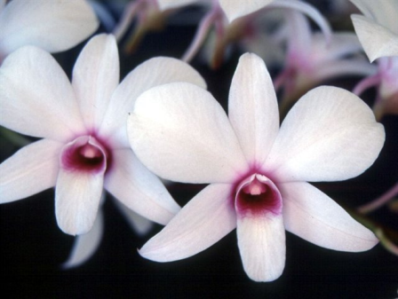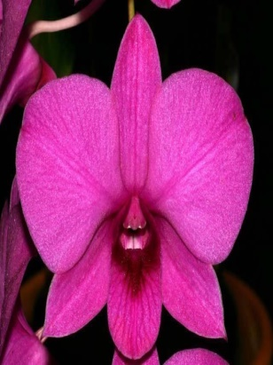
Dendrobium affine Dendrobium bigibbum

