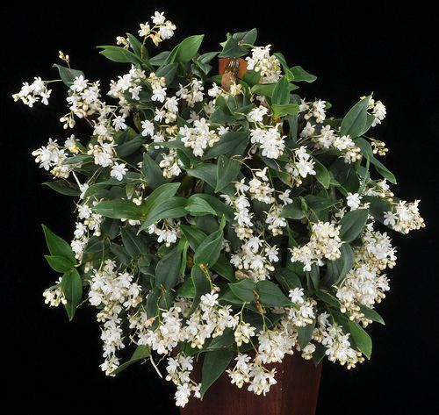
Dendrobium aberrans CCM/AOS 81 Points
Three hundred nineteen flowers and four hundred buds on ninety-eight inflorescences on a well grown 40 cm diameter plant mounted on tree fern; sepals and petals white, blushed pink on reverse; lip white; column white, blushed pink; substance firm; texture matte.

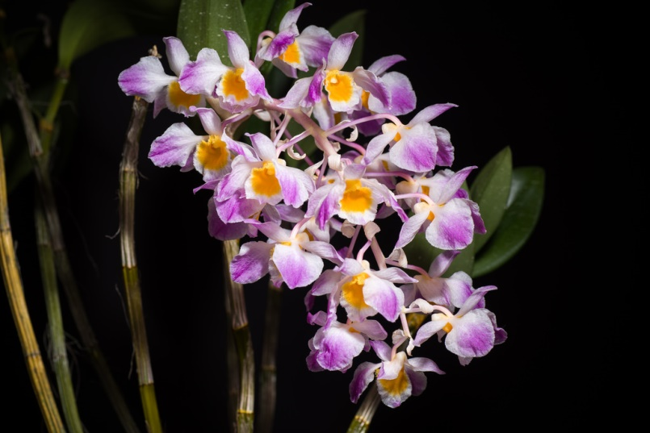
Dendrobium amabile HCC/AOS 77 Points
Twenty three flowers on one pendent inflorescence; sepals and petals white, blushed magenta apically; lip flat, white, throat deep golden yellow; substance soft; texture crystalline.

Dendrobium Fire Wings AM/AOS 85 Points
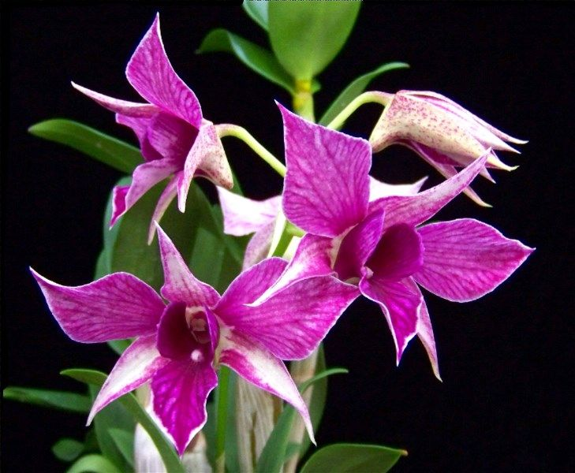
Seven well formed flowers and five buds on two erect inflorescences; flowers white, heavily overlaid and veined dark magenta; column white; substance firm; texture matte.

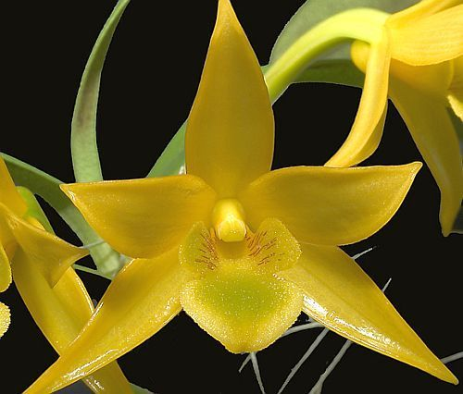
Dendrobium trigonopsis HCC/AOS 77 Points
Seven well formed stellate flowers and two buds on two inflorescences; sepals and petals rich lemon yellow; lip midlobe yellow, olive green centrally, side-lobes yellow, stippled oxblood; substance heavy; texture waxy, lip matte.

Dendrobium Lorrie Mortimer AM/AOS 81 Points
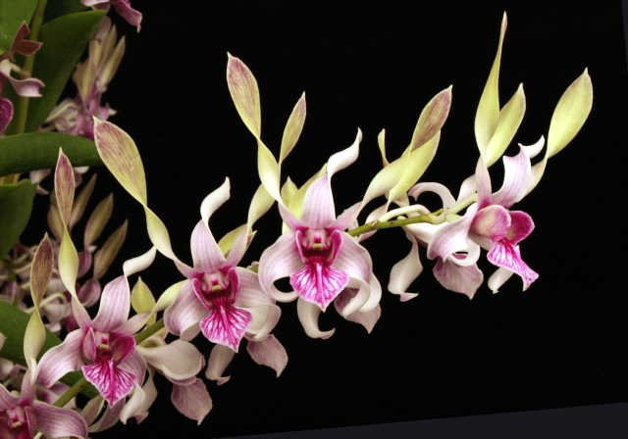
Seventy-three evenly spaced flowers and twenty-three buds on fifteen inflorescences; sepals white, veined magenta; petals white, suffused yellow green distal two-thirds; lip white, veined magenta, throat solid magenta; substance firm; texture matte.

