Section Phalaenanthe
Looking through recent awards (last 10 years), some trends emerge. Non-traditional Phalaenanthe colors seem to be popular, the darker the better. A good example is Den Jaquelyn Thomas ‘Orquivalle” - D. bigibbum x D. gouldii.
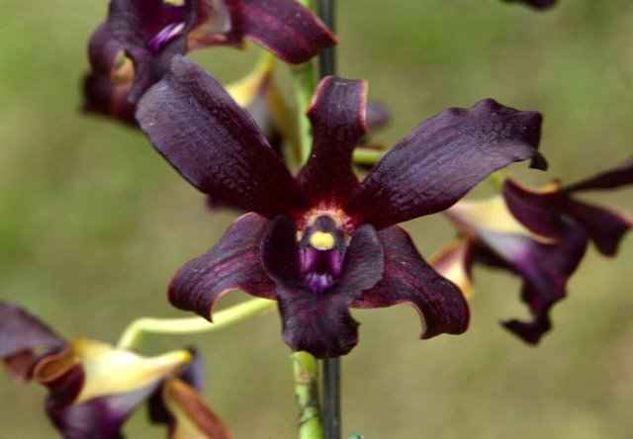
Stripes and peloric forms also seem to be trending.
Section Latouria
Quite a few Latouria hybrids have been awarded in recent years, particularly hybrids of D. spectabile, D. atroviolaceum and D. abberans. The D. spectabile awardees seem to revel in the curly exotic flowers. It looks like they will remain popular for years to come. The trend with D. atroviolaceum seems to reward flatter flowers with colorful lips. The D. abberans awardees grow lots of flowers on relatively compact plants.
Dendrobium Mini Snowflake - D. abberans x D. johnsoniae
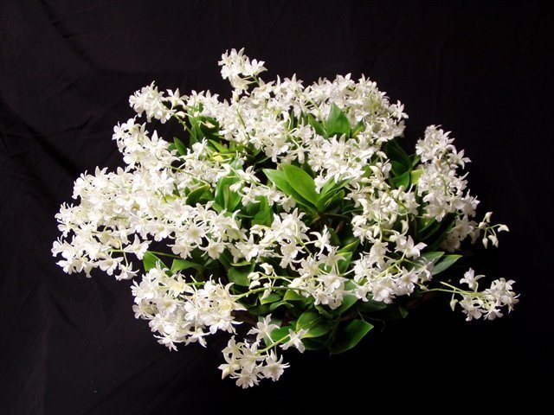
Section Spatulata
The wonderful curls and twists of the Antelope Dendrobiums are still as popular as ever. Breeding trends favor smaller plants with golden flowers or pale pastel colors.
Den Gloucester Sands – D. discolor x D. canaliculatum
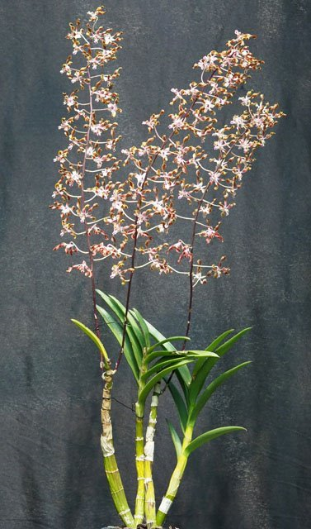

Sections Dendrocoyne and Rhizobium
The Australian Dendrobiums have exhibited a tremendous rise in popularity in the last decade and have experienced a corresponding increase in AOS awards. The flower size of awardees is increasing and more D. tetragonum hybrids are appearing. Since 2015, 529 progeny in 5 generations have been registered and they have been awarded 59 times.
I was not able to discern any particular trends in the remaining Sections, it just seems more of the same.

