Phalaenanthe Color Breeding Lines
Phalaenanthe color breeding has for years been dominated by the colors found in Dendrobium bigibbum, ranging from violet through purple, magenta and lilac to mauve and white. Line breeding has expanded and improved these colors as well as improving flower form. Adding other colors to the palate has been the goal of breeders. This involves hybridizing Phalaenanthe species with species of other Dendrobium Sections. So far, breeders have been successful in adding many shades of yellow and, to a limited degree, red-purples.
The Phalaenanthe species Dendrobium affine has produced a number of yellows with species of several Dendrobium Sections. D. affine x D. speciosum (Section Dendrocoryne) produced Den Aussie Virgin 2003, a beautiful stellate light yellow.
Den Aussie Virgin D. speciosum
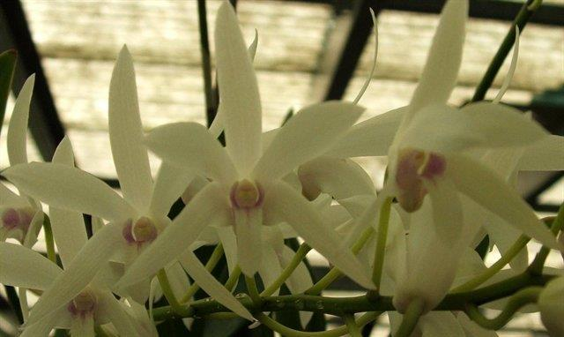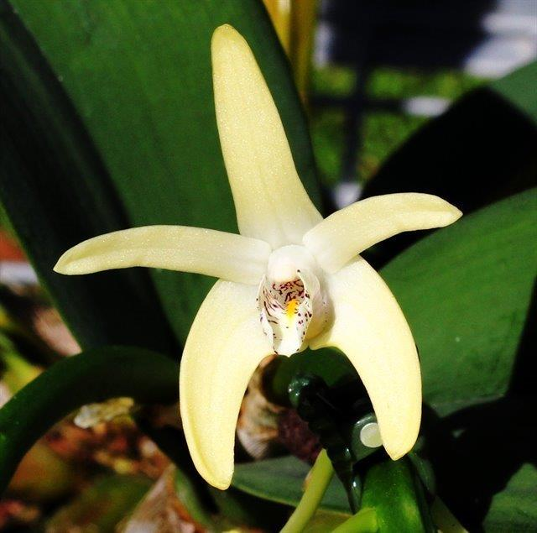

Another D. affine cross, this time with D. discolor(Section Spatulata) called Den Chieno, produces a flower with a light cream-yellow base color overlaid rose.
Den Chieno D. discolor
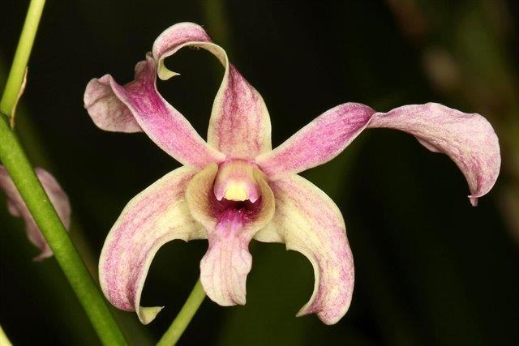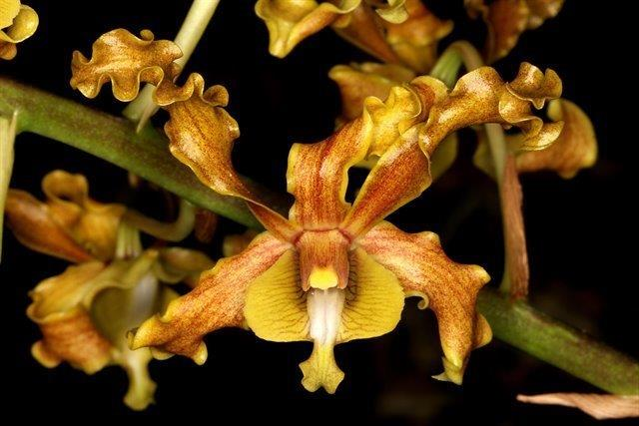
Crosses with bright yellow species do not always result in yellow offspring. Case in point is a D. affine cross with D. agrostophyllum (Section Trachyrhizum), a bright yellow species. The resultant cross, Den Bill Lonne, looks much like its Phalaenanthe parent.
Den Bill Lonne D. agrostophyllum D. affine
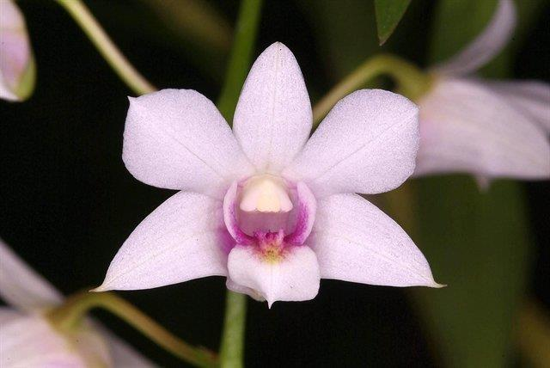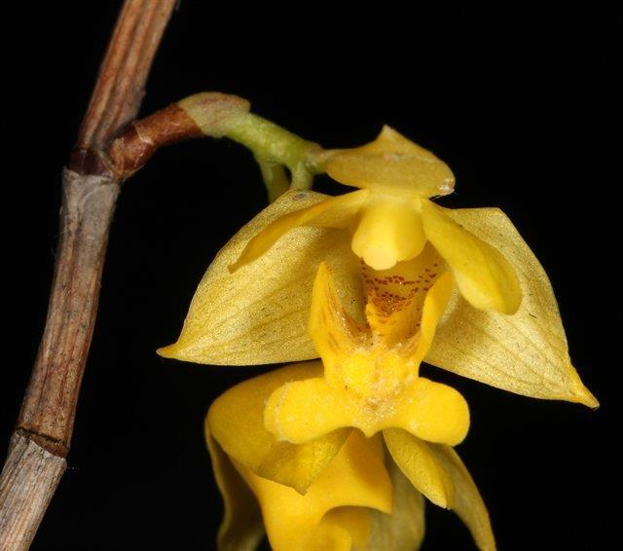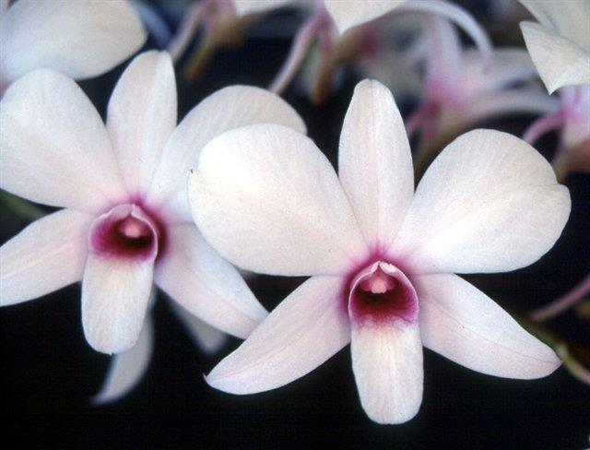

The final D. affine cross is with Den Pearly Snow which hosts two Section Spatulata species, D. canaliculatum ( 45%) and D. lineale (25%) resulted in a light yellow hybrid called Den Siew May.
Den Siew May D. canaliculatum D. lineale
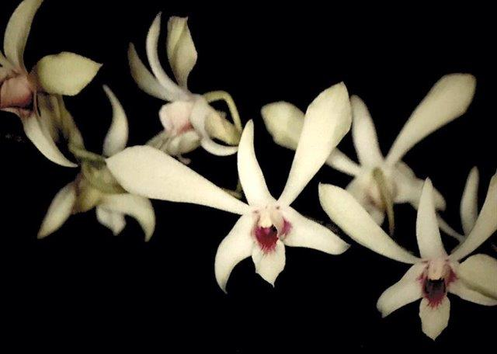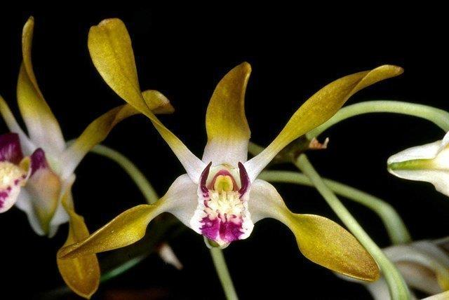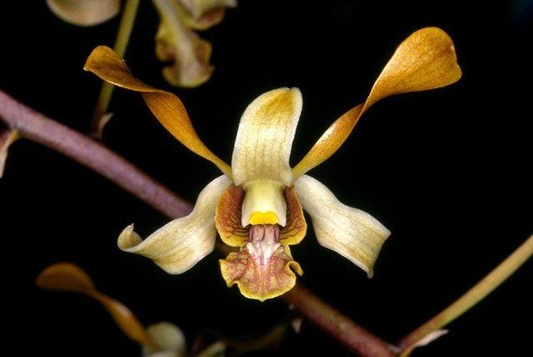
Yellow hybrids of D. bigibbum have been successfully made with various yellow Dendrobium species. Den Pixie Princess is a beautiful yellow flower with a rich purple lip. It is a complex hybrid comprising a least six Dendrobium species. Two of the yellow species are four generations back in the lineage.
Den Pixie Princess D. canaliculatum D tokai
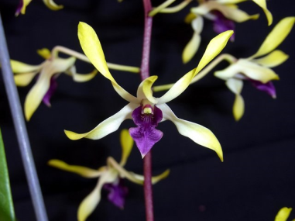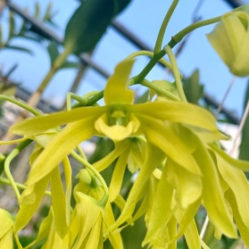
Very few D. bigibbum F-1 hybrids produce yellows, but there are quite a few yellow offspring with various yellow species four to five generations back. Some yellow species not mentioned so far are:
D. schulleri D. gouldii
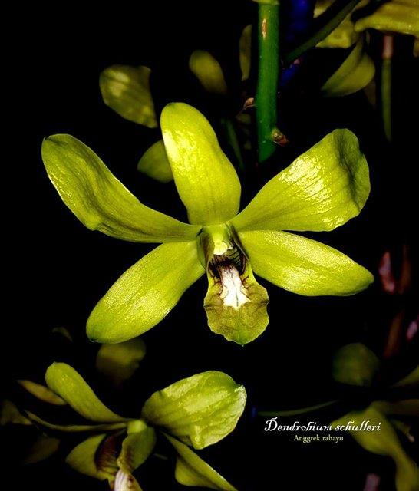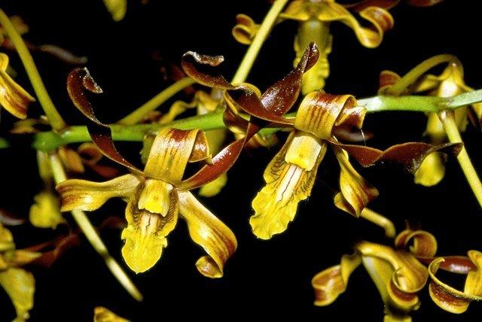

Phalaenanthe hybrids in the reddish range have been more elusive. A good attempt, which is very reddish and has great form, is Den Hepa, a D. bigibbum cross with about an eighth D gouldii three generations back.
Dendrobium Hepa
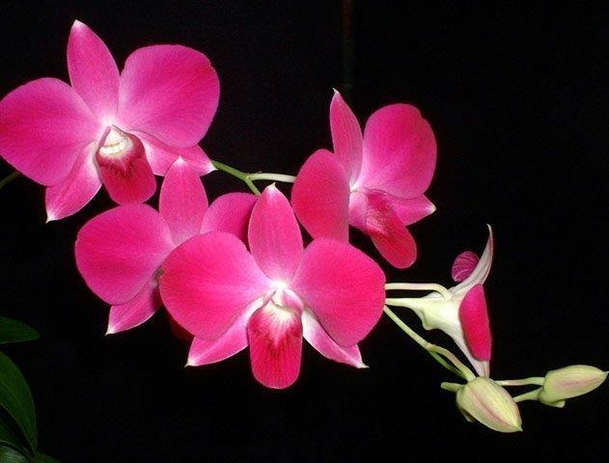
Another D. bigibbum reddish hybrid is Den Peewee. It is crossed with a Section Dendrocoryne species D. tetragonum and takes on the form of that parent.
Dendrobium Peewee
