Dendrobium discolor Lindley 1841
SECTION Spatulata
Common Name: Golden Antler Orchid
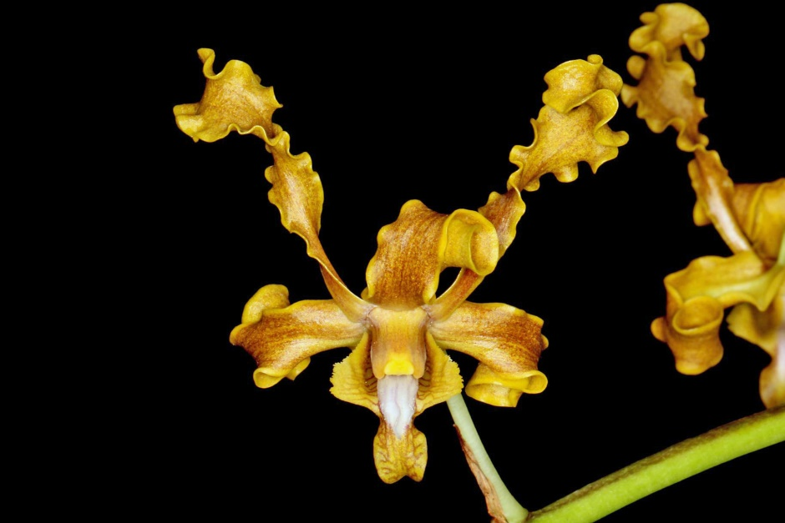
Synonyms
Callista undulatum [R. Br.] Kuntze 1891; Dendrobium arachnanthe Kraenzl. 1910; Dendrobium broomfeildii [Fitz.]Fitzgerald 1888; Dendrobium discolor f. broomfieldii (Fitzg.) Dockrill 1964; Dendrobium discolor subsp. incurvata Liddle & P.I.Forst. 1990; Dendrobium discolor var. broomfieldii (Fitzg.) M.A.Clem. & D.L.Jones 1989; Dendrobium discolor var. fimbrilabium (Rchb.f.) Dockrill 1964; Dendrobium discolor var. fuscum (Fitzg.) Dockrill 1964; Dendrobium elobatum Rupp 1953; Dendrobium fuscum Fitzg. 1879; Dendrobium undulans Bakh.f. 1963; Dendrobium undulatum R. Brown 1810; Dendrobium undulatum var. albertisianum F.Muell. 1875; Dendrobium undulatum R. Br. var broomfeildii Fitz. 1888; Dendrobium undulatum R. Br. var carterae 1911; Dendrobium undulatum var. fimbrilabium Rchb.f. 1878; Durabaculum albertisiana (F.Muell.) M.A.Clem. & D.L.Jones 2002; Durabaculum arachnanthe (Kraenzl.) M.A.Clem. & D.L.Jones 2002; Durabaculum fimbrilabium (Rchb.f.) M.A.Clem. & D.L.Jones 2002; Durabaculum fuscum (Fitzg.) M.A.Clem. & D.L.Jones 2002; Durabaculum undulatum M.A.Clem. & D.L.Jones 2002; Durabaculum undulatum var broomfieldii M.A.Clem. & D.L.Jones 2002 ³
Description/Range
The largest of the Australian Dendrobium, it has 3 varieties with 1 being extremely variable in size and color, with few to numerous, cylindrical stems that are leafy in the upper two thirds and carries distichous, ovate to elliptic, leathery, obtuse leaves that can bloom at any time of the year, with the maximum occuring in the spring on an axillary, arched, to 2' [to 60 cm] long, densely 10 to 80, fragrant flowered raceme arising from the upper portion of an old cane as the new growth arises, which is found in Queensland Australia and New Guinea and

grows warm to hot as an epiphyte, as well as a lithophyte, directly on the coast in mangroves or behind dunes, where they can have salt spray as well as on cliffs and rock faces up to an altitude of 550 meters. ³
Northeastern Australia and New Guinea. The habitat extends from near Rockhampton to the tip of the Cape York Peninsula and includes the islands of the Torres Striates and the lowlands of southern New Guinea, particularly the region near Merauke, Irian Jaya. Plants grow on trees and rocks in exposed situations. They often grow on trees in coastal swamps where they tolerate salt spray, but plants are also found on cliffs and rock faces from sea level to 1800 ft. (0-550 m). In the western part of the habitat, conditions are hot and dry. -- Source: Charles Baker⁴
F-1 Hybrids and Progeny
Dendrobium discolor has 157 F-1 hybrids registered since 1932. It has receive12 AOS awards, evenly split between cultural and quality. D. discolor and its progeny have been used extensively with 3,710 progeny in 11 generations. Kaede has 26 Australian awards and Pixie Princess has 16, 7 of which are AOS.

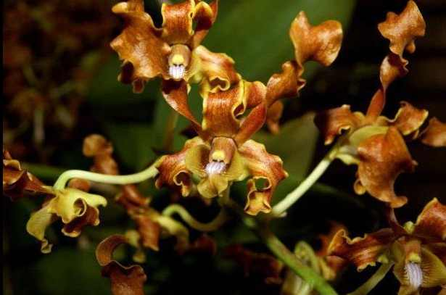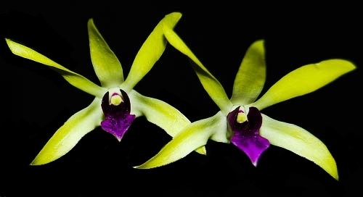
Dendrobium Kaede Dendrobium Pixie Princess AM/AOS
D. helix x D. discolor Sixth Generation D. discolor Hybrid
Awards
AM | HCC | CCM | CCE | Total
4 | 2 | 5 | 1

Culture

Light:
Dendrobium discolor do best in full sunshine (25000-50000 lux), close to the glass where glasshouse treatment is required. In addition to the natural light, you will have to use artificial light lamps.

Temperature:
The average temperature of the summer day is 25-26 ° C, night 21 ° C, giving a daily difference of 4-6 ° C. In winter, the average day temperature is 27-30 ° C, night 16-17 ° C, giving a daily difference of 13 ° C.

Humidity:
The Antler Orchid need the humidity of 80-90% throughout the growing period (i.e. from the time the first shoots of Spring show themselves until the last pseudobulb in Summer has grown to its maximum). In winter, the humidity drops to 65%.
Too dry air has a negative effect on the development of the plant: its growth is inhibited, and the leaves begin to turn yellow and dry out. The higher temperature, the higher the humidity should be, and the higher the humidity, the more often and longer it is necessary to ventilate the room where the plants are contained, otherwise the probability of rotting and various kinds of fungal diseases.

Substrate, growing media and repotting:
Dendrobium discolor grows best in pots with staghorn peat as substrate (crocks and charcoal at the bottom ot the pot). After potting, keep the plant in a cool, shady place for a few days before placing it in its growing position. Do not overpot. Use the smallest pot that will accommodate your plant.
It does not need frequent repot, therefore, it is desirable to transplant only when it is really necessary, for example, in cases of strong salinization or compaction of the substrate, at its critically high or low pH (the norm is from 5.5 to 6.5) or when the plant grows very strongly and the pot becomes cramped to it (pseudobulbs begin to hang from the edges of the pot). Repotting is best done immediately after flowering when new roots and new growth begin to grow.

Watering:
Water must be literally poured on throughout the summer season right up to the time when the season's growths have reached full development; with the coming of autumn the quantity of water should be appreciably diminished, but this plant should not be allowed to dry out, and even in midwinter watering should be continued by giving the compost a good soaking once a fortnight-choosing a bright, clear morning for the purpose.
Watering is directly dependent on the temperature of the content, the higher it is, the more often it needs to be watered. When watering, excess water should flow freely from the pot, since stagnation of water both inside the pot and in its pan can very quickly lead to rotting of the roots and the lower part of the plant.

Fertilizer:
It is recommended to use a 1/4-1/2 dose of orchid fertilizer weekly. You can use the balanced fertilizer throughout the year or from spring to mid-summer use high-nitrogen fertilizer, and then until the end of autumn high-phosphoric fertilizer to stimulate flowering.

Rest period:
Dendrobium discolor need less water in the winter, especially if they grow under the conditions of a dark, short day that occurs at moderate latitudes. They should dry somewhat between waterings, but they should not be dry for a longer period. Frequent morning fogging and rare, economical watering should allow the plant to go through a dry period of rest, while providing it with sufficient humidity. Fertilization should be reduced or eliminated until new growths appear and a more abundant spring watering begins.²

References
Aldridge, Peggy. 2008. An Illustrated Dictionary of Orchid Genera. Selby Botanical Garden Press.
¹la Croix, Isobyl. 2008. The New Encyclopedia of Orchids. Timber Press
Cribb, CJ. Genera Orchidacearum, Vol. 6. Oxford: Oxford University Press.2014. Epidendroidae. In: Pridgeon AM, Cribb PJ, Chase MW, Rasmussen F, eds.

Lavarak, Bill; Harris, Wayne; Stocker, Geoff. 2000. Dendrobium and its Relatives,
Timber Press.

Schelpe, Sybella; Stewart, J. 1990. Dendrobiums: An Introduction to the Species
in Cultivation. Orchid Sundries Ltd.

³ Jay Pfahl's IOSPE at www.orchidspecies.com
⁴OrchidWiz.Database X7.0
http://apps.kew.org/wcsp/qsearch.do
https://secure.aos.org/aqplus/SearchAwards.aspx
²https://travaldo.blogspot.com

