Dendrobium johannis Rchb.f 1865
SECTION Spatulata
Common Name: Johan’s Dendrobium
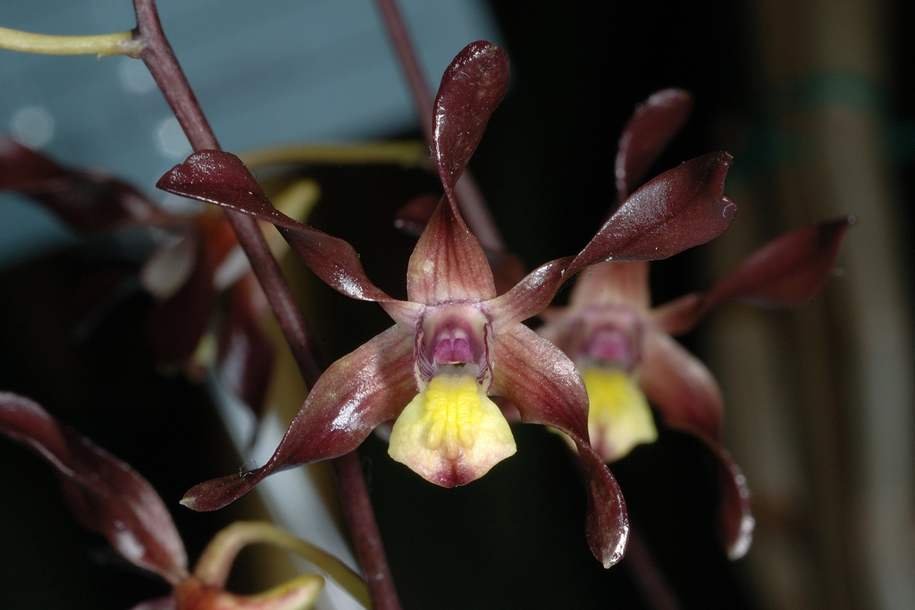
Synonyms
Callista johannis (Rchb. f.) Kuntze 1891; Cepobaculum johannis (Rchb.f.) M.A.Clem. & D.L.Jones 2002; Dendrobium undulatum R. Br. var johannis[Rchb.f]F.M.Bailey 1883 ³
Description/Range
This small to large sized, hot to warm growing epiphytic species that comes from northeastern Australia and Papua and New Guinea in and around rainforests and swamps with scarce winter rain and high light has densely clustered, brown, unevenly swollen pseudobulbs carrying 3 to 8, on the apical one quarter, lanceolate, dark green, tough, thick leaves that are sharply pointed apically. The bloom season is mainly from spring through fall and winter occuring on a 6 to 20" [15 to 50 cm] long, axillary, several to many [2 to 20] flowered, racemose inflorescence with waxy, glossy, fragrant [not so nice], longlasting flowers that arise from the nodes at the apex of leafy and leafless canes. ³

Northeastern Australia and New Guinea. Distribution extends northward from near Coen on the eastern Cape York Peninsula to the Torres Strait Islands and across to Papua New Guinea. Plants grow along the edges of rainforests, in swampy areas where winter rainfall is low, and in moderately open forests where light is high. -- Source: Charles Baker⁴
Dendrobium johannis is native to Australia and New Guinea. It grows in open forest, swampy areas and monsoonal thickets at altitudes of between 50 and 600 meters above sea level. Johan's Dendrobium is a small to large sized, hot to warm growing epiphytic species with densely clustered, brown, unevenly swollen, 10-30 cm long, 1-1.5 cm wide pseudobulbs carrying 3 to 8, on the apical one quarter, lanceolate, dark green, tough, thick, 10-20 cm long and 1.2-1.5 cm wide leaves that are sharply pointed apically.
The Chocolate Tea Tree Orchid blooms mainly from spring through fall and winter on a 15 to 50 cm long, axillary, 2 to 20 flowered, racemose inflorescence with waxy, glossy, fragrant, longlasting flowers that arise from the nodes at the apex of leafy and leafless canes. The sepals and petals are brown, and occasionally the apex of these is yellow. The labellum is yellow, the side lobes being purple striped.²
Awards
CHM | HCC | Total
1 | 1 | 2

F-1 Hybrids and Progeny
Dendrobium johannis has 70 F-1 hybrids registered since 1950 and a total progeny of 169 in 5 generations. The most awarded of the F-1 generation is Den Touch of Gold, a 1996 primary with D. gouldii. It produced 2 offspring and has quite a few awards including 2 AM and 9 HCC. The F-1 most used in breeding is Den Minnie, a primary with D. carronii.
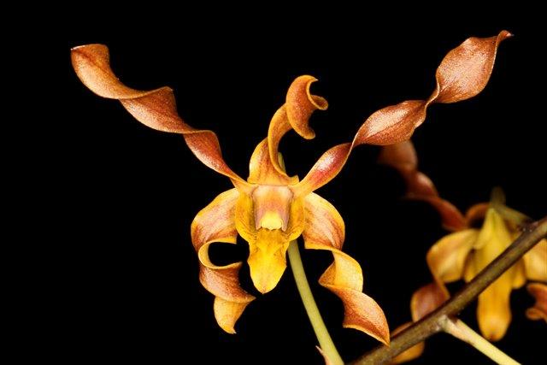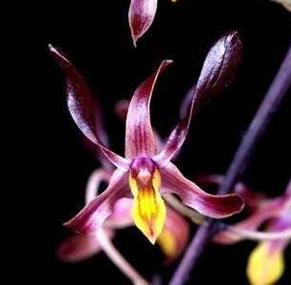
DendrobiumTouch of Gold AM/AOS Dendrobium Minnie AM/AOS

One of the progeny, a third generation hybrid called Den Jairak Fire Horn, has been awarded 3 AM by the AOS.
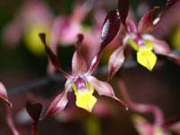
Dendrobium Jairak Fire Horn

Culture

Light:
Dendrobium johannis do best in full sunshine (25000-50000 lux), close to the glass where glasshouse treatment is required. In addition to the natural light, you will have to use artificial light lamps.

Temperature:
The average temperature of the summer day is 25-26 ° C, night 21 ° C, giving a daily difference of 4-6 ° C. In winter, the average day temperature is 27-30 ° C, night 16-17 ° C, giving a daily difference of 13 ° C.

Humidity:
Johan's Dendrobium need the humidity of 80-90% throughout the growing period (i.e. from the time the first shoots of Spring show themselves until the last pseudobulb in Summer has grown to its maximum). In winter, the humidity drops to 65%.
Too dry air has a negative effect on the development of the plant: its growth is inhibited, and the leaves begin to turn yellow and dry out. The higher temperature, the higher the humidity should be, and the higher the humidity, the more often and longer it is necessary to ventilate the room where the plants are contained, otherwise the probability of rotting and various kinds of fungal diseases.

Substrate, growing media and repotting:
Dendrobium johannis grows best in pots with staghorn peat as substrate (crocks and charcoal at the bottom ot the pot). After potting, keep the plant in a cool, shady place for a few days before placing it in its growing position. Do not overpot. Use the smallest pot that will accommodate your plant.
It does not need frequent repot, therefore, it is desirable to transplant only when it is really necessary, for example, in cases of strong salinization or compaction of the substrate, at its critically high or low pH (the norm is from 5.5 to 6.5) or when the plant grows very strongly and the pot becomes cramped to it (pseudobulbs begin to hang from the edges of the pot). Repotting is best done immediately after flowering when new roots and new growth begin to grow.

Watering:
The Chocolate Tea Tree Orchid water must be literally poured on throughout the summer season right up to the time when the season's growths have reached full development; with the coming of autumn the quantity of water should be appreciably diminished, but this plant should not be allowed to dry out, and even in midwinter watering should be continued by giving the compost a good soaking once a fortnight-choosing a bright, clear morning for the purpose.
Watering is directly dependent on the temperature of the content, the higher it is, the more often it needs to be watered. When watering, excess water should flow freely from the pot, since stagnation of water both inside the pot and in its pan can very quickly lead to rotting of the roots and the lower part of the plant.

Fertilizer:
It is recommended to use a 1/4-1/2 dose of orchid fertilizer weekly. You can use the balanced fertilizer throughout the year or from spring to mid-summer use high-nitrogen fertilizer, and then until the end of autumn high-phosphoric fertilizer to stimulate flowering.

Rest period:
Dendrobium johannis need less water in the winter, especially if they grow under the conditions of a dark, short day that occurs at moderate latitudes. They should dry somewhat between waterings, but they should not be dry for a longer period. Frequent morning fogging and rare, economical watering should allow the plant to go through a dry period of rest, while providing it with sufficient humidity. Fertilization should be reduced or eliminated until new growths appear and a more abundant spring watering begins.²

References
Aldridge, Peggy. 2008. An Illustrated Dictionary of Orchid Genera. Selby Botanical Garden Press.
¹la Croix, Isobyl. 2008. The New Encyclopedia of Orchids. Timber Press
Cribb, CJ. Genera Orchidacearum, Vol. 6. Oxford: Oxford University Press, 344-349.2014. Epidendroidae. In: Pridgeon AM, Cribb PJ, Chase MW, Rasmussen F, eds.

Lavarak, Bill; Harris, Wayne; Stocker, Geoff. 2000. Dendrobium and its Relatives,
Timber Press.

Schelpe, Sybella; Stewart, J. 1990. Dendrobiums: An Introduction to the Species
in Cultivation. Orchid Sundries Ltd.

³ Jay Pfahl's IOSPE at www.orchidspecies.com
⁴OrchidWiz.Database X7.0
http://apps.kew.org/wcsp/qsearch.do
https://secure.aos.org/aqplus/SearchAwards.aspx
²https://travaldo.blogspot.com

