Dendrobium unicum Seidenfadden 1970
SECTION Dendrobium
Common Name: The Unique Dendrobium
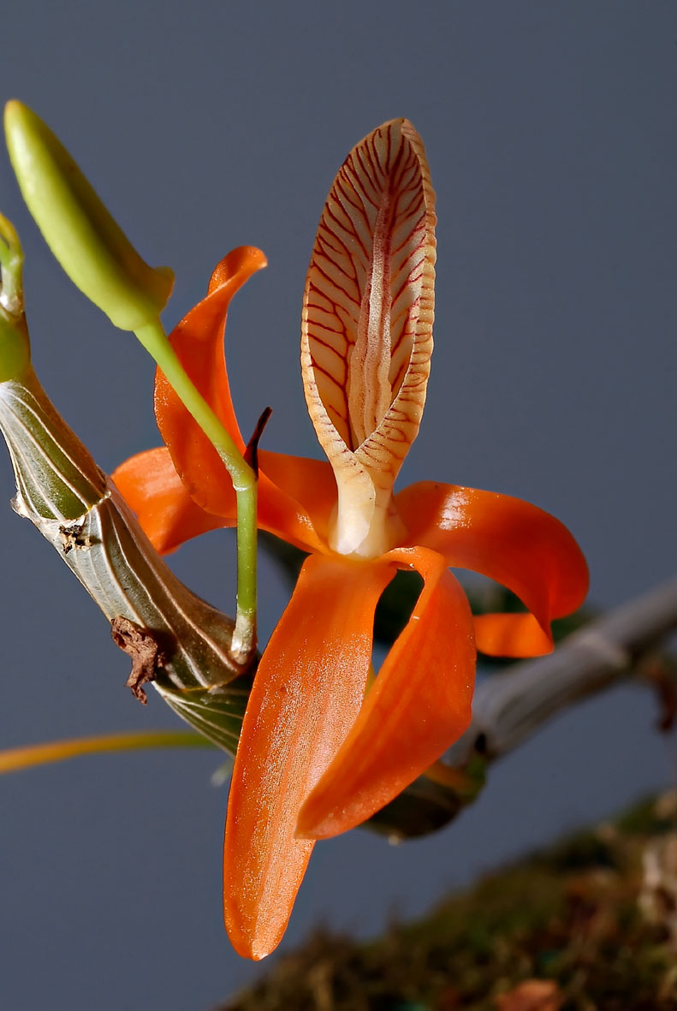
Synonyms
None
Description/Range
D. unicum has clustered, small stems carrying 2 to 3, apical, narrow, persistent leaves and blooms in the later spring and early summer on axillary, short [1 to 2"], raceme that arises from near and at the apex of leafed and leafless canes with up to 4 fragrant peach to apricot scented flowers. It is found in Vietnam, Laos, Myanmar and

Thailand in evergreen, in semi-deciduous and deciduous dry lowland forests and savanna-like woodlands at elevations of 800 to 1550 meters and is found on rocks and small bushes. ³
Northern Thailand, Laos, and Vietnam. In Thailand, plants have been found near Omkoi at 2600-3300 ft. (800-1000 m) and near Loei at 4600-5100 ft. (1400-1550 m). In Laos, they have been reported in Vientiane and Sedone. They grow on rocks or bushes in areas with low, scrub like vegetation. -- Source: Charles Baker⁴
It is a miniature sized, cool to warm species, which reaching 7-9 cm in height, with clustered, small, 7-9 cm long stems carrying 2 to 3, apical, narrow, persistent, 5-7 cm long leaves.
The Unique Dendrobium blooms in the later spring and early summer on axillary, short, raceme that arises from near and at the apex of leafed and leafless canes with up to 4 fragrant flowers. The flowers are 3.5-5.0 cm in diameter. They have a strange shape, long, slender petals of both whorls and deep orange or bright red-orange color. They can be completely open or be so strongly twisted that they seem tangled. The large lip, directed upwards, has the shape of a tube and is strongly innervated. It protrudes forward and can be white, cream or beige. It is slightly serrated along the edges.

F-1 Hybrids and Progeny
Dendrobium unicum is a relative late comer to the orchid community. It was not described until 1970. Growers have wasted no time in developing hybrids from this species. It has produced 20 F-1 hybrids which have gone on to produce an additional 47 grexes in 5 generations. Stardust and Rainbow Dance are the most awarded with 16 and 12 respectively.

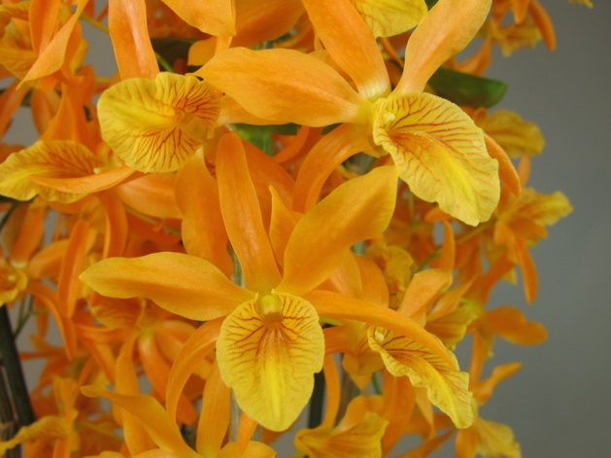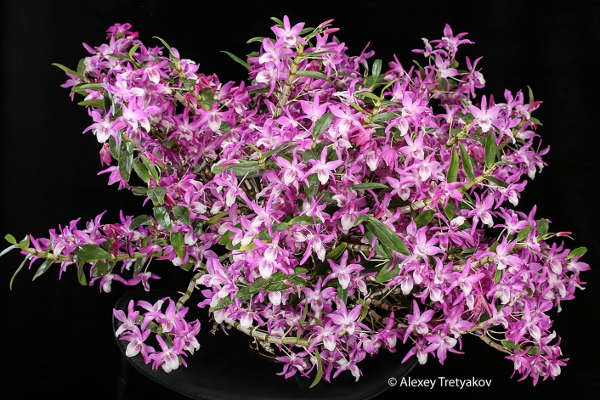
Dendrobium Stardust AM/AOS Dendrobium Rainbow Dance AM/AOS

Awards

The species has been awarded by the AOS 16 times. Awards include 3 AM, 5 CCM, 1 CHM, 1 FCC, 6 HCC.

Culture

Light:
Dendrobium unicum needs a light level of 25000-40000 lux. The plants need for shading from spring to autumn, but the light should be as much as they can bear without burning the leaves. Strong air movement should be ensured all the time.

Temperature:
It is a thermophilic plant. In summer the average day temperature is 27-28 ° C, night 20 ° C, which gives a daily difference of 7-8 ° C. In spring, the average day temperature is 31-34 ° C, at night 14-21 ° C, with a daily amplitude of 10-19 ° C. The average winter temperature is 26-30 ° C during the day and 10-12 ° C at night, giving a daily difference of 15-19 ° C.

Humidity:
The Unique Dendrobium need the humidity of 80-85% in summer and early autumn.

Substrate, growing media and repotting:
Dendrobium unicum can be mounted to pieces of tree ferns or cork, with high humidity ensured and daily watering during the summer. If the plants are grown in pots, any loose, fast-drying substrate can be used. Repotting is best done in early spring, when the growth of new roots begins.

Watering:
For 6 months from spring to early autumn, the rainfall is abundant, but for the remaining 4-5 months in winter and at the beginning of spring are small. During active growth, the cultivated plants should be kept constantly in moisture, while when new growths reach maturity at the beginning of autumn, the amount of water should be gradually reduced.

Fertilizer:
The plants should be fertilized every week 1/4-1/2 of the recommended dose of fertilizer for orchids. A fertilizer with a high nitrogen content is beneficial from spring to mid-summer, and a fertilizer richer in phosphorus should be used in late summer and autumn.

Rest period:
For most of 5-6 months from autumn until spring, the Dendrobium unicum should dry a little before the next watering, but they can not stay dry for a longer period. For a period of 1-2 months at the end of winter, the amount of water should be reduced more and the plants should be completely dry. The plants also should not be fertilized during this period.²

References
Aldridge, Peggy. 2008. An Illustrated Dictionary of Orchid Genera. Selby Botanical Garden Press.
¹la Croix, Isobyl. 2008. The New Encyclopedia of Orchids. Timber Press
Cribb, CJ. Genera Orchidacearum, Vol. 6. Oxford: Oxford University Press, 344-349.2014. Epidendroidae. In: Pridgeon AM, Cribb PJ, Chase MW, Rasmussen F, eds.

Lavarak, Bill; Harris, Wayne; Stocker, Geoff. 2000. Dendrobium and its Relatives,
Timber Press.

Schelpe, Sybella; Stewart, J. 1990. Dendrobiums: An Introduction to the Species
in Cultivation. Orchid Sundries Ltd.

³ Jay Pfahl's IOSPE at www.orchidspecies.com
⁴OrchidWiz.Database X7.0
http://apps.kew.org/wcsp/qsearch.do
https://secure.aos.org/aqplus/SearchAwards.aspx
²https://travaldo.blogspot.com

