Dendrobium bellatulum AM/AOS 81 Points
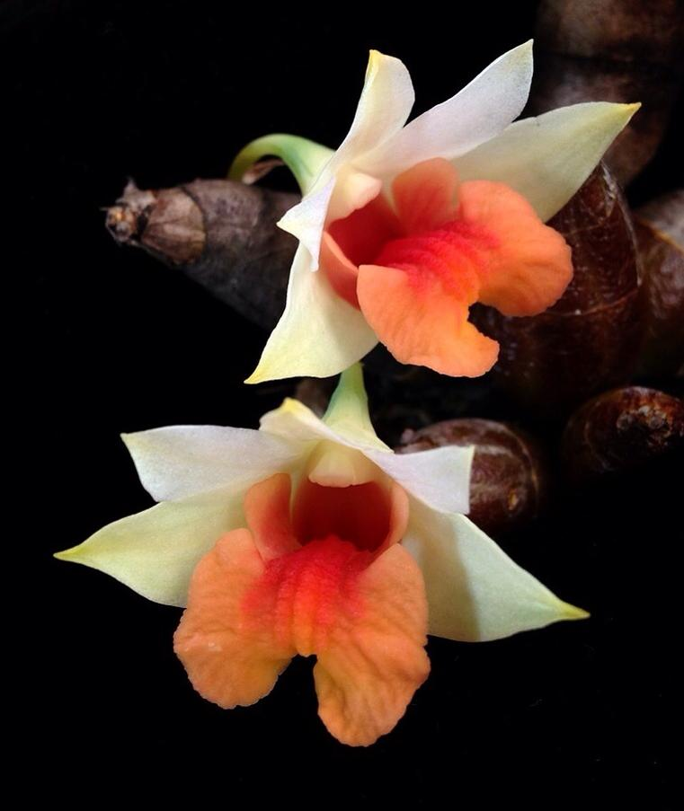
Seven flowers and one bud well presented on seven canes; sepals white, suffused butter yellow; petals white, apices blushed light yellow; lip salmon, red-orange medially; column cream; substance firm; texture crystalline.

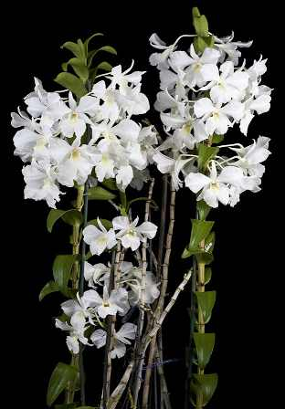
Dendrobium Hawaiian Spectacular CCM/AOS 87 Points
Forty-three flowers and thirteen buds on ten inflorescences grown on a 40 cm tall by 15 cm wide plant on bark in a 12 cm clay pot; sepals and petals pure white; lip white, throat chartreuse ; column white, anther cap green; substance medium firm; texture matte.

Dendrobium trigonopus HCC/AOS 75 Points
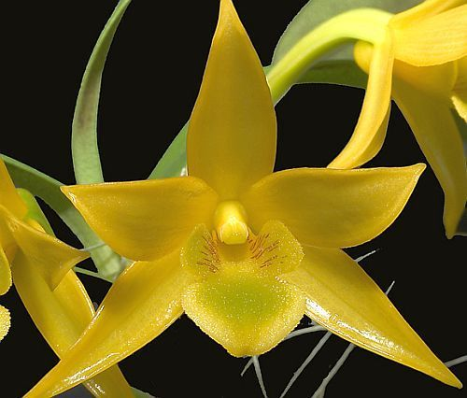
Eight flowers and two buds on four nodding inflorescences; sepals and petals golden yellow; lip golden yellow, main lobe chartreuse centrally, side lobes minutely spotted oxblood; substance heavy; texture waxy.

Dendrobium sanderae HCC/AOS 77 Points
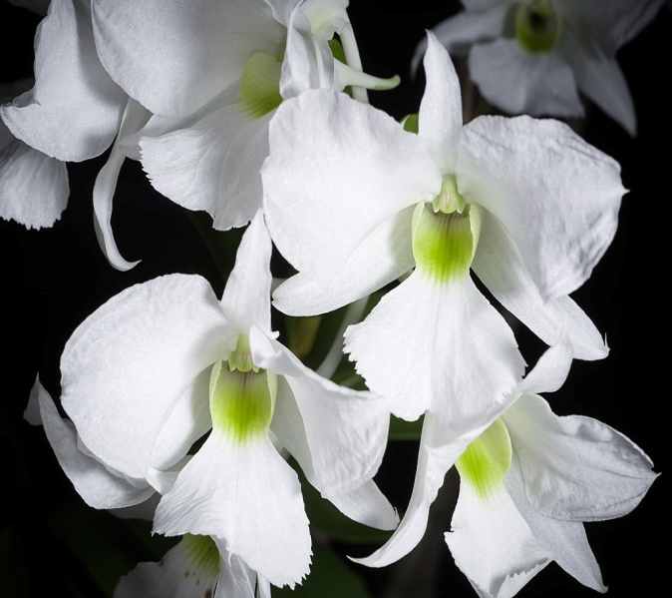
Nineteen round, full flowers on three canes; sepals and petals bright white; trilobed lip white, throat and sidelobes overlaid chartreuse; column chartreuse; substance firm; texture crystalline.

Dendrobium formosum AM/AOS 81 Points
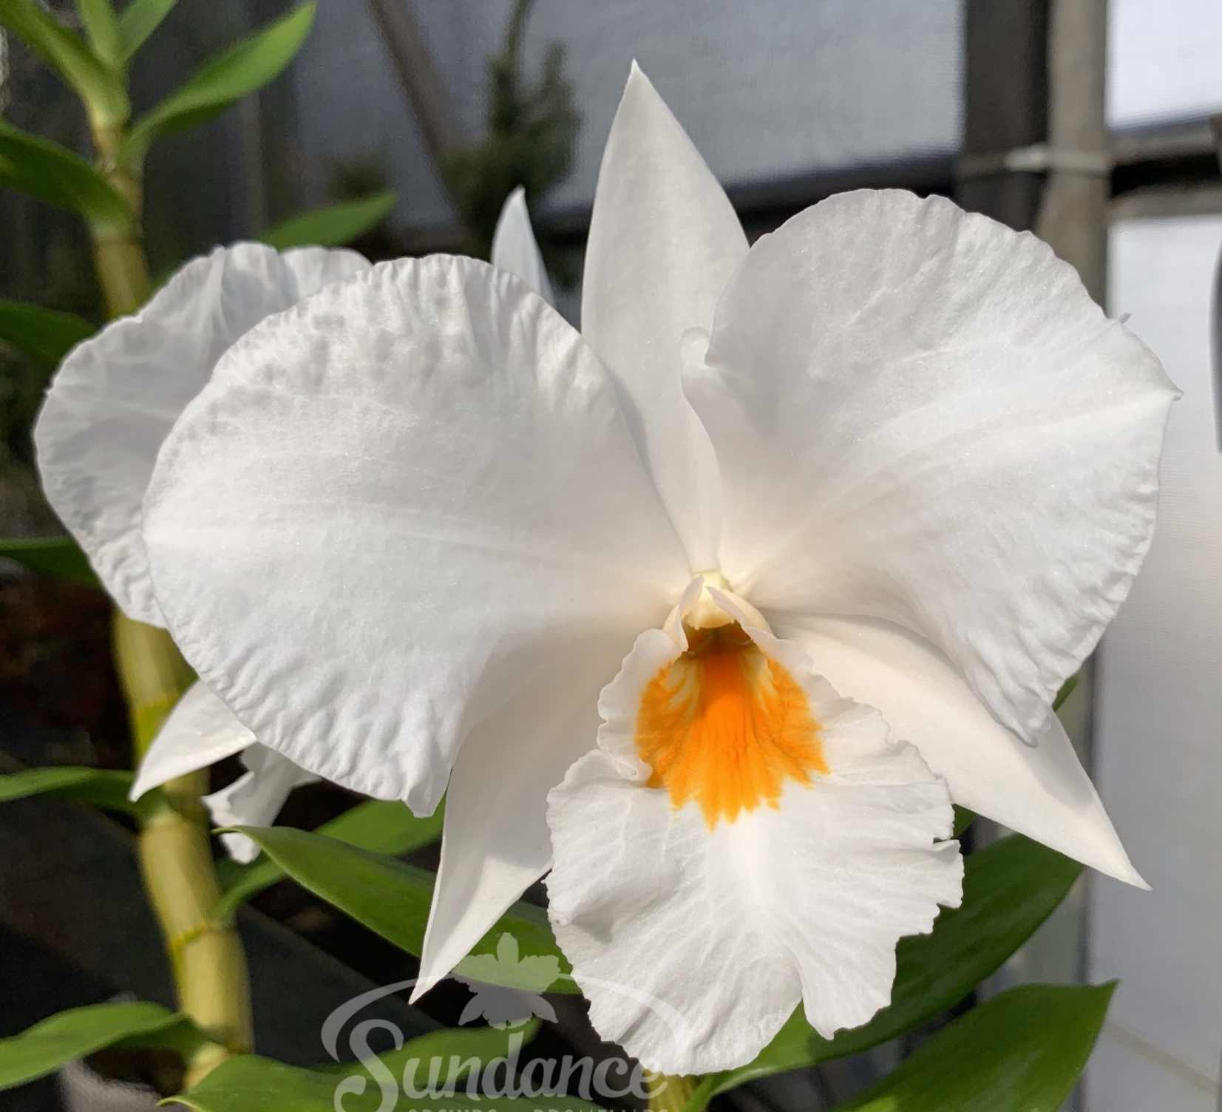
Twenty-seven large, full flowers on ten inflorescences presented on four upright canes; lanceolate sepals white; rounded petals white, margins crimped; lip white, throat orange yellow; substance firm; texture matte.

