Dendrobium cruentum Rchb.f 1884

SECTION Formosae
Common Name: The Bolld Red Dendrobium
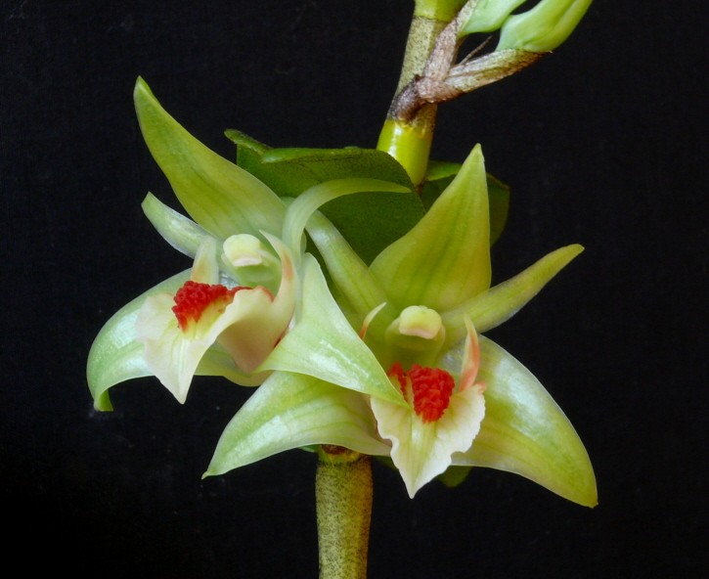
Synonyms
Callista cruenta (Rchb. f.) Kuntze 1891³
Description/Range
Found in Myanmar, Thailand and Vietnam as a small to medium sized, hot to warm growing, epiphytic species from elevations below 1000 meters in open forests where it is found on smaller trees. The plant has erect pseudobulbs that are swollen basally and has leaf sheaths with black hairs carrying many, deciduous, elliptic-oblong, leathery leaves that are hairy on the underside and are spaced all along the stem. The bloom season is in the spring through fall on an axillary, short, 1 to 2 flowered, inflorescence with faintly fragrant, longlasting flowers that arise from the nodes on the stem in between leaves at the upper apex of the leafed pseudobulb, and needs a definite rest from water and fertilizer in the winter months³

F-1 Hybrids and Progeny
Dendrobium cruentum has 36 F-1 hybrids registered since 1969 and a Total Progeny of 88 in 3 generations. The species has received 6 AOS awards and the progeny another 130 awards worldwide. The most awarded offspring is Dendrobium Frosty Dawn (Den Dawn Maree x Den Lime Frost) with 16 AOS awards and 16 progeny. Dawn Maree, a primary with D. formosum, is quite a hybrid with 12 AOS awards and 48 progeny.

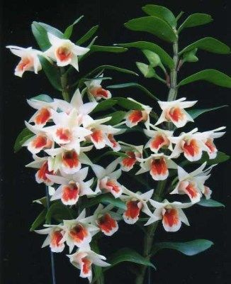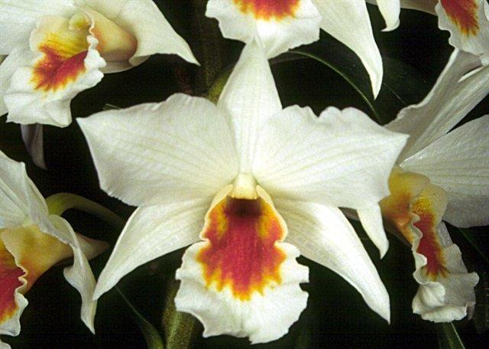
Dendrobium Dawn Maree AM/AOS Dendrobium Fire Coral AM/AOS
D. formosum x D. cruentum D. cruentum x Formidible

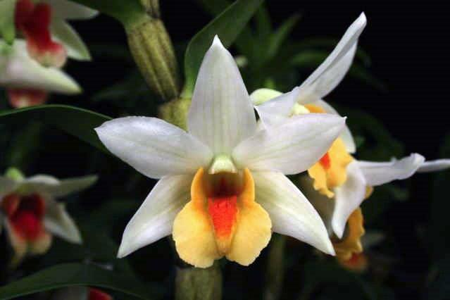
Dendrobium Frosty Dawn AM/AOS

Culture

Light:
Dendrobium formosum needs a light level of 30000-40000 lux. They likes high levels of light, and when new growths reach mature, it can tolerate almost full sun.

Temperature:
The average temperature of the summer day is 19-21 ° C, the night 12-13 ° C, and the daily difference is 7-9 ° C. In spring, the average day temperature is 23-24 ° C, the night 5-12 ° C, and the daily difference is 11-18 ° C. In winter, the average day temperature is 18-21 ° C, the night 2-3 ° C, giving a daily difference of 15-18 ° C.

Humidity:
In summer and autumn, The Beautiful Giant-Flowered Dendrobium need the average humidity of 80-85%, and at the beginning of winter it drops to 75%. Then, for a period of about 2 months at the end of winter and early spring.

Substrate, growing media and repotting:
Dendrobium formosum can be grown mounted on tree ferns or cork or placed in baskets, high humidity is ensured and watering is done at least once a day in summer. When grown in pots, it works very well as the substrate of Osmund fern. Repotting is best done in early spring, when new roots grow.

Watering:
Watering is moderate to heavy from late spring to early autumn, but it is drier in the winter. The plants should be abundantly watered during active growth, but when new growths reach maturity in autumn, the amount of water should be gradually reduced.

Fertilizer:
It is recommended to use a 1/2-1/4 dose of orchid fertilizer weekly. From spring to mid summer, fertilizer with an increased nitrogen content is preferred, and fertilizer with an increased content of phosphorus should be used at the end of summer and autumn.

Rest period:

A cool, dry rest is very important and should last until new growths appear in the spring. You can complete eliminate water in the winter, but the plants will be better if for the most part of this period they will dry a little between watering, but they will not stay dry for too long. At the end of winter for 1-2 months, the plants should then dry completely between waterings and stay dry longer. Occasional morning fogging between waterings should protect the plants from drying out. Fertilization should be significantly reduced or eliminated until spring, when larger watering resumes.⁵

References
Aldridge, Peggy. 2008. An Illustrated Dictionary of Orchid Genera. Selby Botanical Garden Press.
¹la Croix, Isobyl. 2008. The New Encyclopedia of Orchids. Timber Press
Lavarak, Bill; Harris, Wayne; Stocker, Geoff. 2000. Dendrobium and its Relatives,
Timber Press.

³ Jay Pfahl's IOSPE at www.orchidspecies.com
⁴OrchidWiz.Database X7.0
⁵https://travaldo.blogspot.com/care-and-culture.html
http://apps.kew.org/wcsp/qsearch.do
https://secure.aos.org/aqplus/SearchAwards.aspx

