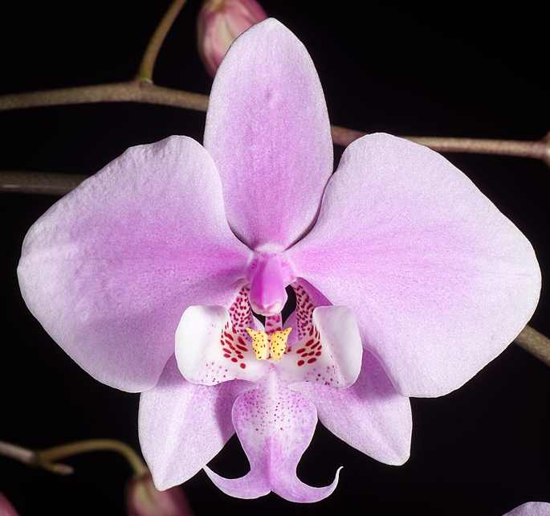
Phalaenopsis schilleriana AM/AOS 86 Points
Forty-nine flowers beautifully arranged on one sixty cm arching inflorescence; sepals and petals light pink, color more saturated centrally; lip white, overlaid light pink, mid lobe speckled darker pink basally, side lobes spotted dark red-brown basally, callus yellow, spotted red-brown; column pink, anther cap white; substance firm; texture matte.

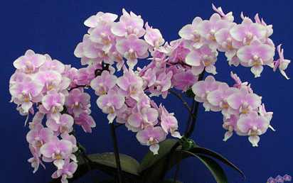
Phalaenopsis Jiaho’s Pink Girl CCM/AOS 87 Points
One hundred twenty-seven flowers on six, 50 cm average branched inflorescences; sepals and petals white, overlaid light pink; lip white, overlaid pink basally, callus yellow, spotted pink; substance firm; texture crystalline.

Phalaenopsis Little Hal HCC/AOS 75 Points
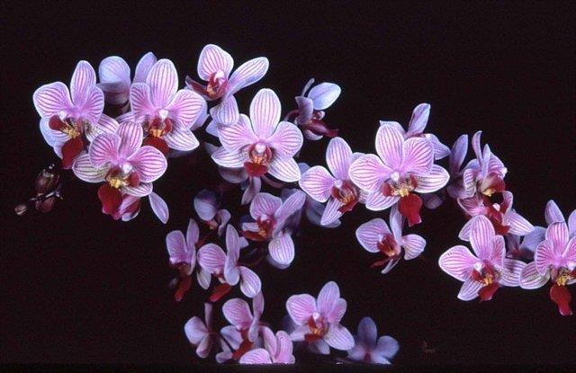
Thirty sixflowers and two buds on two arched inflorescences; sepals and petals white, overlaid light pink, striped darker pink; lip central lobe dark burgundy, side lobes dark rose pink, callus yellow, stippled pink; substance firm; texture crystalline.

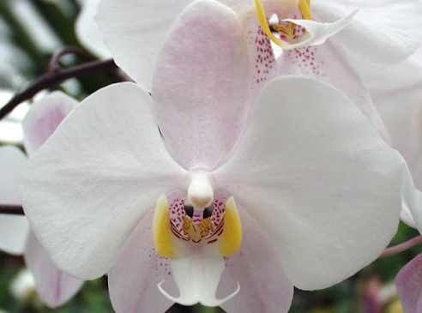
Phalaenopsis philippinensis HCC/AOS 77 Points
Twenty two flowers and two buds well arranged on one arching inflorescence; sepals white, blushed light pink, lightly spotted pink basal half; petals white; lip white, side lobes golden yellow, striped burgundy, callus yellow, spotted burgundy; substance firm; texture matte.

Phalaenopsis Mini Mark AM/AOS 81 Points
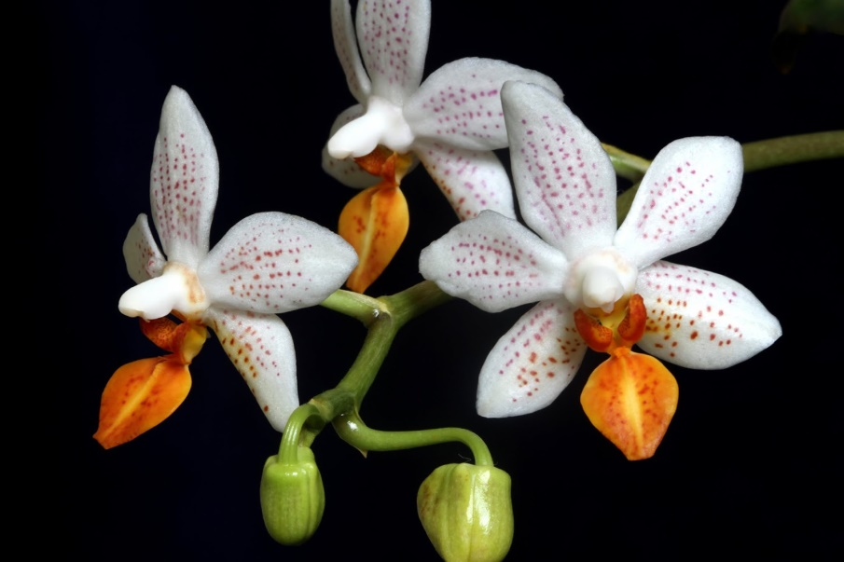
Thirty six flowers and two buds well-arranged on one branched inflorescence; sepals and petals white, finely spotted red-orange, spots linear; lip white, mid lobe suffused orange, spotted red-orange, side lobes deep red-orange; column white; substance firm; texture waxy.

