BUILDING BLOCK DATA
Phalaenopsis philippinensis Golamco ex Fowlie & C.Z.Tang 1987
SUBGENUS Phalaenopsis SECTION Phalaenopsis

Description:

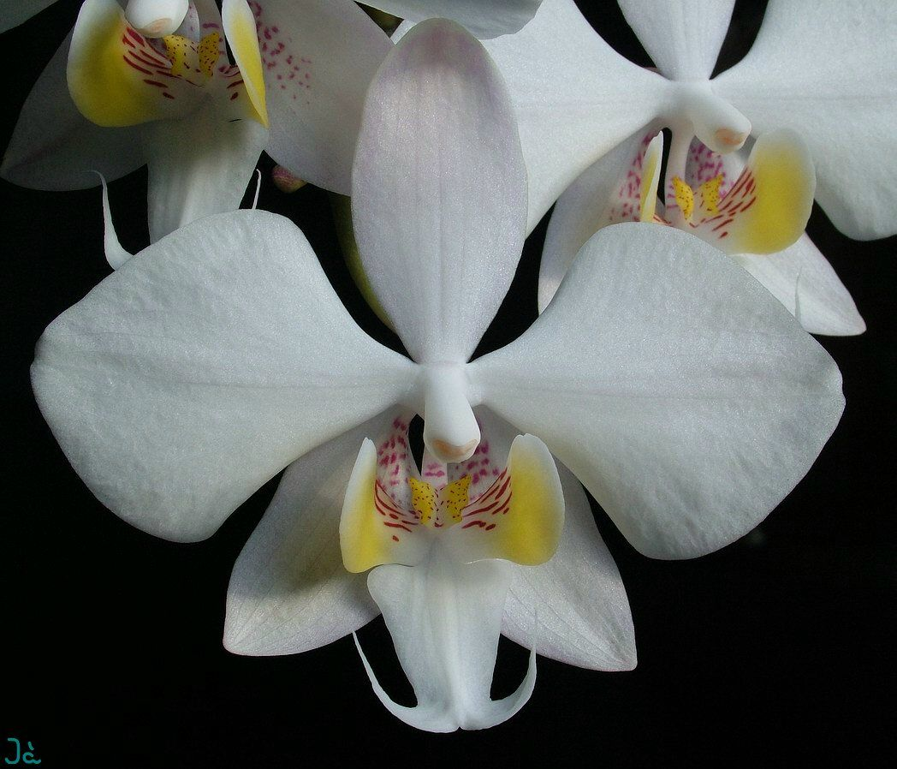
A small sized, warm to cool growing epiphyte with dark green, mottled with silver leaves that blooms on an axillary, erect to semi-pendulous, to 48" [120 cm] long, freely branching inflorescence carrying slightly fragrant flowers. ³
Pendent epiphytes. Leaves oblong-elliptic to oblong-oblanceolate, tapered to the base, obtuse-rounded, the upper surface dark green over-lain with silvery gray marbling, the lower surface dark purple, to 36 x 13.5 cm. Inflorescences laxly arching-pendent panicles, to 120 cm long, the floral bracts minute, triangular, to 8 mm long. Flowers deli-cate, membranous, numerous (to 100+), white, pale pink suffusion, the lateral sepals with dark red spots at the base, the lip white with dark yellow lateral lobes, with dark red stripes at the base of the lateral lobes of the lip, the column white. Dorsal sepal elliptic to elliptic-ovate, obtuse-rounded, to 4.5 x 2.3 cm, the lateral sepals obliquely ovate, sub-acute, divergent, to 4.5 x 2.4 cm. Petals rhomboid, cuneate-clawed, obtuse, broadly rounded, to 4.5 x 4.5 cm. Lip three-lobed, to 2.5 cm long, to 4 cm wide across the expanded lateral lobes, the lateral lobes elliptic-obovate, obtuse-rounded, erect-incurved forming a cylinder, the mid-lobe oblong-ovate, the base hastate to subauriculate, the apex notched with the lanceolate lobules elongate and recurved, the callus uniseriate, peltate, channeled, the posterior edge extended in a pair of wing-like teeth. Column stout, straight, to 0.8 cm long. Pedicel and ovary to 5 cm long.. This showy species has only recently been described. When first published (Golamco 1984) the name was invalid because no Latin diagnosis or description accompanied the English description and the binomial combination was not explicitly cited. These oversights were corrected by Fowlie and Tang. When P philippinensis was first discovered and brought into cultivation, it was confused with the similar P. xleucorrhoda. The richly marked leaves and the pure yellow lateral lobes of the lip have made it a very desirable species. Like the closely related P schilleriana and P stuartiana, P philippinensis tends to open all the flowers on an inflorescence quickly. Having all flowers open at once makes P philippinensis a particularly excellent display plant. This quality of producing a massive display of flowers is dominant in its hybrids.¹

Distribution/Habitat:

Philippine Islands. Found on northeastern Luzon in Nueva Vizcaya Province as well as the provinces of Quirino, Isabela, and northern Aurora. It is found in the Sierra Madre rainforests, where it grows in the shade on tall trees, usually near streams, at about 3950 ft. (1200 m).Source: Charles Baker⁴
Awards:

Origin | HCC | AM | FCC | JC | CC2 | CCM | Total
 | 5 | 4 | 0 | 1 | 1 | 1 | 12
Years | 1992-2012 | 1999-2003 |  | 2008 | 2012 | 2000

Hybrids: F-1 113

Before  1940 | 1940-49 | 1950-59 | 1960-69 | 1970-79 | 1980-89 | 1990-99 | After 1999
 |  |  |  |  | 2 | 49 | 62

Hybrids: Total Progeny - 192

Before  1940 | 1940-49 | 1950-59 | 1960-69 | 1970-79 | 1980-89 | 1990-99 | After 1999
 |  |  |  |  | 2 | 53 | 137
Being only recently described, Phalaenopsis philippinensis is behind the other Section Phalaenopsis species in regard to hybrids, It most likely catch up because it is a desirably plant for hybridization. The first hybrids were not registered until 1984.
Outstanding progeny and reason they are considered outstanding:
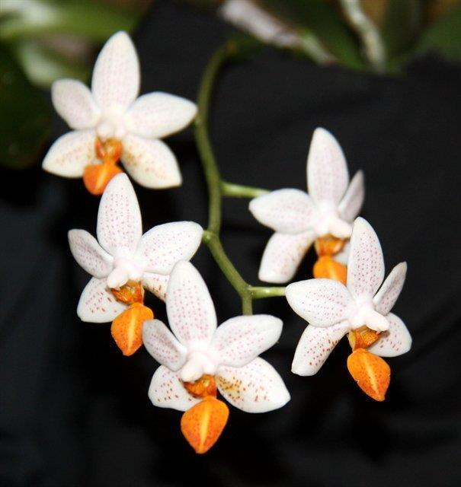
Phalaenopsis Mini Mark AM/AOS

Mini-Mark is the most awarded of the F-1 generation of P. philippinensis. It has received 14 AO aards including 7 AM, 4 HCC, an AQ and a CCM. It has been crossed 7 times, all but one of wich are primaries. A couple of attractive properties of this cross are the rich yellow-orange of the lip and the fact that all of the floers open at the same time.

Desirable characteristics which can be passed to progeny:
There are very few references to P. philippinensis in the popular literature, but Christenson lists several desirable traits that give the species potential for future breeding. Hybrids carry the trait of opening all of the flowers of an inflorescences quickly producing an excellent display plant. The leaves are richly marked, and with Phalaenopsis leaves so prominent, this is very desirable. A third great trait is the rich yellow color of the rei-lobed lip.¹

Undesirable characteristics which can be passed to progeny:
I was unable to find reference to undesirable traits and have never grown the species so am unable to make personal observations.

References:

Aldridge, Peggy. 2008. An Illustrated Dictionary of Orchid Genera. Selby Botanical Garden Press.
¹ Christenson, Eric A. 2001. Phalaenopsis- A Monograph.Timber Press.
² Cribb, CJ. 2014. Epidendroidae. In: Pridgeon AM, Cribb PJ, Chase MW, Rasmussen F, eds. Genera Orchidacearum, Vol. 6. Oxford: Oxford University Press, 344-349.

³Jay Pfahl's IOSPE at www.orchidspecies.com
⁴OrchidWiz.Database X7.1
http://apps.kew.org/wcsp/qsearch.do

https://secure.aos.org/aqplus/SearchAwards.aspx

