Phalaenopsis- Section Phalaenopsis Species

SPECIES PROGENY AWARDS AWARD TYPE RANGE TEMP/LHT BLOOM TIME
F-1/Total AOS Peak
amabillis | 483/33,257 | 45 | 20 AM, 1 AQ, 8 CCM, 1 CHM, 6 HCC | Widespread SE Asia | Warm/Lo | Feb-Mar
aphrodite | 62/33,353 | 38 | 13 AM, 1 AQ, 1 CBR, 2 CCE, 12 CCM, 1 CHM, 8 HCC | Taiwan & Philippines | Warm/Lo | Mar
philippinensis | 113/192 | 12 | 1 AM, 1 CCE, 1 CCM, 5 HCC, 1 JC | Philippines | Warm/Lo | March
sanderiana | 117/27,201 | 6 | 3 AM, 1 FCC, 1 CBM, 1 CCM | Philippines | Hot/Lo | May
stuartiana | 399/28,217 | 33 | 12 AM, 5 CCM, 2 CHM, 14 HCC | Philippines | Hot/Lo | March
schilleriana | 255/29,795 | 51 | 20 AM, 1 AQ, 2 CC, 4 CCE, 11 CCM, 13 HCC | Philippines | Warm/Lo | Feb

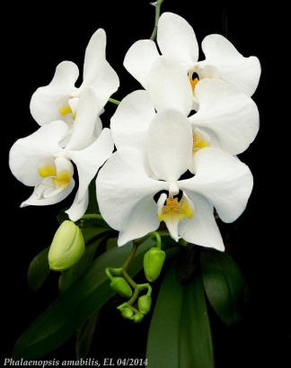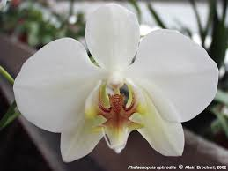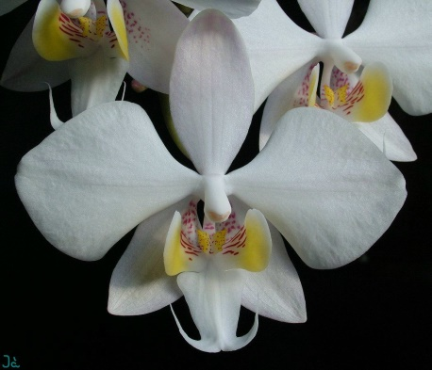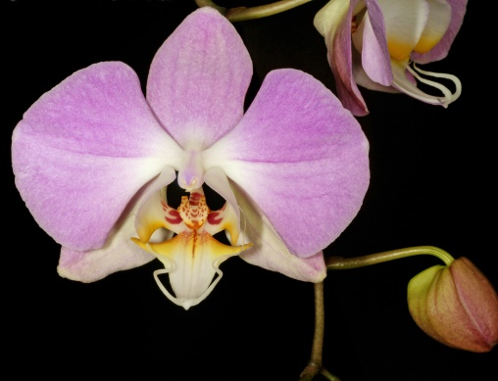
Phal amabillis Phal aphrodite Phal philippinensis Phal sanderiana

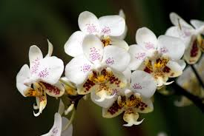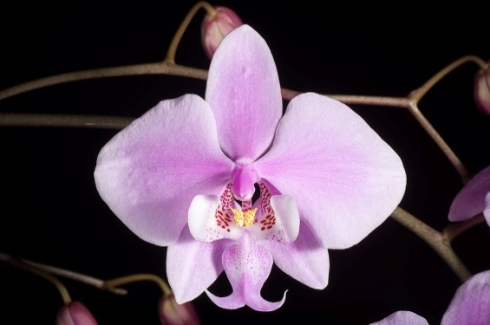
Phal stuartiana Phal schilleriana

