Phalaenopsis Blume 1825
SUBFAMILY Epidendroideae, TRIBE Vandeae, SUBTRIBE Aeridinae₁
ETYMOLOGY: From the Greek ‘phalaina’ , moth, and ‘opsis’, like, meaning resembling a moth.⁴
SYNONYMS: Biermannia King & Pantling 1897; Doritis Lindley 1833; Grafia Rchb. 1837; Grussia M Wolff 2007; Kingidium P.F.Hunt 1970; Kingiella Rolfe 1917; Lesliea Seidenf. 1988; Nothodoritis Z.H.Tsi 1989; Ornithochilus [Lindley] Benth. 1883; Polychilos Breda 1828; `Polystylus A. Hasselt ex Hassk. 1855; Sedirea Garay & H.R. Sweet 1974; `Stauritis Rchb.f 1862; `Stauroglottis Schau. 1843; Stauropsis Rchb.f 1860; `Synadena Raf. 1836[1838]₁
TYPE SPECIES: Phalaenopsis amabilis (L.)Blume 1825

DESCRIPTION:

Plants
Plants of Phalaenopsis all have short stems. This is in keeping with Holt- turn’s theory that stem length in monopodial orchids is generally an adaptation to light requirements: genera that require high light levels have long internodes and, hence, long vining stems (Arachnis, Renan- thera), while genera that require low light levels have short internodes (Grosourdya, Phalaenopsis). Phalaenopsis is distinguished by stems that might almost be called acaulous (literally “without stems”): the internodes, or the spaces between leaves, are extremely short. Elongate internodes occasionally occur as anomalous growth characters in the genus, usually through etiolation caused by overly wet conditions or as an aberrant growth most likely occurring through a genetically controlled internal hormone imbalance. The latter is most often seen where the apical meristem of the stem is consumed in the production of an inflorescence that initially bears large, basal, subfoliaceous bracts toward the base.
Typically the stems in Phalaenopsis are borne at right angles to vertical host stems. And unlike other genera in the Aeridinae, no species of Phalaenopsis has been recorded growing primarily on horizontal hostbranches. This is in keeping with the architecture of the leaves. Leaves in Phalaenopsis m e typically laxly arching-pendent in nature. Borne on an essentially horizontal stem, this arrangement allows rain water to drain away from the growing point (the crown of the plant) along the midvein of the leaves. In so doing, pathogens—and especially bacterial rots—are avoided in nature.

Roots
Roots in Phalaenopsis are of three kinds: aerial, prostrate epiphytic, and substrate. Aerial roots are typically cylindric and unbranched, unless they have suffered physical damage, and bear large, elongate, pigmented root tips. The root tips may be either green or purple and, like leaf pigmentation, appear to be governed by a simple, probably singleallele, inheritance pattern. Epiphytic roots (or those roots that follow a host stem, with one side appressed to the host stem and the other side exposed to the air without any substrate covering) are typically flattened and ribbon-like. In subgenus Parishianae and certain species of section Phalaenopsis (especially P. philippinensis, P. schilleriana, and P. stuartiana), the exposed surfaces are heavily wrinkled, although no real study has been made for this characteristic throughout the genus. Substrate roots are typically cylindric, larger in diameter than the corresponding aerial roots, and usually lacking pigment in the root tips. Individual roots may show one or more of these stages depending on their environment.
The roots of Phalaenopsis are usually unbranched unless they are damaged (branching is a standard wound response in the Aeridinae) or unless they obtain significant length with age.
Root tissue has been used for the micropropagation of Phalaenopsis with varying success. Root tissue of orchids in general appears to be physiologically “determined” to be root tissue. The hormonal forcing of root parenchyma (largely undifferentiated cells that are capable of cell division, or mitosis) to initiate mitosis and subsequently form the tissue for generating protocorm-like-bodies (PLBs) has a number of drawbacks, especially a sizeable inducement of macro-mutations. One species, P. stuartiana, flies in the face of this pattern. Phalaenopsis stuartiana has often been recorded as generating plantlets from root pri- mordia. Typically, a large plant of P. stuartiana establishes itself on a bench or plaque in a greenhouse; if the plant is removed, the broken root segments remaining on the bench or wall produce plantlets. I am unaware of any situation wherein P. stuartiana produces plantlets from the roots of an undisturbed parent plant. Nor have I seen this phenomenon in the closely related P. schilleriana.

Leaves
Although leaf thickness varies from species to species, the overall leaf texture and morphology are similar throughout the genus. All species of Phalaenopsis bear succulent, fleshy leaves. This is consistent with the plants lacking any other water storage organs, such as pseudobulbs, with which to endure the dry season. Unlike high light requiring genera of the Aeridinae such as Aerides and Vanda, most Phalaenopsis species do not appear to use their root systems as storage organs during the dry season (i.e., shedding their leaves and transferring water storage and carbohydrate reserves to the roots during the dry season). Their relatively close, humid natural environments shield the plants from excessive drying.
Plants of subgenera Aphyllae, Parishianae, and Proboscidioides are normally deciduous in nature. Native to areas governed by monsoonal climate with a pronounced dry season, these plants shed their leaves to tvoid excessive dehydration. This could be considered a shared evolu- ionary character (a synapomorphy in cladisdc terms) but could equally 'epresent independent evolution of the character as a parallel response o the environment (convergent evolution). These plants do not require a severe dry period and in cultivation watering should be ufficient to avoid leaf loss.
The leaves do show some variation in pigmentation, in both the basic ground color and the superposed patterns. In section Fuscatae the eaves are a drab olive green, unlike other species in the genus. In submenus Parishinae the upper leaf surface is a dark bluish green and often somewhat prismatic. In some species of subgenus Phalaenopsis the leaves are overlain with a silver sheen and richly marked with darker purple spots. Color patterning of the leaves appears to correlate strongly with traditionally recognized species complexes. In those species with unmarked leaves, the presence or absence of purple suffusion on the lower leaf surfaces appears to be variable and again, controlled by a simple, probably one-allele system.
The leaves of many species of subgenus Polychilos show mosaic patterning of several more or less pallid green shades that may be a result of nutritional deficiencies in cultivation. Species related to P. lueddemanniana, in particular, typically produce foliage mottled with minute sectors of paler green coloration. Although falsely attributed to a “possible” virus, the cause of this mottling is unknown. Specific studies should be undertaken to ascertain the possibility of a calcium or other mineral deficiency in this species cluster.

Inflorescences
The inflorescences, or flower stalks, of Phalaenopsis range from short, few-flowered racemes to long-scapose racemes, to variously branched panicles. Some species produce panicles with every blooming (P. schilleriana, P. stuartiana) while others produce either racemes or panicles depending on the vigor of the plant and/or the age of the inflorescence. Simple unbranched racemes appear to be recessive in breeding, judging from the multiflora hybrids that have been created using such species as P. lobbii.
The peduncle, or the non-flowering portion of the inflorescence, is usually terete and bears several nodes, each concealed by a solitary, tightly fitting tubular bract. Each node produces a quiescent growing point (meristem) that is visible to the naked eye when the bract is removed. This primary meristem is flanked by a pair of much smaller meristems, which may not be visible prior to their activation and growth. If the rachis is damaged, if none of the flowers are pollinated, or if the rachis is removed shortly after the flowers fade, the primary meristems of the uppermost node(s) will typically initiate growth. In most species this growth results in new branches of the inflorescence, which go on to produce a secondary flush of flowers.

The column and the broad stigmatic cavity are the only totally consistent characters for the genus. Columns in Phalaenopsis are more or less straight, subcylindric, and dilated toward the apex. The base of the column may be unadorned or have a pair of swollen “knees.” These knees presumably play a role in pollination and are absent or much reduced in subgenus Phalaenopsis. The clinandrium (anther bed) may be unadorned or extended in a concave hood. The hooded clinandrium defines section Zebrinae. The rostellum of nearly all Phalaenopsis species is elongate and held over and parallel to the apex of the stigmatic cavity. The exception is P lowii, which has a highly elongate rostellum (and corresponding stipe of the pollinarium). The elongate rostellum of P. lowii is the primary reason for placing it in the monotypic subgenus Proboscidioides.
The anther in Phalaenopsis may be more or less rounded or angularly lobed with a central channel. The morphology of the pollinarium, comprised of a viscidium, stipe, and pollinia, is uniform throughout the genus. The only exceptions are the elongate stipes found in subgenus Proboscidioides and section Esmeralda. Pollinia number has traditionally been a heavily weighted character in the classification of orchid genera. That is less true today as we continue to find multiple exceptions within otherwise tightly defined genera, such as Aerides and Gastrochilus. Phalaenopsis has either four pollinia borne in two appressed pairs or two pollinia with a cleft or suture on one side. The evolutionary progression from four to two pollinia appears to have occurred twice within the genus, in the subgenera Phalaenopsis and Polychilos.

Fruits
With the traditional emphasis in orchid taxonomy on floral, and especially lip morphology, characters of the fruit have been largely overlooked in study of the family. In the case of Phalaenopsis, no particularly significant differences have been noted among the species with the exception of chlorophylly in subgenera Aphyllaeand Polychilos. In most species of the genus, the perianth withers following pollination. The perianth is persistent and remains attached to the apex of the ovary as small, shrivelled structures for the duration of the fruit. Although the Full extent of chlorophylly in Phalaenopsis is not known because the fruits of some species have not been recorded to date, species of subgenera Aphyllae and Polychilos appear to consistently display chlorophylly. In these subgenera the perianth turns green (i.e., loses all the other pigments, revealing the underlying chlorophyll) following effective pollination and the segments remain fleshy and leafy for the complete duration of the fruit. The ovary of Phalaenopsis, which eventually develops into a fruit, is termed inferior. This means that the ovary is located wholly below the floral segments, which are fused to the apex of the ovary. In most plants, and a few orchid genera, there is a clear distinction between the ovary and the stalk that bears the individual flower. The stalk for each flower (i.e., the string-like “stem” you pull off an apple or cherry) is called the pedicel. In Phalaenopsis the ovary, defined by the region which has ovules and/or seeds present, internally tapers at the base to a sterile segment, the pedicel. These regions are usually visually undifferentiated prior to pollination, although the pedicel becomes obvious once the ovary has swollen.The fruits of Phalaenopsis are commonly called seed “pods.” This is a slang horticultural term: the fruits of Phalaenopsis (and almost all orchids) are correctly called capsules. A capsule is a many-seeded fruit that is dry at maturity and opens to release its seeds. The capsule in Phalaenopsis is composed of six parallel segments akin to the stays of a barrel. Prior to opening, these convex-rounded segments translate as six grooves (i.e., the fruit is said to be six-sulcate). Fruits of Phalaenopsis may be green or variously pigmented. In particular, the fruits of subgenus Aphyllae are purple suffused and heavily mottled with dark purple-brown, similar to species of Ascocenlrum and Luisia.
DISTRIBUTION: A vandaceous genus comprised of 83, mostly epiphytic and some lithophytic species spread throughout most all of Asia east of India and the Pacific to the Philippines and south to Australia. ¹
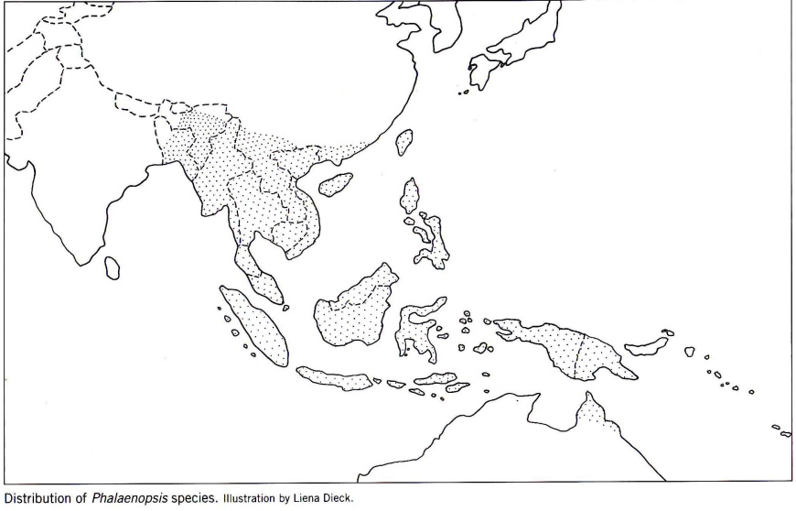₅
References
¹ Jay Pfahl's IOSPE at www.orchidspecies.com
²Christenson, Eric A. 2001. Phalaenopsis- A Monograph. Timber Press.

³Cribb, CJ. 2014. Epidendroidae. In: Pridgeon AM, Cribb PJ, Chase MW, Rasmussen F, eds. Genera Orchidacearum, Vol. 6. Oxford: Oxford University Press, 344-349.

⁴ la Croix, Isobyl. 2008. The New Encyclopedia of Orchids. Timber Press
⁵Frowine, Steven. 2008. Moth Orchids, The Complete Guide to Phalaenopsis. Timber Press

