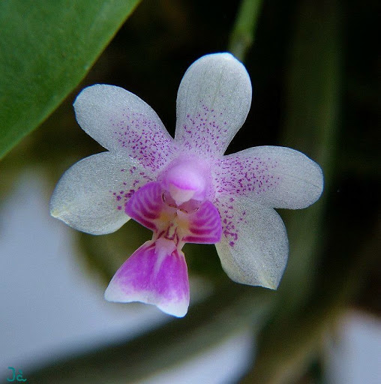
Phalaenopsis deliciosa AM/AOS 86 Points
Thirty seven sequentially blooming flowers and twenty two buds on two branched 25 cm inflorescences; sepals and petals white, basal halves stippled magenta; lip white, overlaid magenta, side lobes striped darker magenta, throat light yellow; substance firm; texture crystalline.

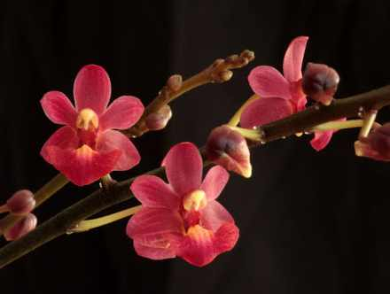
Phalaenopsis Musick Surprise HCC/AOS 77 Points
Twelve flowers and seven buds on two branched, 22 cm inflorescences; sepals and petals orange-red, indistinctly lined darker red; lip orange-red, throat yellow; column and anther cap cream yellow; substance firm; texture crystalline.

Phalaenopsis Purple Gem CCM/AOS 81 Points
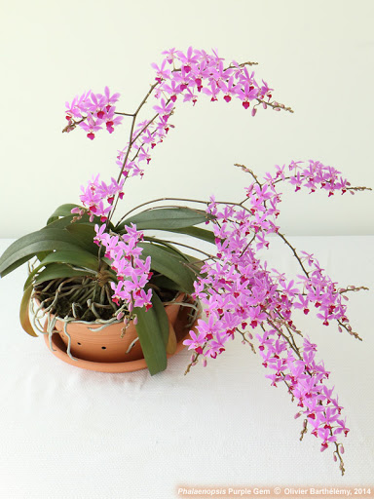
One hundred seven flowers and twenty-three buds on three branched, arching 42 cm inflorescences on a plant with clear unmarked leaves grown in a 30 cm clay pot on bark; sepals and petals light pink; lip dark magenta; column purple, anther cap cream; substance firm; texture matte.

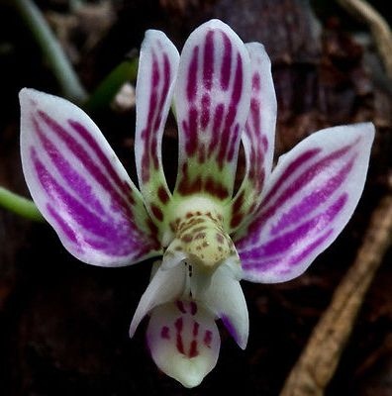
Phalaenopsis finleyi HCC/AOS 77 Points
Twenty two flowers and two buds on two inflorescences; sepals and petals reflexed, white, olive green basally, striped magenta; lip white, midlobe striped and spotted magenta, side lobes distal margin magenta; column ovive green, spotted oxblood; substance firm; texture matte.

Vandaenopsis Pulcherrimin AM/AOS 81 Points
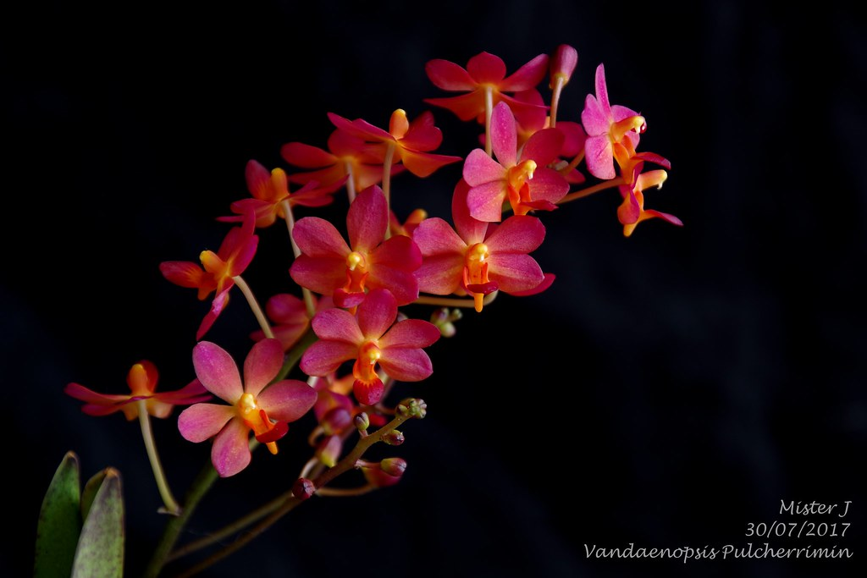
Fifteen well-arranged flowers and four buds on one branched inflorescence; sepals and petals rich orange-red, yellow basally; lip burnt orange; column and anther cap golden yellow; substance firm; texture diamond dust.

