BUILDING BLOCK DATA
Phalaenopsis pulcherrima (Lindley) J. J. Smith 1933
SUBGENUS Parishianae SECTION Esmeralda

Description:
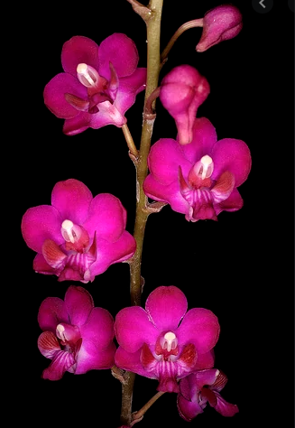
A small sized, hot to warm growing, clump forming, lithophytic or terrestrial orchid at elevations of 50 to 600 meters with a short, leafy stem, carrying oblanceolate to narrowly elliptic, obtuse to subacute leaves that blooms in the summer and fall on a simple, erect to 40" [100 cm] tall, successively to 10, many flowered inflorescence. ³
Terrestrials forming large clumps by basal offshoots. Leaves oblong to elliptic, acute, concave, to 15 x 3 cm. Inflorescences stiffly erect ra-cemes to 60 cm long, the peduncle to 30 cm long, the rachis many-flowered, the floral bracts minute, scarious. Flowers brilliant saturated cerise, the erect lateral lobules of the midlobe of the lip orange, the disk of the midlobe white, the column white. Dorsal sepal elliptic to elliptic-obovate, cuneate, obtuse-rounded, to 1.2 x 0.6 cm, the lateral sepals obliquely broadly triangular-ovate, obtuse, attached to the long column foot, to 1 x 0.9 cm. Petals subsimilar and subequal to the dor-sal sepal. Lip three-lobed, to 1.2 cm long, the lateral lobes narrow, antrorse, linear-lanceolate, lateral to the callus, the midlobe three-lob-ulate, the lobules subequal, the lateral lobules erect, broadly elliptic, obtuse, broadly rounded, the middle lobule broadly triangular-ovate, deflexed, obtuse to subacute, the callus uniseriate, small, transverse, with a rounded leading edge. Column straight, stout, with a pair of knee-like projections at the base. Pedicel and ovary to 1.6 cm long. Etymology: From the Latin, pulcher ("beautiful"). Phalaenopsis pulcherrima readily produces basal offshoots, resulting in large clumps of stems in cultivation. Although the species is easy to grow, some people report difficulty getting the plants to flower: plants either do not flower at all or only produce a few inflorescences on a many-stemmed plant. All three species of section Esmeralda prefer higher light intensities than other species in the genus and poor flow-ering is usually the result of less than optimum light intensity. Peloric clones of P pulcherrima are not uncommon and have been given the informal varietal name champornensis. This name has never been validly published, and I resist giving a formal designation to a ter-atologic monstrosity. Three sporadically occurring color morphs have been formally named and are sought after by horticulturists and orchid breeders.¹
Synonyms:

Phalaenopsis pulcherrima f. alba (O.Gruss & Roeth) E.A.Christenson 2001
Distribution/Habitat:

Distribution: Widespread from northeast India and southern China throughout Indochina to Malaysia (Malay Peninsula), Indonesia (Sumatra), and East Malaysia (Sabah).¹
Found in the Chinese Himalayas, Assam India, Myanamar, Thailand, Malaysia, Laos, Cambodia, Yunnan China, Vietnam, Borneo and Sumatra in evergreen, lowland forests along canyons of montane streams and rivers on rocks and in sandy soils.³
Widespread from northeast India through Burma, Thailand, Cambodia, Laos, and Vietnam, then southward through Malaya, Sumatra, and Borneo. In Thailand, plants have been reported from all regions, except in the vicinity of Bangkok. Plants are usually found at relatively low elevations, but collections have been reported from as high as 4250 ft. (1300 m). Plants generally grow as terrestrials in the shade of bushes and shrubs. They are normally found in sandy, well-drained soil that contains an accumulation of organic debris. Source: Charles Baker⁴
Awards:

Origin | HCC | AM | AD | JC | CHM | CCM | Total
 | 44 | 51 | 1 | 7 | 5 | 6 | 118
Years | 1990-2017 | 1964-2015 | 1992 | 1960-2017 | 1984-2019 | 1967-2015

Hybrids: F-1 286

Before  1940 | 1940-49 | 1950-59 | 1960-69 | 1970-79 | 1980-89 | 1990-99 | After 1999
2 | 0 | 5 | 28 | 48 | 36 | 71 | 96

Hybrids: Total Progeny – 10,790
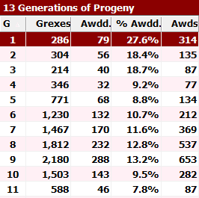
Phalaenopsis pulcherrima is obviously a major building block species with almost 11,000 progeny in 13 generations. 1004 of the grexes have received 2894 awards.

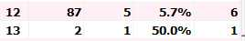

Outstanding progeny:

Phalaenopsis Fire Cracker AM/AOS
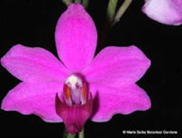
This grex has received 14 AOS awards most of which are quality awards. The hybrid is a F-1 with Phal. Red Coral. It is quite flouriferous with an average of 28 flowers per. The flowers open sequentially, so there are most often buds on the spike. There is a nice range of color from pink to lavender to blue.

Phalaenopsis Pixie Star AM/AOS

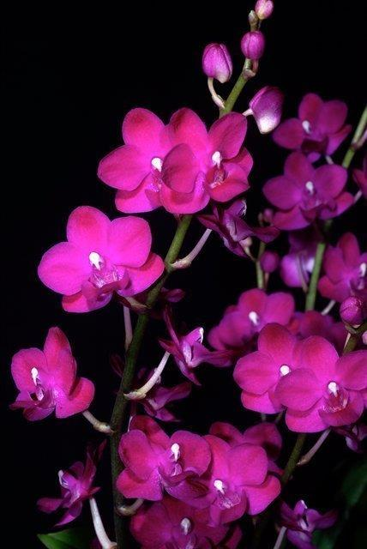
This is another F-1 of P. pulcherrima with Phal. Joyfull which has a lot of P. equestris resulting in a brightly colored, compact multi-floral. The grex has 21 AOS awards and 9 total progeny.

Desirable characteristics which can be passed to progeny:

Contributes an upright inflorescence, brilliant cerise and dark pink flowers, good flower count and ease of propagation because it readily forms basal keikis.

Undesirable characteristics which can be passed to progeny:

The flower form is not as flat as breeders would like and the flowers tend to flower sequentially where opening all at once is preferred. The inflorescences are very long and the flower’s substance is only average.

References:

Aldridge, Peggy. 2008. An Illustrated Dictionary of Orchid Genera. Selby Botanical Garden Press.
¹ Christenson, Eric A. 2001. Phalaenopsis- A Monograph.Timber Press.
² Cribb, CJ. 2014. Epidendroidae. In: Pridgeon AM, Cribb PJ, Chase MW, Rasmussen F, eds. Genera Orchidacearum, Vol. 6. Oxford: Oxford University Press, 344-349.

³Jay Pfahl's IOSPE at www.orchidspecies.com
⁴OrchidWiz.Database X7.1
http://apps.kew.org/wcsp/qsearch.do

https://secure.aos.org/aqplus/SearchAwards.aspx

