Phalaenopsis- Section Deliciosa Species

SPECIES PROGENY AWARDS AWARD TYPE RANGE TEMP/LHT BLOOM TIME
F-1/Total AOS Peak
chibae | 18/20 | 8 | 2 AM, 1 CCE, 1 CHM, 3 HCC | Vietnam | Hot/Lo | May
deliciosa | 35/53 | 12 | 3 AM, 2 CHM, 5 HCC, 1 JC | Widespread SE Asia | Hot/Lo | August
mysorensis |  |  |  | India

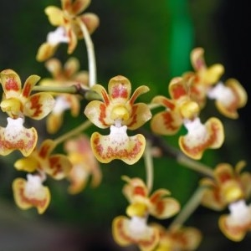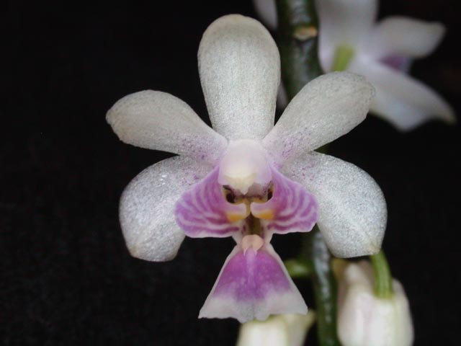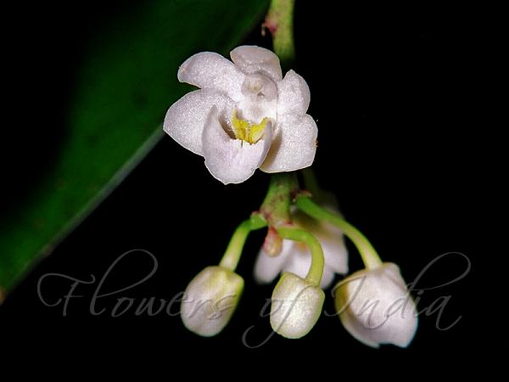
Phal chibae Phal delicosa Phal mysorensis

