Phalaenopsis- Section Esmerelda Species

SPECIES PROGENY AWARDS AWARD TYPE RANGE TEMP/LHT BLOOM TIME
F-1/Total AOS Peak
buyssoniana | 36/500 | 11 | 2 AM, 3 CCM, 4 HCC, 1 JC | Thailand & Indochina | Warm/Lo | September
pulcherrima | 286/10,790 | 118 | 1 AD, 51 AM, 6 CCM, 5 CHM, 46 HCC, 7 JC | SE Asia | Warm/Lo | September
regnieriana

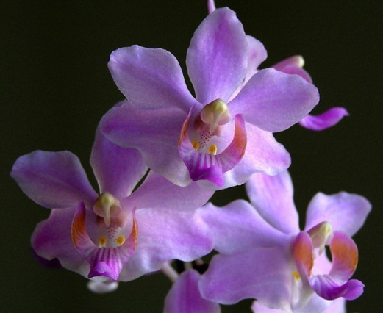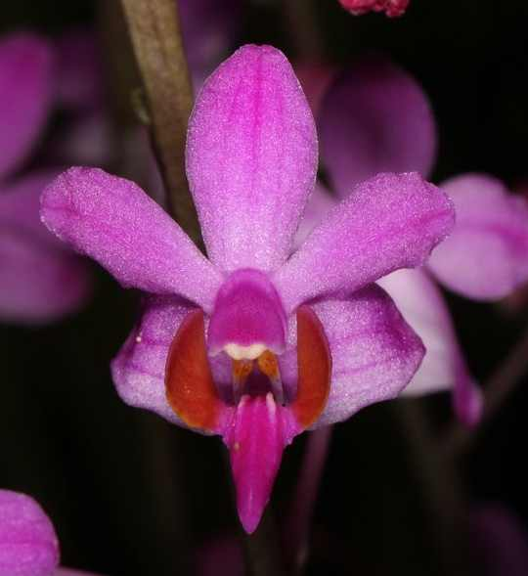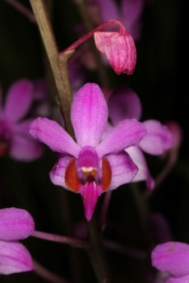
Phal buyssoniana Phal pulcherrima Phal regnieriana

