Species Report

Phalaenopsis chibae T. Yukawa 1996
SUBGENUS Parishinae SECTION Deliciosae E. A Christ 1986₃

Description:
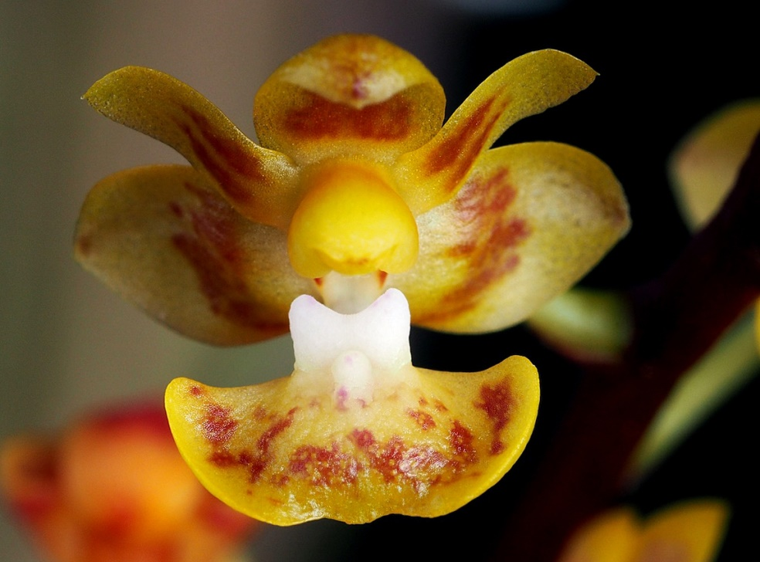
A small sized, hot to warm growing epiphyte with elliptic to obovate, obliquely emarginate, lightly suffused with purple leaves that blooms in the spring on an erect, racemose, dull purple, to 4" [11 cm] long, several flowered inflorescence with to 13 simultaneously opening flowers. ³
Presumably epiphytes. Leaves elliptic to obovate, obliquely emarginate, lightly suffused with purple, to 11 x 4.5 cm. Inflorescences erect racemes, dull purple, to 11 cm long, the floral bracts triangular, acute, to 3 mm long. Flowers to 13, to 1.2 cm wide, opening simultaneously, pale yellow with chestnut-brown irregular markings, the tips of the sepals and petals unmarked, the callus white with purple markings. Dorsal sepal oblong, obtuse, concave, 4.5 x 3.5 mm, the lateral se-pals obliquely elliptic-ovate, obtuse, 6 x 4.5 mm. Petals oblong, obtuse, concave toward the apex, 5.5 x 2.5 mm. Lip three-lobed, sac-cate, densely pubescent behind the callus, 6 x 8.5 mm, the lateral lobes much smaller than the midlobe, triangular, acute, 1 mm long, the midlobe transverse, broadly reniform, obtuse-rounded with a central shallow notched, 5 x 8.5 mm, the callus biseriate, the posterior callus a conspicuous transverse thick wall-like ridge across the entire base of the midlobe, the anterior callus a small raised pad. Column stout, with a prominent foot, to 4 mm long; the pollinia four in two highly unequal pairs. Pedicel and ovary terete, to 1.4 cm long. Etymology: Named for Masaaki Chiba of Japan, who discovered the species. This recently discovered species is quite rare in cultivation, and I know the entity only from the original publication and observing one plant in bud in a private collection in Chicago. It is truly unique in the genus in having a single transverse callus. I agree with Yukawa that on the basis of its four pollinia and small spur it is best placed in this section—and I admit that the buds are superficially similar to those of P deliciosa—but will emphasize the oddness of the callus. Future study may show that P chibae deserves a separate section or subgenus.¹
Synonyms:

Doritis chibae (T.Yukawa) T.Yukawa & K.Kita 2005; Kingidium chibae [Yukawa] Gruss & Rolke 1997³
Distribution/Habitat:

Vietnam. Found near Dalat at 1300-1950 ft. (400-600 m).⁴ Found in Vietnam in tropical moist forests at elevations of 400 to 600 meters.³ Distribution: Endemic to Vietnam at 400-600 m in elevation.¹
Awards:

Origin | HCC | AM | FCC | CBR | CCE | CCM | Total
 | 3 | 2 | 0 | 1 | 1 | 1 | 8
Years | 2003-2015 | 2004-2012 |  | 2000 | 2012 | 2006

Hybrids: F-1

2000-2009 | 2010-2019 |  |  |  |  |  | Total
9 | 9 |  |  |  |  |  | 18

Hybrids: Total Progeny

2000-2009 | 2010-2019 |  |  |  |  |  | Total
10 | 10 |  |  |  |  |  | 20

Being only recently described, Phalaenopsis chibae is behind the other Section Deliciosae species in regard to hybrids, It most likely catch up because it is a desirably plant for hybridization. The first hybrids were not registered until 2003.

Significant Progeny

Phalaenopsis Musick Surprise AM/AOS
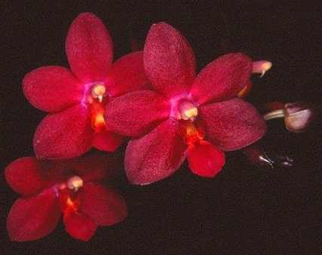
This is a primary cross with Phalaenopsis pulcherrima, another star of the multi-floral miniature group of Phals. It has a couple of offspring and 6 AOS awards. The hybrid is highly variable in its color palatte ranging from white to pink to the image at the left. It is a very floriferous, with an average of 26 flowers on a very compact plant.The hybrid gets its round, full form from P. pulcherrima.

Phalaenopsis Tying Shin Glider HCC/AOS

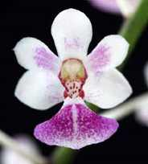
This is another attractive multi-floral miniature orchid with a good flower count and good arrangement of the flowers on the inflorescence. Three of its 4 awards are from Taiwan, The P. chibae vertically elongated form is dominant over its other 2 other Deliciosae parents.

References:

Aldridge, Peggy. 2008. An Illustrated Dictionary of Orchid Genera. Selby Botanical Garden Press.
¹Christenson, Eric A. 2001. Phalaenopsis- A Monograph.Timber Press.
² Cribb, CJ. 2014. Epidendroidae. In: Pridgeon AM, Cribb PJ, Chase MW, Rasmussen F, eds. Genera Orchidacearum, Vol. 6. Oxford: Oxford University Press, 344-349.

³Jay Pfahl's IOSPE at www.orchidspecies.com
⁴OrchidWiz.Database X7.1
http://apps.kew.org/wcsp/qsearch.do

https://secure.aos.org/aqplus/SearchAwards.aspx

