SPECIES REPORT
Phalaenopsis regnieriana Rchb.f. 1987
SUBGENUS Parishianae SECTION Esmeralda

Description:

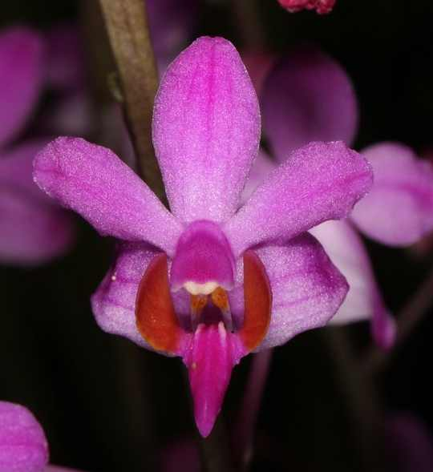
A small sized, hot to warm growing terrestrial with a short, leafy stem, carrying oblanceolate to narrowly elliptic, obtuse to subacute leaves that blooms in the summer on a simple, erect to 3' [90 cm] tall, inflorescence carrying many flowers of which up to 10 may be open at once with the inflorescence lengthening as the bloom season unfolds. ³
Terrestrials similar to P pulcherrima in growth habit, leaf morphology, inflorescence structure, dimensions, and general characteristics of the flower, including column morphology. Lip three-lobed, to 1.4 cm long, to 0.5 cm wide across the expanded lobule of the midlobe, the lateral lobes linear-lanceolate, ca. 1.8 mm long, the midlobe three-lobulate, the lateral lobules small, suborbicular, rounded-obtuse, the middle lobule oblong-ovate, obtuse-rounded, the callus bifid. Phalaenopsis regnieriana spent most of its history in obscurity, placed by authors without scrutiny in the synonymy of P pulcherrima as early as 1892 in Stein's Orchideenbuch. Holttum (1965) studied the holotype of P. regnieriana and established that this species deserved recognition. Seidenfaden (1988a) also examined the holotype and provided an il-lustration for the first time. At first glance a flower of P. regnieriana resembles a slightly deformed P pulcherrima. The sepals, petals, and col-umn are essentially identical. The lip is also similar but differs in P regnieriana by having the lateral lobules of the midlobe as small, lightly incurved lobules, unlike the large, parallel, erect lobules found in P pulcherrima. In addition, the callus of P regnieriana is a well-developed bifid structure, unlike the rounded to very shallowly notched callus of P pulcherrima. Known only from the type collection, Seidenfaden questions the Thailand origin of this species, noting Regnier's horticultural connec-tions with Indochina in addition to the total absence of modern Thai collections of this species. I will only add a comment about the existence of one unusual collection from Indochina (Annam, without precise locality, 2 Oct. 1921, McClure 7494), which I located in Zurich (Z). This collection bears very narrow, oblanceolate leaves less than 2 cm wide (resembling the very weak-growing, cultivated color variants that suffer from inbreeding depression) and may represent P regnieriana. Unfortunately, the one sample of this collection, originally distributed by the Canton Christian College, has neither buds nor flowers remaining on the specimen. ¹
Although Phalaenopsis regnieriana is recognized as a species by Christenson, most other authors consider it synonymous with Phalaenopsis pulcherrima. The American Orchid Society does also. OrchidWiz lists it but with No Data.
Distribution/Habitat:

Recorded as endemic to Thailand.¹

References:

Aldridge, Peggy. 2008. An Illustrated Dictionary of Orchid Genera. Selby Botanical Garden Press.
¹ Christenson, Eric A. 2001. Phalaenopsis- A Monograph.Timber Press.
² Cribb, CJ. 2014. Epidendroidae. In: Pridgeon AM, Cribb PJ, Chase MW, Rasmussen F, eds. Genera Orchidacearum, Vol. 6. Oxford: Oxford University Press, 344-349.

³Jay Pfahl's IOSPE at www.orchidspecies.com
⁴OrchidWiz.Database X7.1
http://apps.kew.org/wcsp/qsearch.do

https://secure.aos.org/aqplus/SearchAwards.aspx

