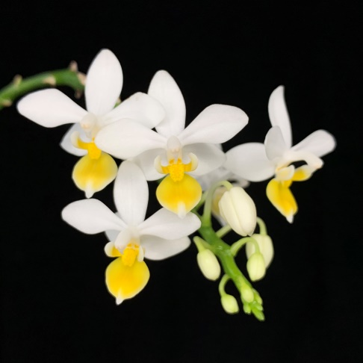
Phalaenopsis equestris HCC/AOS 76 Points
Thirty-four flowers and fourteen buds on two branched inflorescences: sepals and petals pure white; lip white, all but apex overlaid lemon yellow; substance firm; texture crystalline.

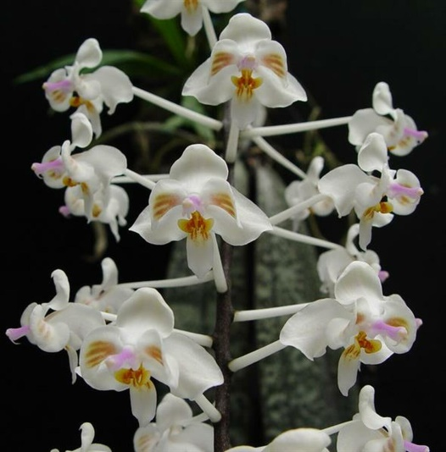
Phalaenopsis celebensis AM/AOS 82 Points
Twenty six flowers and six buds well presented on one arching inflorescence:sepals white, dorsal cupped; petals white, overlaid light brown centrally, overlay striped; lip white, overlaid light brown, striped red-brown; column white, overlaid lavender; substance firm; texture matte.

Phalaenopsis Purple Gem CCM/AOS 81 Points
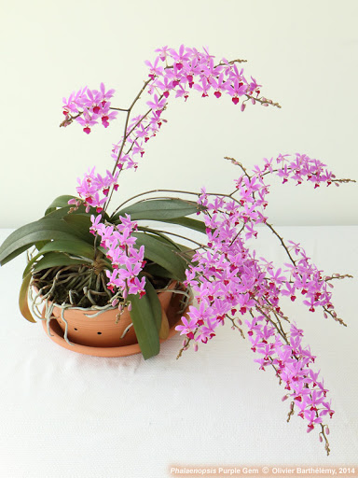
One hundred seven flowers and twenty-three buds on three branched, arching 42 cm inflorescences on a plant with clear unmarked leaves grown in a 30 cm clay pot on bark; sepals and petals light pink; lip dark magenta; column purple, anther cap cream; substance firm; texture matte.

Phalaenopsis lindenii HCC/AOS 77 Points
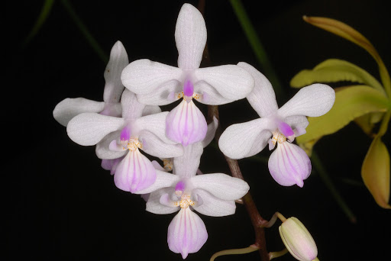
Seven flowers and four buds on one inflorescence; sepals and petals white, indestinctly veined light magenta; lip white, overlaid apically and veined light magenta; column magents; substance firm; texture crystalline.

Vandaenopsis Pulcherrimin AM/AOS 81 Points
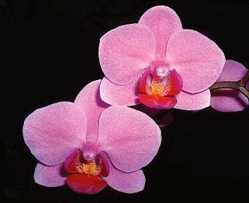
Twenty-three well-arranged flowers and four buds on one branched inflorescence; flowers light pink; lip dark fuchsia, golden yellow basally: column and anther cap fuchsia ; substance firm; texture matte.

