BUILDING BLOCK DATA
Phalaenopsis equestris (Schauer)Rchb.f 1850
SUBGENUS Phalaenopsis SECTION Phalaenopsis Benth 1883

Description:
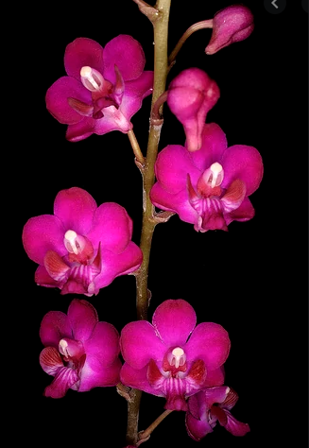
A small sized, hot growing epiphyte with a short stem enveloped by several imbricating leaf bases and carrying to 5, fleshy, recurved, oblong-elliptic to oblong-ovate, acute or subobtuse leaves that blooms at almost any time of the year although the peak is September through April on a suberect to arcuate, to 12" [30 cm] long, racemose or paniculate, denesly many flowered inflorescence with small, purple bracts and successively opening flowers. ³
Epiphytes. Leaves variable in size and shape, oblong-elliptic to oblon ovate to elliptic, acute to subobtuse, green without any markings, generally to 20 x 6.5 cm but larger in some populations. Inflorescences densely many-flowered racemes or panicles, long-pedunculate, the peduncles erect, the rachis arching-subpendent, the apex frequently forming a plantlet following flowering, the floral bracts insignificant, to 2 mm long. Flowers variable in color and size, opening simultaneously, typically the sepals and petals white or pale pink with a central pink suffusion, the lip solid rose or red, the callus white or yellow +/—rose or red spotting, the column rose, the anther white. Sepals sub-similar, subequal, lightly reflexed, oblong-elliptic, acute, to 1.7 x 0.8 cm, the lateral sepals somewhat oblique, divergent. Petals elliptic-rhombic, clawed, obtuse to subacute, to 1.5 x 0.8 cm. Lip three-lobed, to 1.4 cm long, to 1.6 cm wide across the expanded lateral lobes, the lateral lobes oblong-oblanceolate, obtuse-rounded, erect-incurved, the midlobe ovate-trullate, acute with a laterally constricted blunt tip, the callus soli-tary, peltate, quadrangular with a truncate apex. Column lightly arch-ing, to 0.9 cm long. Pedicel and ovary to 2 cm long. Distribution: The Philippines and Taiwan. Etymology: From the Latin, equester, pertaining to riding and cavalry. The basis for this name is obscure.
Phalaenopsis equestris is highly variable, both vegetatively and in flower color. Several independent genes control the expression of both anthocyanions and carotenoids in the lip of P. equestris, and several horticultural varieties have been published based on the permutations of whether or not these genes are expressed. Sweet recognized two of these: var. leucaspis Rchb.f., which lacks yellow pigments associated with the white callus; and var. leuco-tanthe Rchb.f. ex Godefroy-Lebeuf (= var. aurantiaca Gower), which has deep orange pigments associated with the callus. Ac-cording to Cesar Zapata, Jr. (in litt.), these variants and others with different combi-nations of pigment appear to occur spo-radically throughout all populations of P equestris as part of the normal allele frequencies, and no 'evidence suggests any of these are linked to geographic isolation (i.e., candidates for recognition as subspecies). For this reason, and the requisite need to publish additional new varieties for consistency, I do not formally recognize these variants in this study. Peloric forms of all color variants exist, and peloric-flowered hybrids are produced with some frequency from breeding with standard, non-peloric P equestris. This is especially true of hybrid combinations that include P. pulcherrima. This tendency to produce peloric-flowered off-spring also gave rise to the peloric form of P. xintermedia, the informal var. diezii. Phalaenopsis equestris is in the background of nearly all semi-alba (white with a contrastingly colored lip) and striped hybrids. Recently the species has gained favor in producing multiflora hybrids for the pot-plant trade. Taiwanese plants, originally described as P riteiwanensis, do not dif-fer in any significant way from Philippine plants (see the drawing re-produced in Liickel 1980:223). In general, Taiwanese plants of P equestris bear flowers with a more open form and rather nondescript coloration, making them less desirable in horticulture. Three color variants, all important parents in modern breeding pro-grams, are formally treated here. ¹
The three color varieties, rosea, alba and aurea, are no longer recognized taxonomically.
Var. rosea: This variety of P equestris has recently come into wide cultivation. Instead of bearing pale pink or white sepals and petals with a darker, central patch, the floral segments are uniformly dark rose-purple with-out any lighter borders.
Var alba: This is a pure white form of the species with a non-pigmented callus.
Var. aurea: This is another pure white form but with a highly contrasting solid yellow lip.
Synonyms:

Phalaenopsis equestris f. alba hort. 1969; Phalaenopsis equestris f. alba [Hort] E A Christensen 2001; Phalaenopsis equestris f. aurea Christenson 2001; Phalaenopsis equestris f. cyanochila O.Gruss 2001; Phalaenopsis equestris [Schauer] Rchb.f var alba [Hort.] Sweet 1967; Phalaenopsis equestris [Schauer] Rchb.f var leucaspis Rchb.f 1881; Phalaenopsis equestris [Schauer] Rchb.f var leucotanthe Rchb.f 1883; Phalaenopsis equestris var. rosea Valmayor & D.Tiu 1984; Phalaenopsis esmeralda auct. non Rchb.f ?, Phalaenopsis riteiwanensis Masaume 1934, Phalaenopsis rosea Lindley 1848; Phalaenopsis rosea var aurantiaca Gower 1892; Phalaenopsis rosea var deliciosa Barb. 1882; Phalaenopsis rosea var leucaspis [Rchb.f] Rolfe 1886; Phalaenopsis stauroglottis [Schauer] Rchb.f 1881; *Stauroglottis equestris Schauer 1843; Stauroglottis riteiwanensis (Masam.) Masam. 1934 ³
Distribution/Habitat:

Distribution: Found from the Philippines and southern Taiwan near streams in hot valleys at an altitude of sea level to 300 meter.³
Luzon Island, Philippines, to Taiwan at 0-990 ft. (0-300 m), near streams in hot valleys.. Source: Charles Baker ⁴
Awards:

Origin | HCC | AM | FCC | JC | CHM | CCM | Total
 | 30 | 5132 | 2 | 19 | 3 | 12 | 101
Years | 1990-2017 | 1987-2019 | 1993-1995 | 1960-2017 | 1979-2011 | 1959-2014

Hybrids: F-1 564
Before  1940 | 1940-49 | 1950-59 | 1960-69 | 1970-79 | 1980-89 | 1990-99 | After 1999
10 | 2 | 9 | 28 | 24 | 49 | 193 | 249

Hybrids: Total Progeny – 23,601
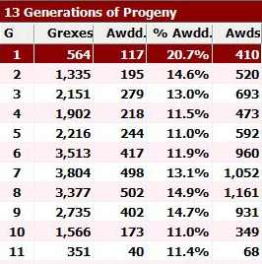
Phalaenopsis equestris is obviously a major building block species with over 23,000 progeny in 13 generations. It is in the background of nearly all semi-alba and striped hybrids, hence the large number of progeny.

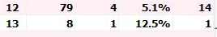

Outstanding progeny:

Phalaenopsis Purple Gem AM/AOS
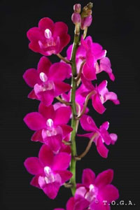
This grex has received 30 AOS awards, all but three are quality awards. The hybrid is a F-1 with Phalaenopsis pulcherrima registered in 1963. It has 33 F-1 and 46 total progeny

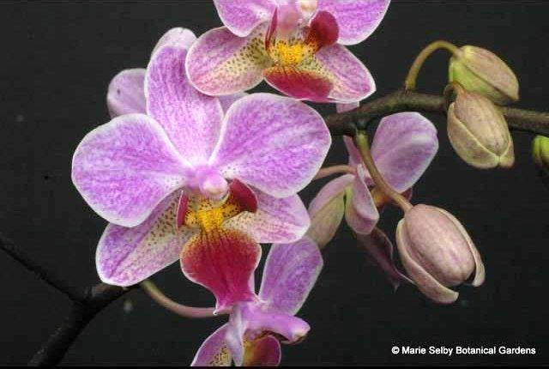
Phalaenopsis Cassandra AM/AOS

This is F-1 primary of P. equestris with P. stuartiana. It has been around for a long time having been registered by Veitch in 1896. The grex has 24 AOS awards, 226 F-1 and 3,759 progeny.

Desirable characteristics which can be passed to progeny:

Produces small, branched, heavily flowering plants which popularized window sill orchids for a wide audience. Peloric forms of all color variants exist and this trait can be passed on to progeny

Undesirable characteristics which can be passed to progeny:

The presentation of flowers on the inflorescence is not the greatest with crowding a big problem.

References:

Frowine, Steven. 2008. Moth Orchids, The Complete Guide to Phalaenopsis. Timber Press
¹ Christenson, Eric A. 2001. Phalaenopsis- A Monograph.Timber Press.
² Cribb, CJ. 2014. Epidendroidae. In: Pridgeon AM, Cribb PJ, Chase MW, Rasmussen F, eds. Genera Orchidacearum, Vol. 6. Oxford: Oxford University Press, 344-349.

³Jay Pfahl's IOSPE at www.orchidspecies.com
⁴OrchidWiz.Database X7.1
http://apps.kew.org/wcsp/qsearch.do

https://secure.aos.org/aqplus/SearchAwards.aspx

