Phalaenopsis- Section Stauroglottis Species

SPECIES PROGENY AWARDS AWARD TYPE RANGE TEMP/LHT BLOOM TIME
F-1/Total AOS Peak
celebensis | 49/75 | 19 | 32 AM, 2 CCM, 1 CBR, 8 HCC, 1 JC | Indonesia | Hot/Lo | Nov
equestris | 564/23,601 | 101 | 3 AM, 1 AQ, 2 CBM, 12 CCM, 3 CHM, 2 FCC, 30 HCC, 19 JC | Philippines, Taiwan | Hot/Lo | Nov
lindenii | 120/654 | 22 | 12 AM, 2 CCM, 7 HCC, 1 JC | Luzon, Philippines | Warm/Lo | Sept

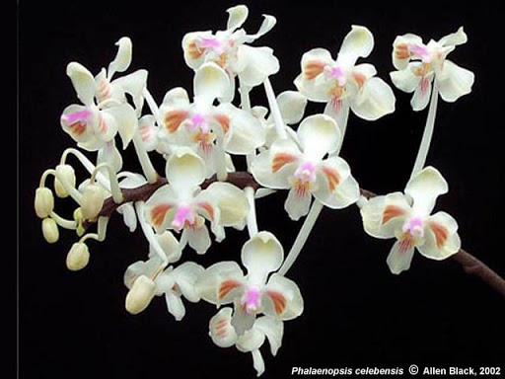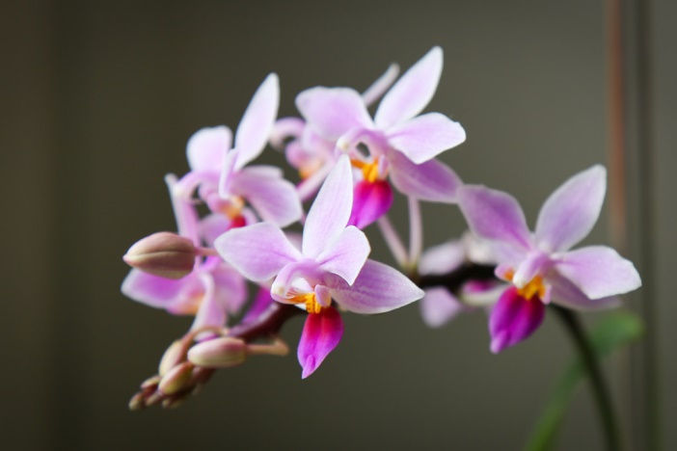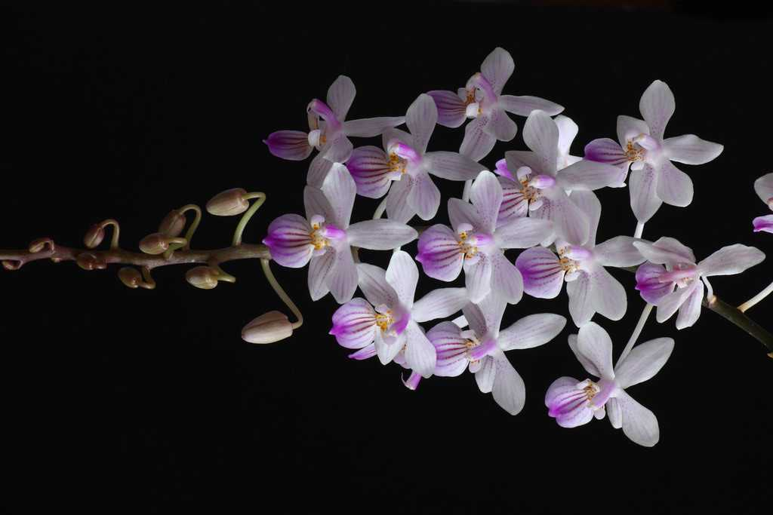
Phal celebensis Phal equestris Phal lindenii

