Phalaenopsis- Section Amboinensis Species

SPECIES PROGENY AWARDS AWARD TYPE RANGE TEMP/LHT BLOOM TIME
F-1/Total AOS Peak
amboinensis | 551/17,394 | 83 | 37 AM, 1 CBR, 7 CCM, 1 CHM, 37 HCC | Indonesia | Hot/Lo | Feb
bellina | 145/548 | 104 | 55 AM, 3 AQ, 1 CBM, 1 CCE, 12 FCC, 29 HCC | Borneo | Warm/Lo | July
bastianii | 20/21 | 10 | 3 AM, 3 CCM, 2 CHM, 2 HCC | Philippines | Warm/Lo | March
doweryensis | 10/10 | 3 | 2 AM, 1 CBR | Borneo | Hot/Lo | Jul/Dec
fasciata | 125/11,254 | 6 | 1 AM, 2 CCM, 3 HCC | Philippines | Hot/Lo | Sept
fimbriata | 58/176 | 5 | 1 AM, 1 CBM, 2 CCM, 1 HCC | Java and Sumatra | Warm/Lo | May
floresensis | 42/100 | 4 | 2 AM, 2 CHM | Indonesia, Flores Island | Hot/Lo | May
gigantea | 292/6,512 | 64 | 22 AM, 1 CBM, 4 CCE, 14 CCM, 22 HCC, 1 JC | Borneo | Hot/Lo | Sept
hieroglyphica | 23/9,924 | 65 | 22 AM, 1 CBM, 5 CCE, 22 CCM, 1 CHM, 1 FCC, 12 HCC | Philippines | Hot/Lo | Oct
javaanica | 114/242 | 9 | 2AM, 1 CBM, 1 CCM, 1 CHM, 3 HCC | Java | Hot/Lo | May
lueddrmanniana | 345/22/350 | 40 | 15 AM, 1 CCE, 4 CCM, 3 CHM, 1 FCC, 13 HCC, 2 JC | Philippines | Warm/Lo | May
maculata | 37/83 | 6 | 1 CBM, 1 CCM, 1 CHM, 3 HCC | Malaysia, Borneo | Hot/Lo | Aug
mariae | 109/1,521 | 10 | 3 AM, 1 CBM, 4 CCM, 2 HCC | Borneo to Philippines | Hot/Lo | Jun
micholitzii | 67/2,163 | 5 | 2 AM, 3 HCC | Philippines | Hot/Lo | Jan
modesta | 44/52 | 4 | 1 CCM, 1 CHM, 2 HCC | Borneo | Hot/Lo | Jun
pallens | 28/506 | 6 | 1 AM, 1 CBM, 1 CCM, 3 HCC | Philippines | Hot/Lo | Mar, Nov
pulchra | 44/77 | 3 | 2 CCM, 1 JC | Philippines | Warm/Lo | May, Sep
pulcherrima | 286/10,790 | 118 | 51 AM, 1 AQ, 1 CBM, 6 CCM, 5 CHM, 46 HCC, 7 JC | SE Asia | Warm/Lo | Sep
venosa | 344/4,074 | 28 | 3 AM, 1 CCE, 4 CCM, 1 CHM, 1 FCC, 5 HCC | Indonesia, Sulawesi | Hot/Lo | Oct
violacea | 520/6,359 | 161 | 65 AM, 2 CBM, 1 CCE, 20 CCM, 63 HCC, 10 JC | Malaysia | Hot/Lo | Jul-Oct

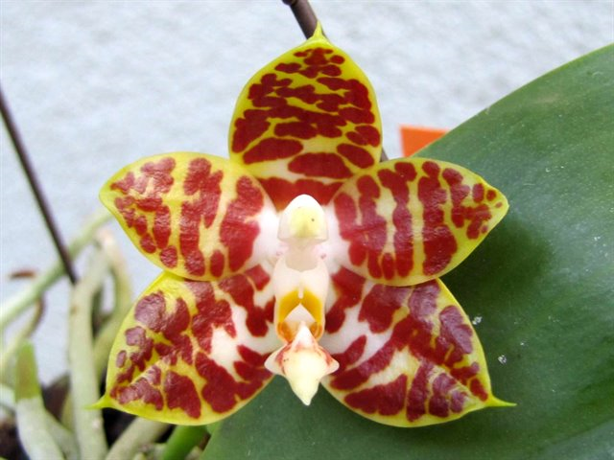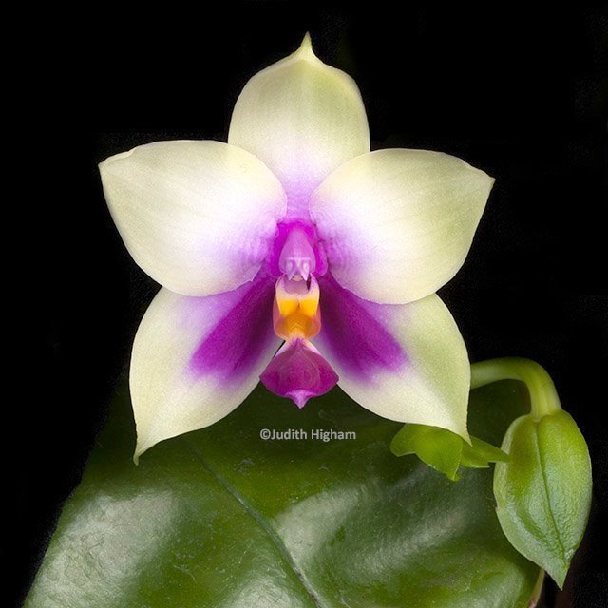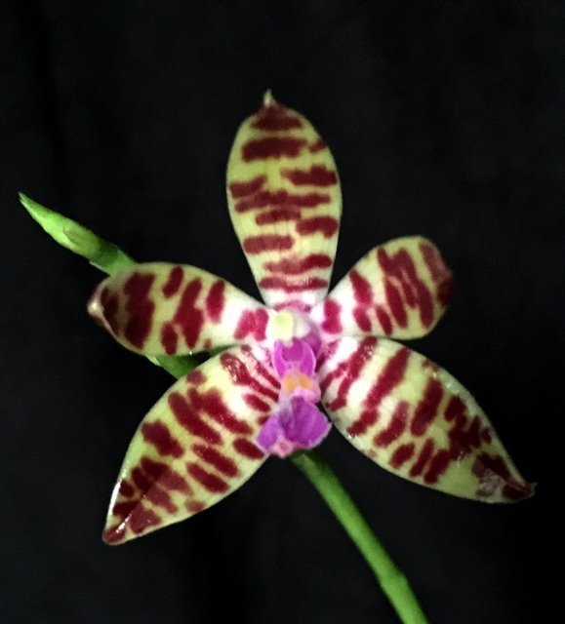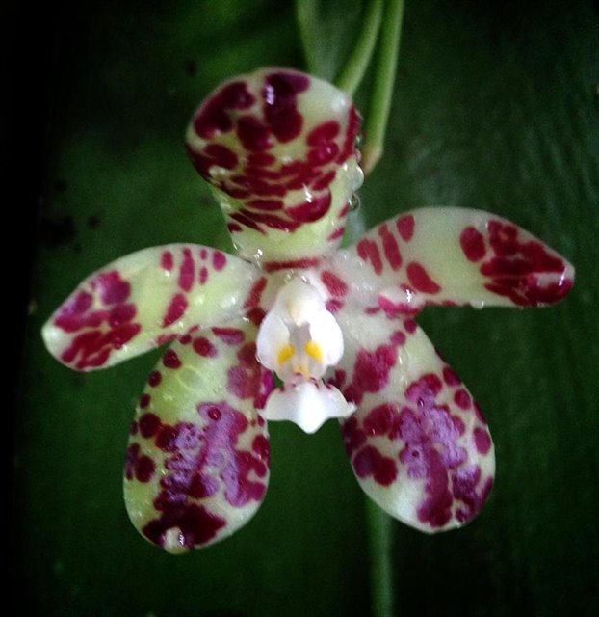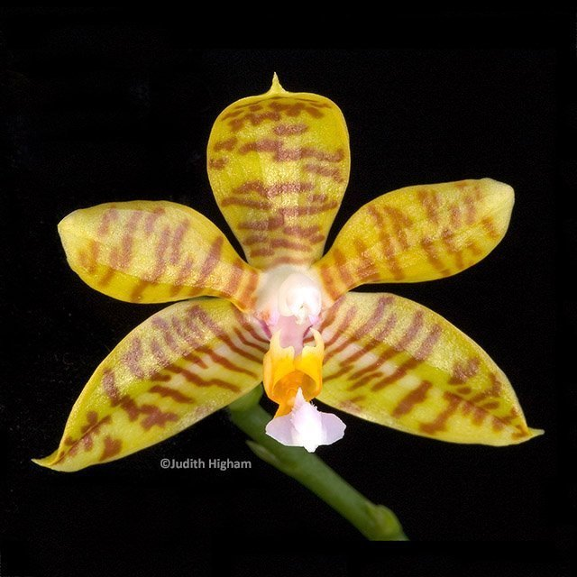
Phal amboinensis Phal bellina Phal bastianii Phal doweryensis Phal fasciata

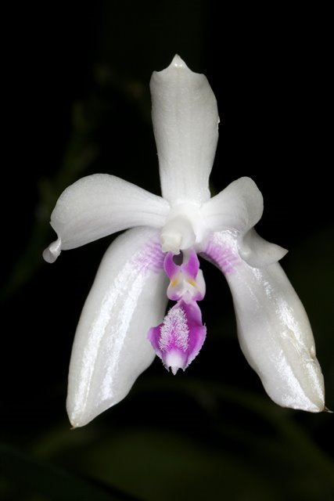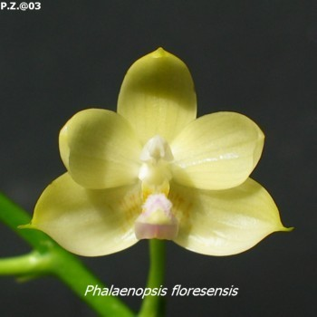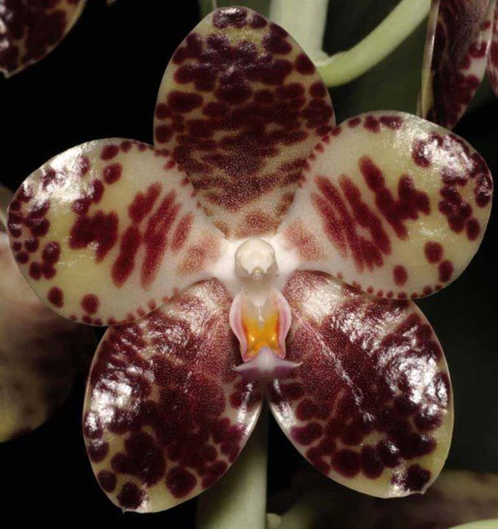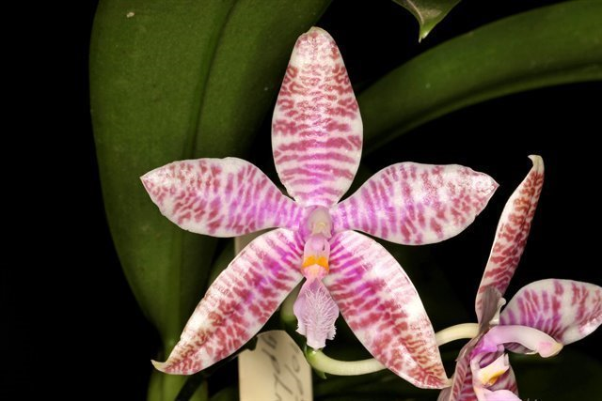
Phal fimbriata Phal floresensis Phal gigantea Phal hieroglyphica

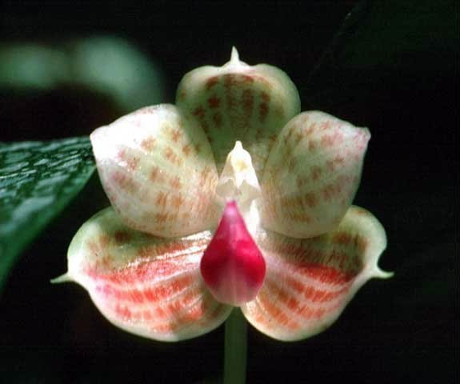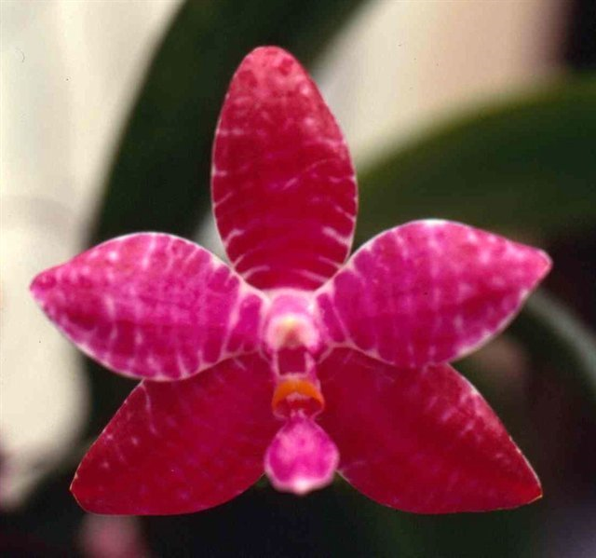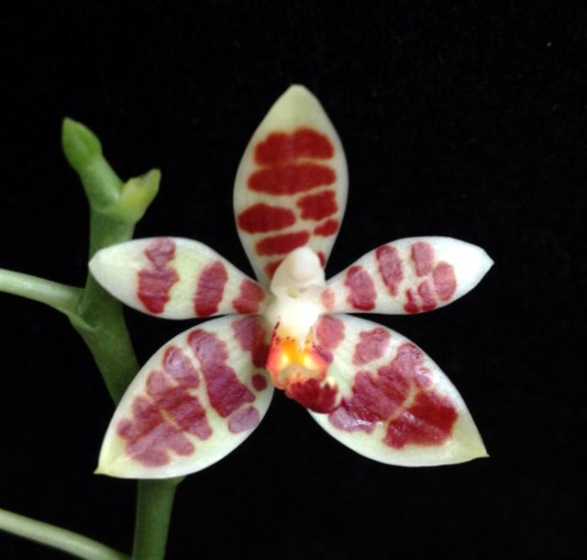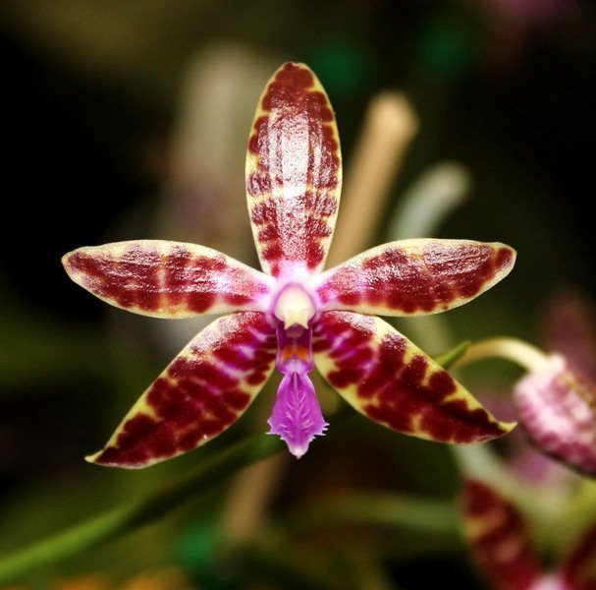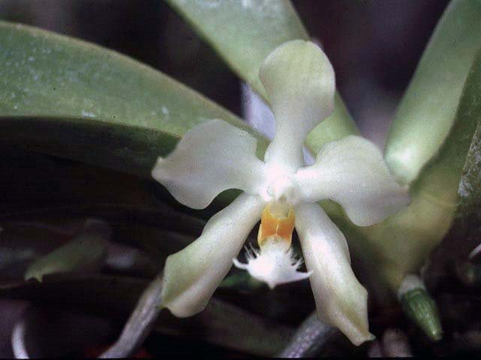
Phal javanica Phal lueddemanniana Phal maculata Phal mariae Phal micholitzii

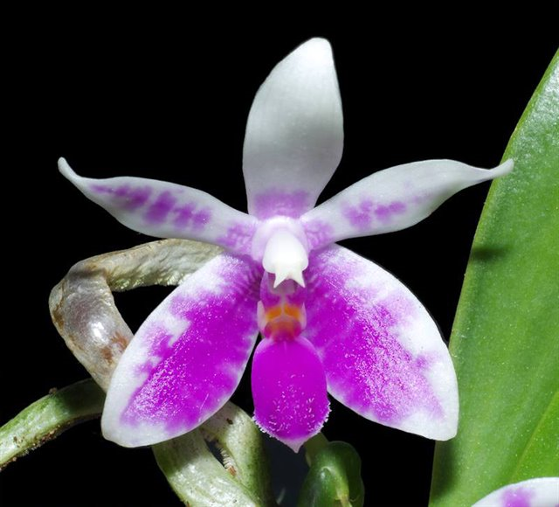 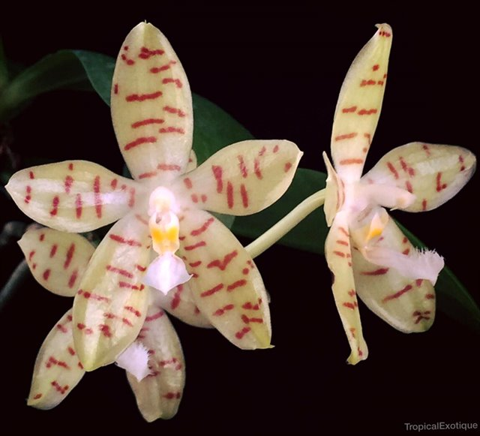 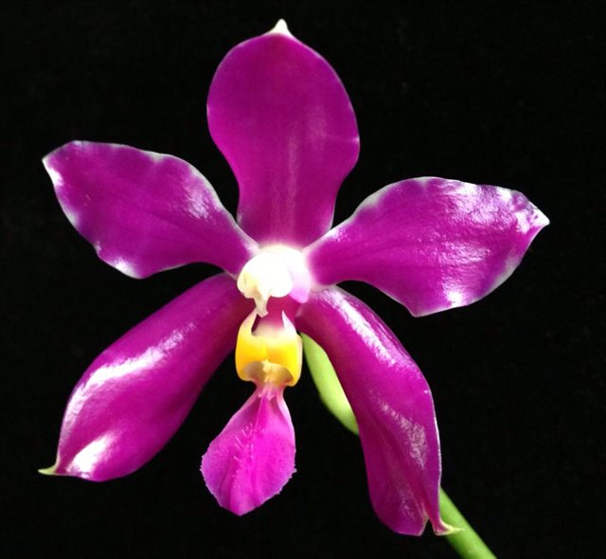 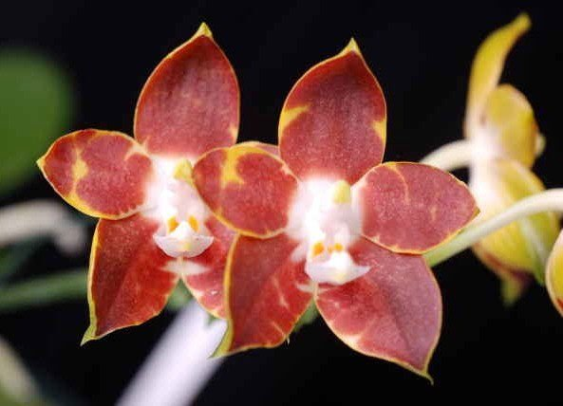 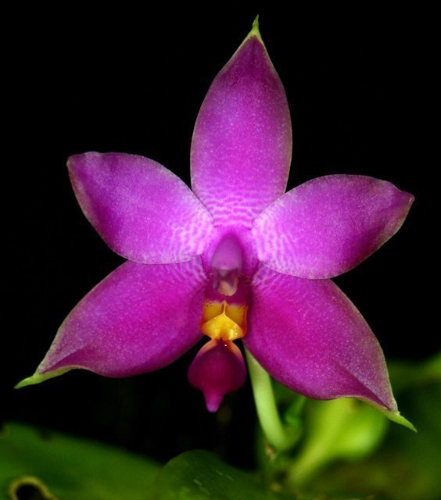 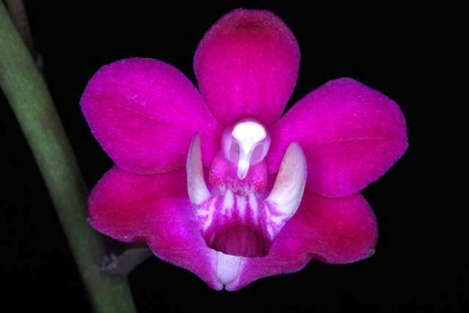 Phal modesta Phal pallens Phal pulchra Phal venosa Phal violacea Phal pucherrima

