Phalaenopsis modesta HCC/AOS 77 Points
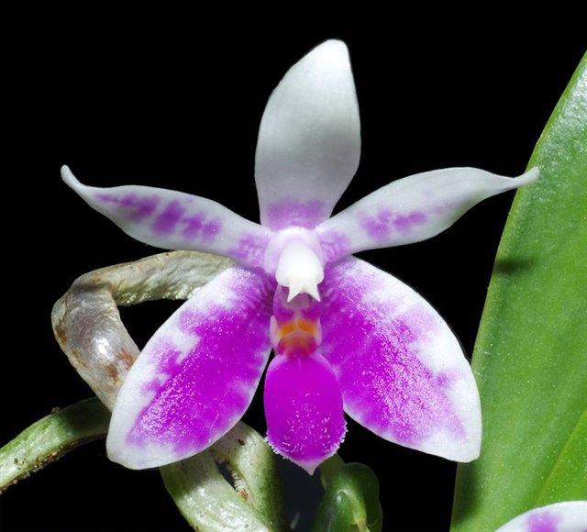
Ten flowers and two buds on four upright inflorescences; dorsal sepal white, blushed light magenta basally; petals white, barred magenta; lateral sepals white, overlaid magenta inferior two-thirds, barred magenta superior one-third; lip white, overlaid solid magenta except narrow distal margin, crest golden yellow; column white; substance firm; texture satiny.

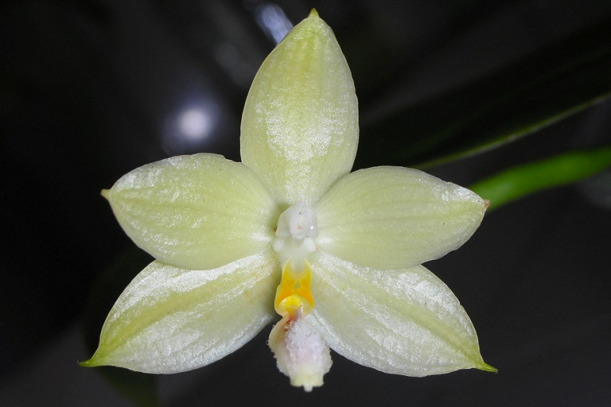
Phalaenopsis floresensis AM/AOS 87 Points
Five full flat flowers and two buds on two arching inflorescences; sepals and petals cream yellow; dorsal sepals with a darker yellow medial stripe; lip mid-lobe cream yellow, rose pink basally, lateral lobes golden yellow; column white; substance heavy; texture waxy.

Phalaenopsis Pylo’s Sweet Purple HCC/AOS 75 Points
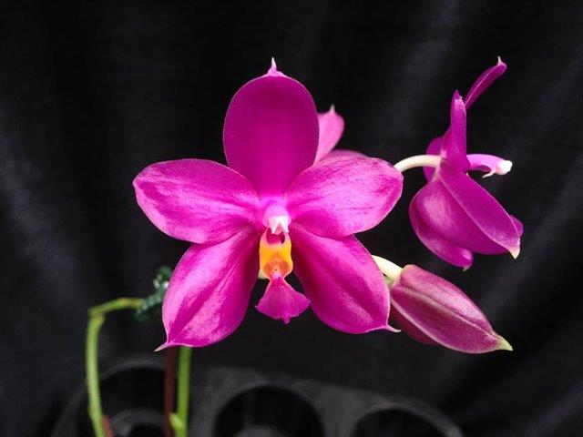
Two flat flowers and one bud on one arched inflorescence; sepals and petals rose-lavender, apices white; lip mid-lobe rose lavender, side-lobes golden yellow; column white, base pink; substance firm; texture glossy.

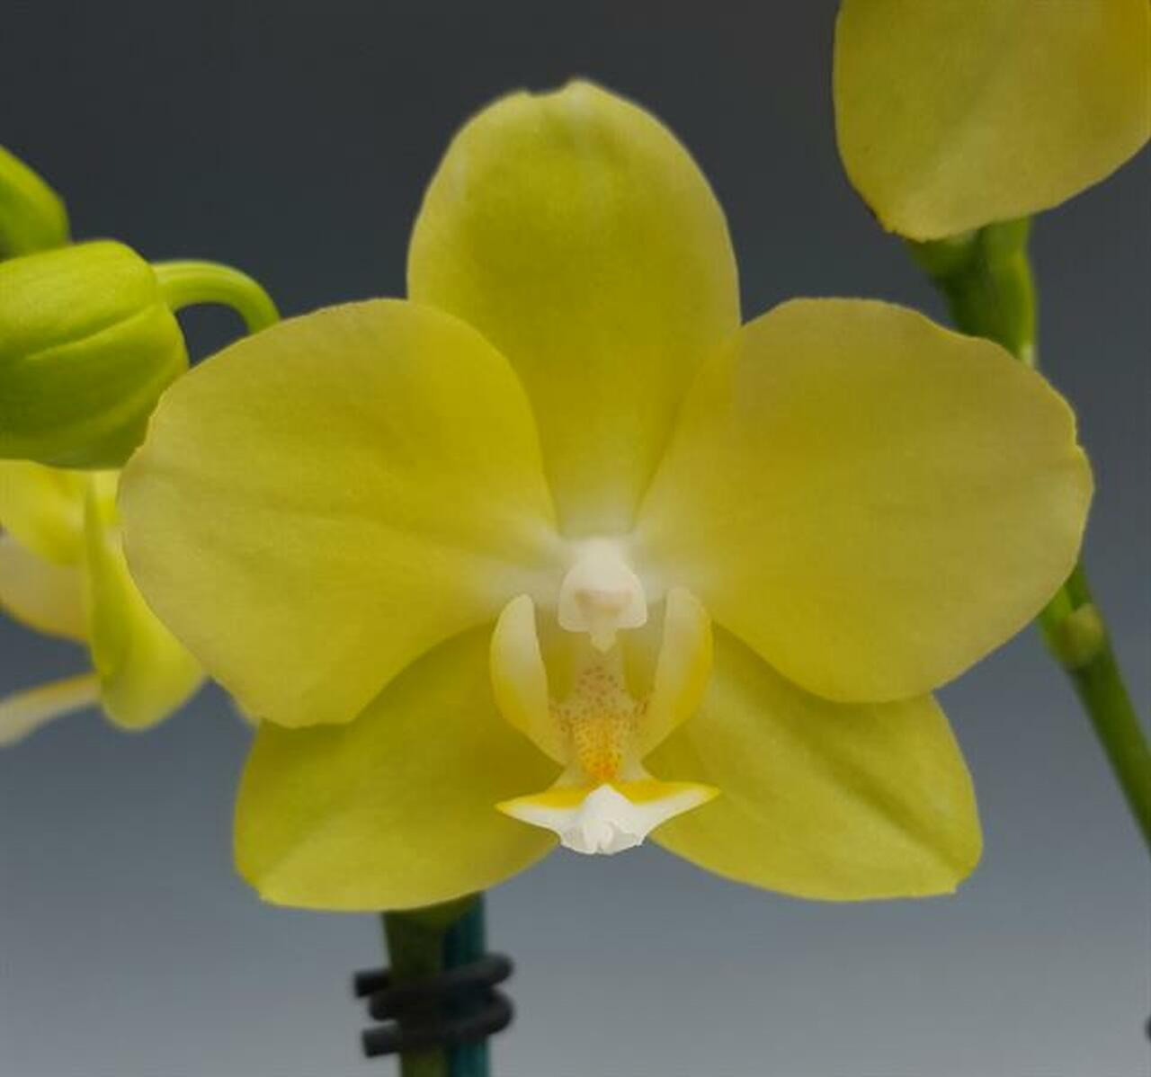
Phalaenopsis Taipei Gold CCM/AOS 82 Points
Forty-six flowers and two buds on three arched inflorescences borne on a plant 70 cm in diameter in a 30 cm plastic pot in bark mix; sepals and petals lempn yelloe, white centrally; lip lemon yellow, throat spotted red-brown, mid-lobe white distally; substance firm; texture matte.

Phalaenopsis pallens AM/AOS 81 Points
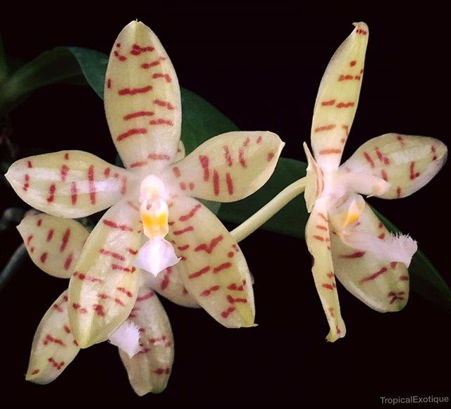
Eight flat, stellate flowers and two buds on four arching inflorescences; sepals and petals cream-yellow, narrowly barred burgundy; lip white, mid-lobe with tufted pubescence, side-lobes gold-yellow; column white; substance firm; texture waxy.

