BUILDING BLOCK DATA
Phalaenopsis violacea Witte 1861
SUBGENUS Phalaenopsis SECTION Polychilos (Breda)Rchb.f

Description:
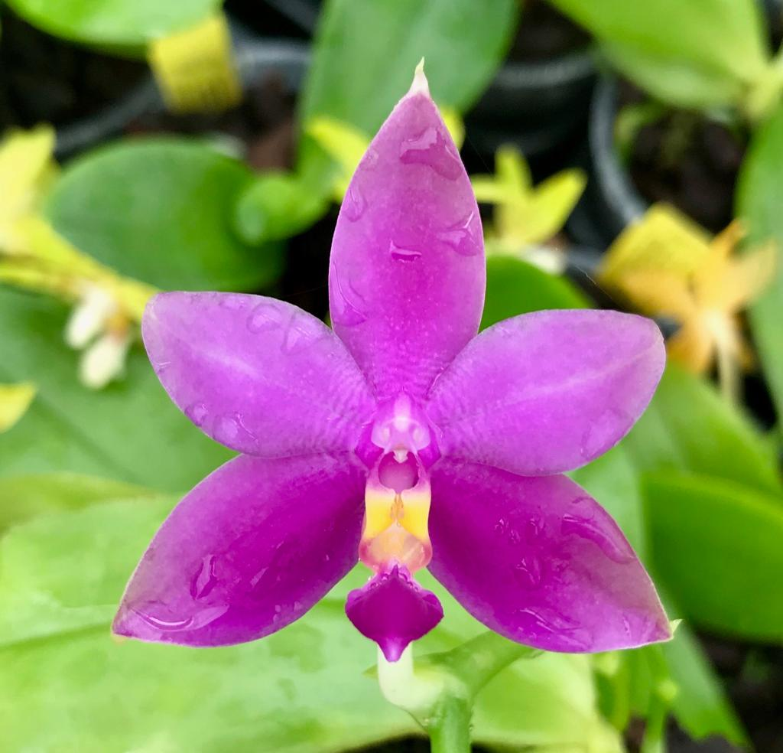
A small to medium sized, hot growing, pendulous epiphyte with a very short stem carrying 3 to 4, elliptical, obtuse, undulate gradually narrowing below into the basally clasping leaves that varies from P bellina by being smaller leafed and with smaller flowers, as well as being easier to cross breed but the results are not as good as with P bellina which is a reluctant breeder from Borneo. P violaceae has extremely fragrant flowers occuring in the spring that are borne one by one in succession on a pendant, stout, jointed, fractiflex, 4 to 5 " [10 to 12.5 cm] long inflorescence with a flattened, zigzag rachis with several [2 to 7], successive, spicy cinnamon scented flowers with 2 to 3 open at any one time.³
Pendulous epiphytes. Leaves succulent, oblong-elliptic to obovate, tapered to the base, acute, rounded, pale to medium green, 20-25 x 7-12 cm. Inflorescences arching racemes, sequentially one- or two-flowered, shorter than the leaves but becoming subequal with age, the rachis fractiflex, the floral bracts ovate, acute, fleshy, bilaterally flattened, to 7 mm long. Flowers fleshy, fragrant, dark rose, the apices of the sepals and petals green, the inner margins of the lateral sepals and the mid-lobe of the lip darker, the lateral lobes of the lip and callus yellow. Dorsal sepal oblong-elliptic, acute-carinate, concave, 20-35 x 8-15 mm, the lateral sepals obliquely elliptic-ovate, acute-carinate, strongly divergent, 22-35 x 11-17 mm. Petals oblique, the upper half oblong, the lower half elliptic-obovate, acute, 20-30 x 7-17 mm. Lip three-lobed, 20-28 mm long, 16-23 mm wide across the expanded lateral lobes, the lateral lobes erect, oblong, truncate with a small tooth-like forward corner and a longer acuminate tooth-like rear corner, the midlobe elliptic-obovate, obtuse-rounded, with a dorsal keel ending in a raised subapical knob above and with a short, carinate keel beneath, the callus bi-seriate with an additional basal glandular field, the posterior callus a stack of fused, short, blunt, apically notched calli, the anterior callus sulcate, bifid. Column lightly arching, dilated toward the apex (club-like), to 1.5 cm long. Pedicel and ovary to 3 cm long. Phalaenopsis violacea has been treated in a broad sense by most authors. This concept included both solid rose-colored flowers from the Malay Peninsula and Sumatra (the "Malaysian" type) and greenish white flowers with purple pigment more or less restricted to the lateral sepals and the lip (the "Borneo" type) known from Borneo and also reported from the Malay Peninsula. The latter are now separated as a distinct species, P bellina, on the basis of differences in morphology and floral fragrance analysis. The flowers of P violacea are usually a rather nondescript rose-purple with varying degrees of green at the tips of the sepals and petals. Recently, more brilliantly flowered clones have entered horticulture, reportedly from Sumatra. Several growers have tagged these with in-formal designations as a distinct new variety. This is actually a back-ward approach to the naming process. The type specimens of both the names listed here came from Sumatra. Thus, if one wanted to make a formal distinction, one would describe the more dull-colored Malay Peninsula entity as new, and the brilliantly flowered Sumatran entity would by definition become a tautonym bearing the epithet of violacea (as, when I published P fimbriata subsp. sumatrana, that action automatically created the tautonym P fimbriata subsp. fimbriata for the original Javan population). I do not elect to formally differentiate these two supposed phases at this time. First, some of the "improved" P violacea in cultivation are actually artificial hybrids of P violacea with P. bellina.¹
Synonyms:

Phalaenopsis violacea f. coerulea Christenson 2001; Phalaenopsis violacea f. alba (Teijsm. & Binn.) Christenson 2001; Phalaenopsis violacea subvar. alba (Teijsm. & Binn.) A.H.Kent 1891; Phalaenopsis violacea var. alba Teijsm. & Binn. 1862 Polychilos violacea (hort. ex H. Witte) Shim 1982; Stauritis violacea [Witte] Rchb.f 1862; Stauropsis violacea Rchb. f. 1862; ³

Distribution/Habitat:

Found in the Malaya peninsula and the Indonesian island of Sumatra at elevations of sea level to 150 meters.³
Borneo, Sumatra, and Malaya. It usually grows on shady trees near lowland rivers, sometimes with P. sumatrana. -- Source: Charles Baker⁴
Awards:

Origin | HCC | AM | CBM | JC | CCE | CCM | Total
 | 63 | 65 | 2 | 10 | 1 | 20 | 161
Years | 1965-2017 | 1961-2019 | 1964, 1961 | 1966-2006 | 2010 | 1959-2019

Hybrids: F-1 520
Before  1940 | 1940-49 | 1950-59 | 1960-69 | 1970-79 | 1980-89 | 1990-99 | After 1999
3 | 1 | 2 | 45 | 100 | 98 | 94 | 177

Hybrids: Total Progeny – 6,359

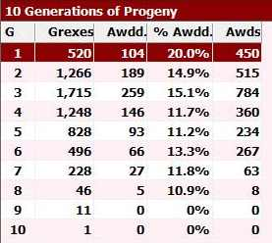
Phalaenopsis violacea is obviously a major building block species with over 6,000 progeny in 10 generations. Many of its progeny are highly awarded and major players in Phalaenopsis breeding in their own right. Eight hundred eighty nine of the P. violacea progeny have been awarded 2,681 awards, quite an astounding record.

Outstanding progeny:
Phalaenopsis Orchid World FCC/AOS

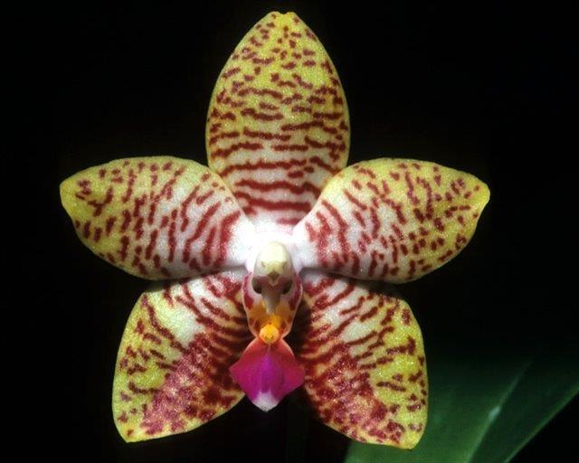
This grex has received 103 AOS awards since 1985, the most of any other P violacea progeny. It is a third generation hybrid through P.Luedde-violacea and P. Malibu Imp. By percentage of parentage, it is half P amboinensis, one quarter P. amabilis and an eighth each of P. violacea and P. lueddemanniana.

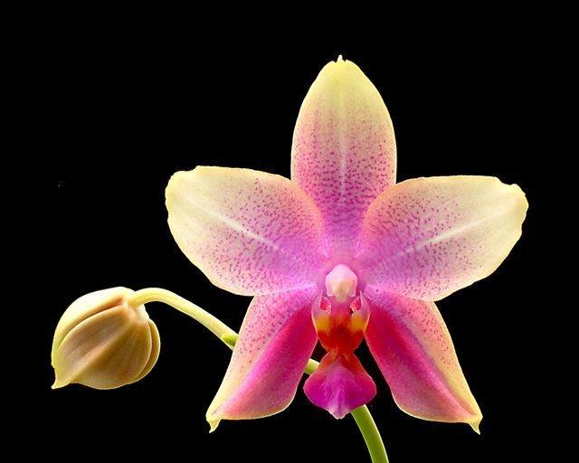
Phalaenopsis Sweet Memory AM/AOS

This is cross with P. Deventeriana, a primary of P. amabilis with P. amboiensis. It was registered by Universal in 1982. The grex has 40 AOS awards, but has not been a prolific breeder with only 39 F-1 and 54 progeny.

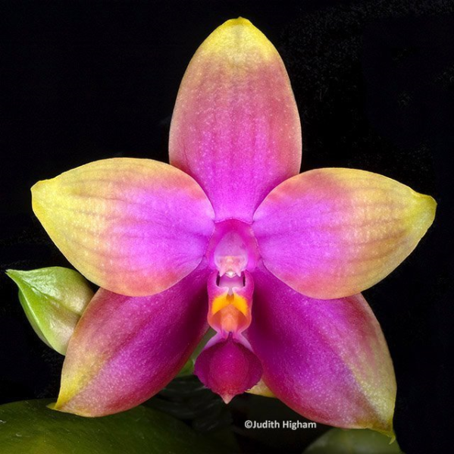
Phalaenopsis Princess Kuhulani AM/AOS

This primary cross with P. amboinensis is both a great breeder and a solid award winner. It has produced 239 F-1 crosses and is in the genetic makeup of 3, 601 progeny.

Desirable characteristics which can be passed to progeny:

P. violacea imparts to hybrids richly colorful, long lasting flowers with an excellent substance. They are compact growing and very fragrant and usually display a colorful lip. The modern superior P violacea form is a result of interbreeding with P. bellina when both were considered P violacea.

Undesirable characteristics which can be passed to progeny:

A problem that has to be dealt with is a low flower count and relatively short inflorescences.

References:

Frowine, Steven. 2008. Moth Orchids, The Complete Guide to Phalaenopsis. Timber Press
¹ Christenson, Eric A. 2001. Phalaenopsis- A Monograph.Timber Press.
² Cribb, CJ. 2014. Epidendroidae. In: Pridgeon AM, Cribb PJ, Chase MW, Rasmussen F, eds. Genera Orchidacearum, Vol. 6. Oxford: Oxford University Press, 344-349.

³Jay Pfahl's IOSPE at www.orchidspecies.com
⁴OrchidWiz.Database X7.1
http://apps.kew.org/wcsp/qsearch.do

https://secure.aos.org/aqplus/SearchAwards.aspx

