Subgenus Polychilos (Breda) E. A. Christ., stat. nov.
Basionym: Polychilos Breda in Kuhl and van Hasselt, Gen. and Sp. Orch. 1. 1827. Type: Polychilos cornu-cervi Breda (= Phalaenopsis cornu-cervi (Breda) Bl.).
Polystylus Hassk., Natuurk. Tijdschr. Nederl. Indie 10:3. 1856. Type: Polystylus cornu-cervi Hassk. (= Phalaenopsis cornu-cervi (Breda) Bl.).
This subgenus bears fleshy, long-lasting flowers with two pairs of calli on the lip (biseriate), the lateral lobes of the lip producing a raised tooth along the leading edge, and two pollinia. The base of the posterior callus may be irregular (and presumably glandular) or a separate field of glandular tissue may occur at the base of the lip, technically yielding a triseriate callus. This triseriate condition is most pronounced in section Polychilos. With a few exceptions (P. floresensis, for one), the flowers of this subgenus are richly pigmented, usually bear spots or bars on the sepals and petals, and are often fragrant. Shim (1982) separated Polychilos as a genus separate from a narrowly defined Phalaenopsis. Although his classification is not followed here, his broad circumscription of Polychilos, one that includes several sections recognized by Sweet (essentially all the "colorful" species), is followed here at the subgeneric level. According to a modern phylogenetic (cladistic) approach, the recognition of a Polychilos as a genus distinct from Phalaenopsis requires further division of Phalaenopsis (i.e., the removal of Polychilos produces a paraphyletic Phalaenopsis in the strict sense). Such an action, which would split Phalaenopsis into at least five genera (the subgenera put forward in this book), is an alternative approach not taken here. Shim's classification has never gained acceptance, and it is unlikely that any classification which radically divides the genus as circumscribed today will find disciples. Species of subgenus Polychilos readily produce interspecific hybrids within the subgenus and produce hybrids with other subgenera with some difficulty. Arends (1970) found a high level of meiotic chromosome homology in hybrids between species of subgenus Polychilos (mean total of 19.00 in the hybrid lueddemanniana x mannii; 18.92 in the hybrid amboinensis x mannii) and lower levels of meiotic chromo-some homology in hybrids between species of subgenus Polychilos and subgenus Phalaenopsis (mean total of 5.00 in the hybrid equestris x mannii; 12.13 in the hybrid amboinensis x sanderiana). These inferred relationships have been robustly supported by anecdotal information from phalaenopsis breeders. The richly colored, often fragrant flowers are probably bee pollinated, but no observations have been made under natural conditions. From the limited number of field-pressed herbarium specimens and personal observations (Comber pers. comm.), it appears that pollination is a relatively rare event in nature. This perhaps helps to explain the remarkable longevity of the flowers. Several species, especially those related to P lueddemanniana, exhibit post-pollination chlorophylly of the perianth. After initiating a fruit, the flowers turn green (i.e., they lose their other pigments), and the sepals and petals persist throughout the life of the fruit. It is assumed that these persistent perianths augment the photosynthate coming from the parent plant.

DISTRIBUTION: A vandaceous genus comprised of 83, mostly epiphytic and some lithophytic species spread throughout most all of Asia east of India and the Pacific to the Philippines and south to Australia. ¹
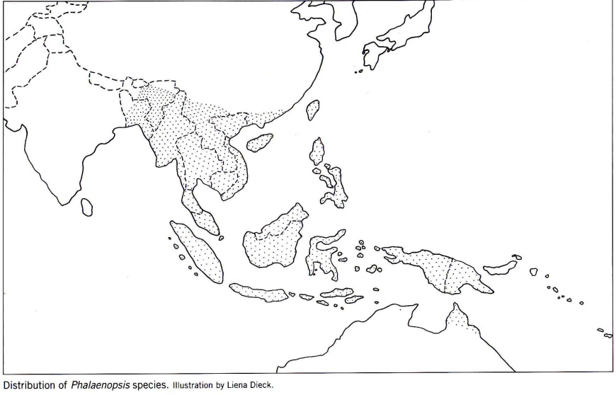₅
References
¹ Jay Pfahl's IOSPE at www.orchidspecies.com
²Christenson, Eric A. 2001. Phalaenopsis- A Monograph. Timber Press.

³Cribb, CJ. 2014. Epidendroidae. In: Pridgeon AM, Cribb PJ, Chase MW, Rasmussen F, eds. Genera Orchidacearum, Vol. 6. Oxford: Oxford University Press, 344-349.

⁴ la Croix, Isobyl. 2008. The New Encyclopedia of Orchids. Timber Press
⁵Frowine, Steven. 2008. Moth Orchids, The Complete Guide to Phalaenopsis. Timber Press

