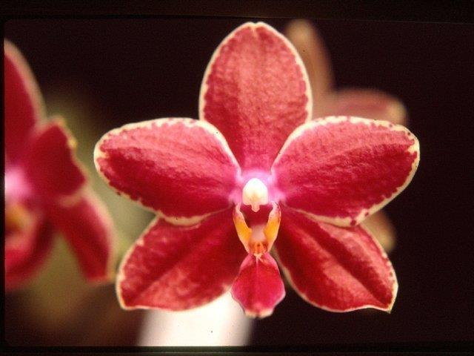
Phalaenopsis Royal Amboin AM/AOS 86 Points
Twenty-three very flat flowers and three buds on one arching inflorescence; sepals and petals cream, heavily overlaid red, with narrow irregular cream picotee; lip mid-lobe orange-red, side-lobes yellow-orange; column white; substance firm; texture waxy.

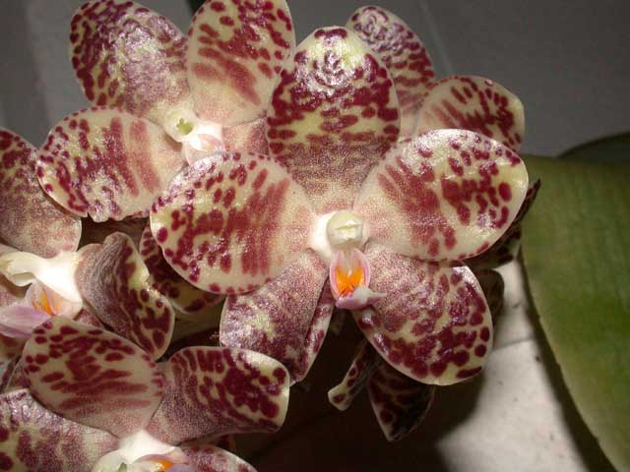
Phalaenopsis gigantea CCM/AOS 87 Points
One hundred twenty-seven flowers and sixteen buds on five 70 cm average pendant inflorescences; plant robust, six 20 cm by 60 cm leaves grown in a 30 cm plastic pot; sepals and petals cream, densely spotted and barred red-brown; lip cream, mid-lobe overlaid lavender, side-lobes orange; column white; substance heavy; texture waxy.

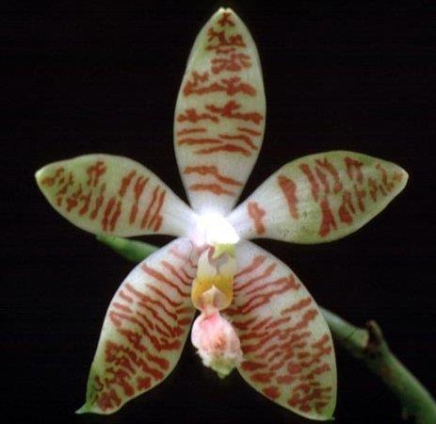
Phalaenopsis Macassar HCC/AOS 75 Points
Ten stellate flowers and three buds on two arching inflorescences; sepals and petals chartreuse, white centrally, narrowly barred mahogany; lip mid-love light lavender, apex chartreuse, side-lobes golden; substance firm; texture waxy.

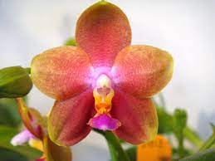
Phalaenopsis Zuma Aussie Delight AM/AOS 81 Points
Nine full, flat flowers on two inflorescences; sepals and petals chartreuse, overlaid and concentrically spotting red-orange, fuchsia centrally; lip orange-yellow, mid-lobe overlaid magenta; substance firm; texture matte.

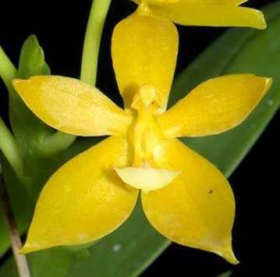
Phalaenopsis Cesario Gene Tobia HCC/AOS 76 Points
Six stellate flowers and four buds on five inflorescences; sepals and petals slightly cupped, lemon yellow; lip lemon yellow, mid-lobe white distally; substance firm, texture waxy.

