Award of Quality (AQ)

American Orchid Definition:
Awarded once to a strain (the result of a mating of specific cultivars), exhibited by a single individual as a group of not less than l2 different clones or the inflorescences thereof, of a raised species or hybrid, which may or may not have been made before, when the result is of sufficient improvement over the former type. The parental cultivar epithets and the hybridizer of this strain, (not necessarily he registrant of the hybrid), must be provided by the exhibitor upon entry. At least one cultivar of the exhibited strain must receive, or have received, a flower quality award. It is granted unanimously without scoring by the judging team assigned. The specific values for which this award is granted must be recorded by the judging team. If the hybridizer and exhibitor are different, each shall receive a certificate. The Award of Quality is not given a cultivar name.
AQ awards are quite often given to Phalaenopsis hybrids and species for a number of reasons. Many phalaenopsis hybrids are marketed to orchid hobbyist as opposed to the mass market. Hobbyists are able to affordably purchase flasks of seedlings and it is not overly difficult to raise successfully a population of an F1 generation in a relatively short period of time. Hobbyists can alternatively purchase groups of seedlings of a new strain relatively inexpensively. Purchasing flasks or groups of seedlings is a particularly common occurrence with the group of phalaenopsis called novelties.
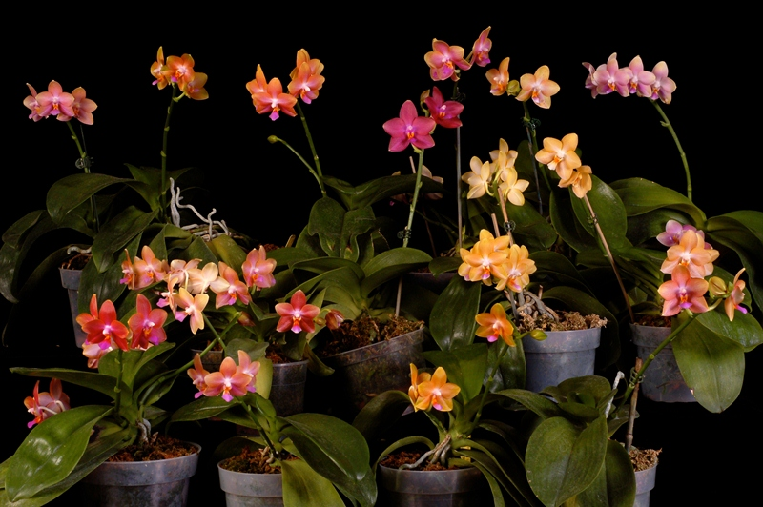
Phalaenopsis Pylo’s Sweet Orange AQ/AOS
Award Description S
Fourteen cultivars of superior quality in the bronze art-shade novelty breeding line; flowers consistently full and flat, ranging in color from light golden brown through bronze to magenta; three AM's and six HCC's exemplified the high standards present when granting this award; hybridizer Peter Lin.
Awarded to: Ronnie and Jerry Brandenburg at the Dallas Center Monthly Judging on 13 April 2013.
This is a significant AQ award not only because it was awarded in our Judging Center to our friends but the group of awarded plants displays very high quality in color, form and orchid culture. Plants in this group far exceeded the AOS requirement that at least one of the plants be awarded a flower quality award. Plants in this group received 3 AM and 6 HCC's attesting to their overall high quality.

