Species Report

Phalaenopsis fimbriata J.J. Small 1921
SUBGENUS Phalaenopsis SECTION Polychilos (Breda)Rchb.f

Description:
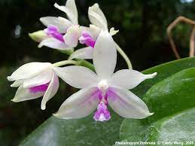
A medium sized, warm to cool growing epiphyte with a short stem enveloped by persistent, imbricating leaf sheaths carrying suberect, oblong-elliptic to elliptic obovate, acute or obtuse leaves that blooms in the spring on a recurved, 11" [27 cm] long, racemose or paniculate, laxly many flowered inflorescence with small ovate-triangular bracts and has simultaneous opening, fleshy flowers. ³
Epiphytes. Leaves oblong-elliptic to elliptic-obovate, acute, tapered to the base, channeled above, to 23 x 7 cm. Inflorescences racemes or panicles to 27 cm long, simultaneously many-flowered, the rachis obtusely four-angled, the floral bracts ovate, acute, to 4 mm long. Flowers with variously twisted segments, the sepals often undulate and/or with recurved apices, the sepals and petals white to pale green, the sepals with purple barring at the base, the lip purple with a white apex. Dorsal sepal oblong-elliptic, obtuse to subacute, to 20 x 9 mm, the lateral sepals obliquely ovate-elliptic, acute, channeled toward the apex, to 20 x 12 mm. Petals oblong-elliptic, cuneate, subacute, often "bowed" (convex and incurved along the midvein with subrevolute margins), to 18 x 6 mm. Lip three-lobed, to 16 mm long, to 14 mm wide across the expanded lateral lobes, the lateral lobes erect, basally triangular, apically obtriangulate, truncate with an undulate margin, the midlobe obovate and trilobulate when flattened, obtuse, with a central keel, the subapical margins fimbriate, involute (upturned), with a subapical raised knob densely covered with long trichomes, the callus triseriate, all calli bifid, the anterior callus with narrower divisions. Column straight, to 8 mm long. Pedicel and ovary to 3 cm long. Phalaenopsis fimbriata has been confused in the past with P tetraspis but is immediately distinguished by having no hood over the anther bed. It is similar both vegetatively and in the flower colors to P modesta but differs by having a subapical pad of soft, downy trichomes unlike the essentially glabrous lip of P. modesta. ¹
Synonyms:

Phalaenopsis fimbriata f. alba O.Gruss & Roellke ex Christenson 2001; Phalaenopsis fimbriata subsp. sumatrana (J.J.Sm.) Christenson 2001; Phalaenopsis fimbriata var. sumatrana J.J.Sm. 1932; Phalaenopsis fimbriata var. tortilis O.Gruss & Roellke 1992; Polychilos fimbriata (J.J. Sm.) Shim 1982. ³
Distribution/Habitat:

Found on the Islands of Java, Sumatra and Sarawak in hill forests on limestone cliffs in moss and on trees in dappled sun at elevations of 790 to 1300 meters.¹
Java and Sumatra. In Java, this now rare orchid is confined to only a few locations in East and West Java. In East Java, plants are found not far from the East Java/Central Java border where they grow in rather dark situations in damp, primary forest at about 1300 ft. (400 m). Plants usually grow epiphytically on tree trunks, mostly not far above the ground. Although Phalaenopsis fimbriata is sometimes found growing with Phalaenopsis viridis, it dies quickly when moved to warmer, lower elevations. Reported as occurring in Borneo by some writers, recent works on the orchids of Borneo by Beaman, Wood, Beaman & Beaman (2001), Wood & Cribb (1994), and Wood, Beaman, & Beaman (1993) do not reflect its occurrence there. -- Source: Charles Baker.⁴

Awards:

Origin | HCC | AM | FCC | CBM | CCE | CCM | Total
 | 1 | 1 | 0 | 1 | 0 | 2 | 5
Years | 2002 | 1983 |  | 1963 |  | 2008, 1979

Hybrids: F-1

1950-1959 | 1960-1969 | 1970-1979 | 1980-1989 | 1990-1999 | 2000-2009 | 2010-2019 | Total
 | 11 | 15 | 20 | 3 | 1 | 8 | 58

Hybrids: Total Progeny

1959-1959 | 1960-1969 | 1970-1979 | 1980-1989 | 1990-1999 | 2000-2009 | 2010-2019 | Total
 | 11 | 25 | 49 | 49 | 18 | 24 | 176

Being only recently described, Phalaenopsis chibae is behind the other Section Deliciosae species in regard to hybrids, It most likely catch up because it is a desirably plant for hybridization. The first hybrids were not registered until 2003.

Significant Progeny

Phalaenopsis Green Delight ‘Ponkan’ HCC/AOS

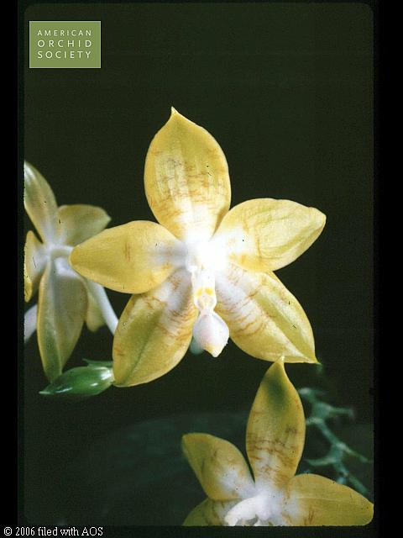
This is a second generation cross by way of P. Sulawesi crossed with P. amboinensis. Green Delight has 18 F-1’s and 43 progeny. It received 1 HCC. It is the most prolific breeder of any P. fimbriata hybrid.

References:

Aldridge, Peggy. 2008. An Illustrated Dictionary of Orchid Genera. Selby Botanical Garden Press.
¹Christenson, Eric A. 2001. Phalaenopsis- A Monograph.Timber Press.
² Cribb, CJ. 2014. Epidendroidae. In: Pridgeon AM, Cribb PJ, Chase MW, Rasmussen F, eds. Genera Orchidacearum, Vol. 6. Oxford: Oxford University Press, 344-349.

³Jay Pfahl's IOSPE at www.orchidspecies.com
⁴OrchidWiz.Database X7.1
http://apps.kew.org/wcsp/qsearch.do

https://secure.aos.org/aqplus/SearchAwards.aspx

