Species Report
Phalaenopsis floresensis Fowlie 1993
SUBGENUS Phalaenopsis SECTION Polychilos (Breda)Rchb.f ³

Description:
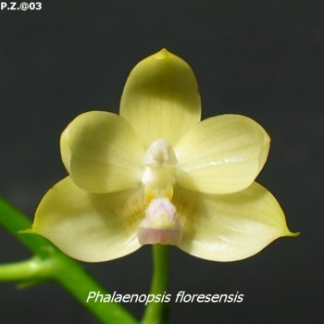
A medium sized, hot growing epiphyte with 5 to 7, narrowly ovate to elliptic, obtuse leaves and blooms in the spring on 4 to 8" [10 to 20 cm] long, shorter than the leaf, few [2 to 3] flowered inflorescence carrying strongly fragrant flowers. ³
Leaves five to seven, narrowly ovate to elliptic, obtuse, to 25 x 9 cm. Inflorescences shorter than the leaves, 10-20 cm long, two-or three-flowered, the floral bracts 4 mm long. Flowers creamy white, to 4 cm wide, variable suffused with yellowish green suffusion especially toward the apices of the sepals, the bases of the lateral sepals with fine, limited, pale brown transverse markings, the midlobe of the lip with a dull rose keel, laterally with one or more pale rose longitudinal stripes. Dorsal sepal elliptic, acuminate-carinate, shallowly concave, 2 x 0.8 cm, the lateral sepals broadly elliptic-ovate, acuminate-carinate, 2 x 1.2 cm. Petals ovate, acuminate, to 1.8 x(1.2 cm. Lip three-lobed, 1.5 cm long, the lateral lobes erect, parallel, narrowly ovate, truncate, the apices minutely crenulate-denticulate, 1.2 cm across when expanded, the midlobe oblong-elliptic, obtuse, with a raised central keel running the length of the midlobe, the apical half covered with a dense mat of fleshy trichomes to 1 mm tall, the callus biseriate, the posterior callus sulcate, bluntly bilobed, the anterior callus deeply bifid, the divisions linear-acute. Column lightly arching, 6-8 mm long. Distribution: Endemic to the island of Flores. Fowlie reported this species at 500-1000 ft. (150-300 m) in elevation in the type description but at 1000-1660 ft. (300-500 m) with the type specimen data. Etymology: With the Latin suffix -ensis, indicating its place of origin on the is-land of Flores. Illustrations: Fessell and Liickel 1994:101, 102; Fowlie 1993:35; Gruss and Wolff 1995:96. This recently described species caused minor confusion when first published. First, the gestalt of the type photograph suggested a close affinity with P javanica, although Fowlie compared his new species with P amboinensis and, to a lesser extent, with P javanica. Second, the type flower was still expanding when photographed and thus the flower was lightly cupped, again similar to P javanica. Without any published analytical drawings, it appeared at first that P floresensis was merely a pal-lid form of P javanica. The second appearance of this species in print (Fessel and Liickel 1994) clarified the characters that separate P floresensis from P javanica, but again the authors used a photograph of a barely open, even more strongly cupped flower similar to P javanica. That their specimen was still maturing its flower is shown by the small floral measurements (they recorded a dorsal sepal 13 mm long compared with the type specimen and subsequent material, which have dorsal sepals +I-20 mm long). Now that additional plants have flowered in cultivation, it is clear that the flowers of P. floresensis expand to a very flat flower similar to better clones of P. amboinensis or P bellina. In P floresensis the flowers are creamy white without any markings on the petals (with only faint pale brown markings toward the base of the lateral sepals), the lateral lobes of the lip are irregularly truncate like the end of a milled board) and the midlobe it with fleshy trichomes for its apical half. In contrast, the flowers of P javanica are marked with longitudinal stripes composed of squarish transverse bars, the lateral lobes of the lip end in two teeth with the posterior pair of teeth long-acuminate, and the midlobe of trichomes restricted to beneath the apex. Phalaenopsis floresensis is readily separated from P ambionensis by its different flower color, the lack of an erect tooth at the apex of the mid-lobe of the lip, and the differently shaped lateral lobes of the lip.¹
Distribution/Habitat:

Found on the island of Flores in Indonesia in forests often near waterfalls at elevations of 100 to 500 meters.¹
Indonesia. This orchid was collected on Flores Island near Wolowaru, which is located in the middle of the island northeast of Ende (Endeh). Plants grow on trees in the deep shade of streamside forests, especially near waterfalls, at 1000-1650 ft. (300-500 m). -- Source: Charles Baker⁴
Awards:

Origin | HCC | AM | FCC | CBR | CCE | CHM | Total
 | 0 | 2 | 0 | 0 | 0 | 2 | 4
Years |  | 1999-2001 |  |  |  | 1996

Hybrids: F-1

1990-1999 | 2000-2009 | 2010-2919 | After 2020 |  |  |  | Total
4 | 23 | 15 |  |  |  |  | 42

Hybrids: Total Progeny

1990-1999 | 2000-2009 | 2010-2019 | After 2020 |  |  |  | Total
4 | 43 | 52 | 2 |  |  |  | 100

Being only recently described(1993), Phalaenopsis floresensis is behind the other Section Ploychilos species in regard to hybrids, It most likely catch up because it is a desirably plant for hybridization. The first hybrids were not registered until 1997.
Significant Progeny

Phalaenopsis Flores Moon HCC/AOS

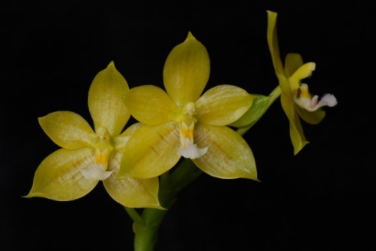
To date, Flores Moon is the only significant hybrid of Phalaenopsis floresensus. It is a primary cross with Phalaenopsis cornu-ervi. The grex has two HCC awards from the AOS. The only apparent contribution from P. cornu-cervi is the lip color and some faint markings on the sepals and petals.

References:

Aldridge, Peggy. 2008. An Illustrated Dictionary of Orchid Genera. Selby Botanical Garden Press.
¹Christenson, Eric A. 2001. Phalaenopsis- A Monograph.Timber Press.
² Cribb, CJ. 2014. Epidendroidae. In: Pridgeon AM, Cribb PJ, Chase MW, Rasmussen F, eds. Genera Orchidacearum, Vol. 6. Oxford: Oxford University Press, 344-349.

³Jay Pfahl's IOSPE at www.orchidspecies.com
⁴OrchidWiz.Database X7.1
http://apps.kew.org/wcsp/qsearch.do

https://secure.aos.org/aqplus/SearchAwards.aspx

