Species Report

Phalaenopsis modesta J.J. Small 1906
SUBGENUS Phalaenopsis SECTION Polychilos (Breda) Rchb.f

Description:
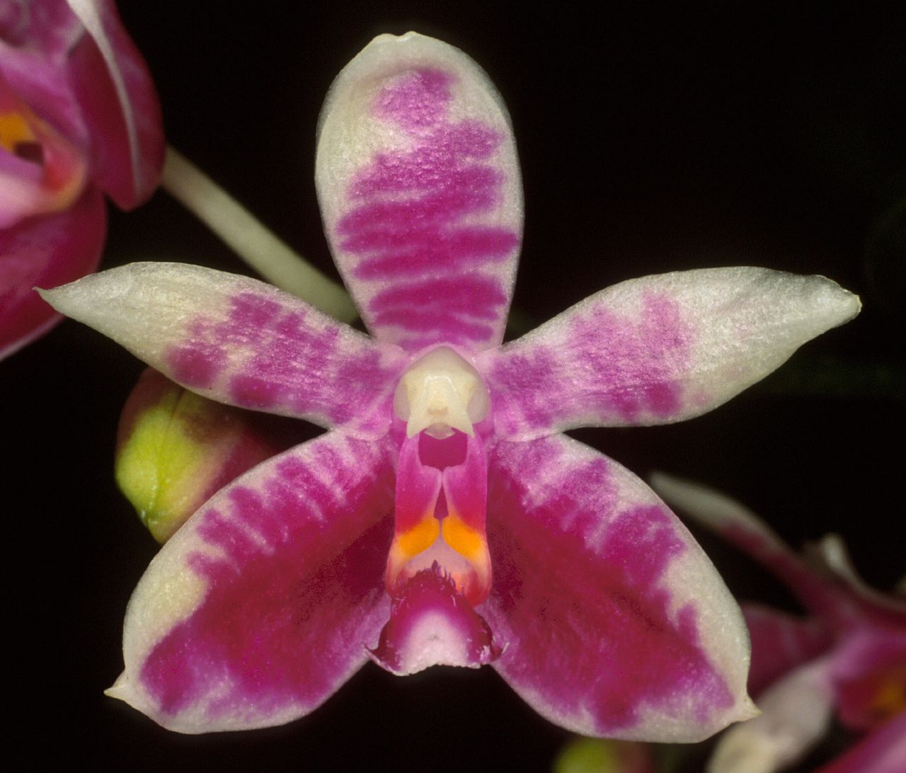
A small sized, hot to warm growing epiphyte with a short stem enveloped completely by several leaf-bearing sheaths and carrying a few, distichous, fleshy, obovate to obovate-lanceolate, acute, gradually narrowing below into the subpetiolate base leaves that blooms in the spring and in the fall on a slender, arching to pendant, 5 to 6" [12.5 to 15 cm] long, racemose or occasionally sparsly branched, few to many flowered inflorescence that is shorter than the leaf with distichous, ovate-lanceolate, cucullate floral bracts and carry somewhat delicate, strongly fragrant honeysuckle, grape, lilac and candy scented flowers. ³
Epiphytes usually found toward the base of host trees. Leaves one to four per stem, elliptic-obovate, tapering to a subpetiolate base, rounded, acute, glossy, to 23 x 6 cm. Inflorescences pendent, usually racemes but sometimes with sparse branches, arching, usually shorter than the leaves, usually few-flowered, the rachis fractiflex, the floral bracts two-ranked, ovate-lanceolate, concave, to 3 mm long. Flowers fragrant in the early morning, the sepals and petals white with variable purple transverse barring, the sepals greenish toward their apices, the lip purple, matching the sepal and petal colors in intensity, the teeth on the lateral lobes of the lip yellowish orange, the column white. Dorsal sepal oblong-elliptic to obovate, obtuse, convex, to 16 x 7 mm, the lateral sepals obliquely elliptic-ovate, acute, apiculate-carinate, to 16 x 9 mm. Petals obliquely elliptic, acute, usually with strongly revolute margins, to 15 x 5 mm. Lip three-lobed, to 14 mm long, 14 mm wide across the expanded lateral lobes, the lateral lobes erect, oblong, subtruncate, the posterior corner a retrorse, falcate hook, the midlobe oblong-elliptic, rounded, a central longitudinal keel ending in a subapical raised cushion. Callus biseriate, the posterior callus sulcate, bifid, the anterior callus nar-rower, bifid. Column nearly straight, to 9 mm long. Pedicel and ovary to 2 cm long. Distribution: Endemic to the island of Borneo in East Malaysia (Sabah) and Indonesia (Kalimantan). Chan et al. (1994) report P. modesta at 50-900 m in elevation, where it has two flowering peaks, from May to June and again from September to November. Phalaenopsis modesta was placed by Sweet in his subsection Glabrae, a subsection that I do not recognize here. Chan et al. (1994) confirm Sweet's observations that the midlobe of the lip in P. modesta sometimes bears trichomes, an observation that further weakens the case for sub-section Glabrae. No specimens have been found matching Smith's apparently spurious description, that the midlobe of the lip is velvety hirsute, a characteristic at odds with the available type material. Phalaenopsis modesta is variable in color, ranging from quite darkly purple-barred clones to pastel lavender-barred clones, to nearly alba clones (a true alba clone will no doubt be found someday). The sepals and especially the lateral sepals may be infused with green in a manner similar to P. fimbriata. This species, with its paucity of small, rather insignificant flowers relative to the plant size, appears to have little to offer growers. While the marking patterns found in the darker clones might prove desir-able in breeding, the narrow petals with typically revolute margins will require judicious use by breeders. Most plants of this species have truly modest inflorescences that are more or less hidden by the leaves. A few plants in cultivation exhibit inflorescences almost four times the length of the leaves. Whether these individuals represent a distinct genetic population or are just responding to being fully mature in cultivation is not known. One problematic variant has been described.¹

Synonyms:

Phalaenopsis modesta f. alba O.Gruss & Roeth 2009; Polychilos modesta (J.J. Sm.) Shim 1982 .³
Distribution/Habitat:

Found in Borneo in lower stature hill and lower montane forests low down or on the base and roots of trees near streams at elevations around 50 to 900 meters. ¹
Borneo, including Sabah, West Kotah, Mt. Kinabalu, and Tawau in the Province of Elphiastone. It also grows in the Crocker Mountain range on trees near streams at 1200 ft. (366 m). -- Source: Charles Baker. ⁴

Awards:

Origin | HCC | AM | FCC | CBR | CCM | CHM | Total
 | 2 | 0 | 0 |  | 1 | 1 | 4
Years | 1992,  2014 |  |  |  | 2001 | 1990

Hybrids: F-1

 | 1960-1969 | 1970-1979 | 1980-1989 | 1990-1999 | 2000-2009 | 2010-2019 | Total
 |  |  | 10 | 7 | 5 | 22 | 44

Hybrids: Total Progeny

 | 1960-1969 | 1970-1979 | 1980-1989 | 1990-1999 | 2000-2009 | 2010-2019 | Total
 |  |  | 10 | 7 | 5 | 30 | 52

Significant Progeny

There don’t appear to be any significant progeny either in terms of awards ot offspring.

References:

Aldridge, Peggy. 2008. An Illustrated Dictionary of Orchid Genera. Selby Botanical Garden Press.
¹Christenson, Eric A. 2001. Phalaenopsis- A Monograph.Timber Press.
² Cribb, CJ. 2014. Epidendroidae. In: Pridgeon AM, Cribb PJ, Chase MW, Rasmussen F, eds. Genera Orchidacearum, Vol. 6. Oxford: Oxford University Press, 344-349.

³Jay Pfahl's IOSPE at www.orchidspecies.com
⁴OrchidWiz.Database X7.1
http://apps.kew.org/wcsp/qsearch.do

https://secure.aos.org/aqplus/SearchAwards.aspx

