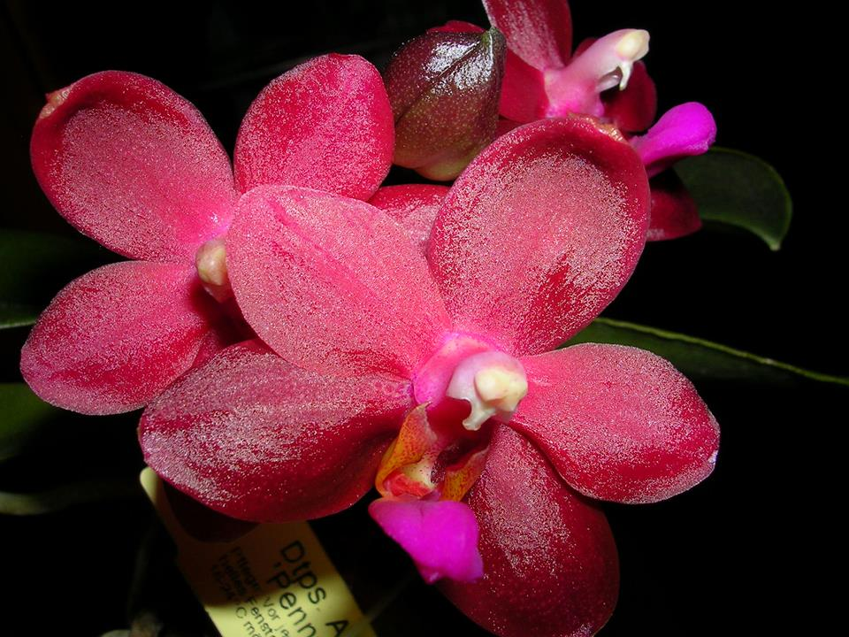
Phalaenopsis Abed-nego AM/AOS 83 Points
Seven round, flat flowers and five buds on two inflorescences; sepals and petals garnet red, apex white; lip mid lobe fuchsia, side lobes red; column rose, anther cap cream; substance heavy; texture waxy.

Phalaenopsis Glenmore HCC/AOS 77 Points
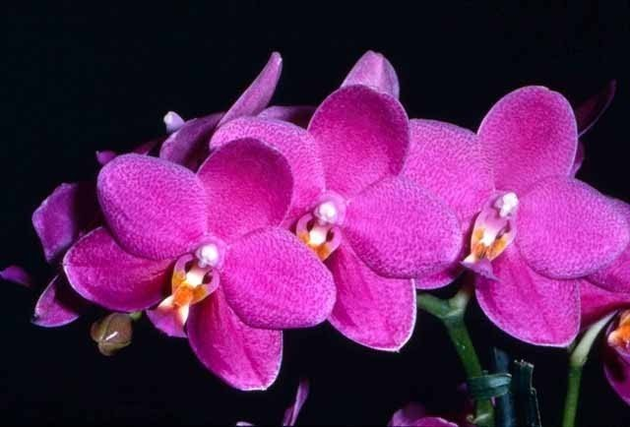
Six flowers and one bud on one 25 cm branched inflorescence; sepals and petals white, overlaid magenta, lateral sepals with narrow white margin apically; lip white, midlobe distal half magenta, side lobes orange; column magenta, anther cap white; substance heavy; texture diamonf dust.

Phalaenopsis Mahalo CCM/AOS 86 Points
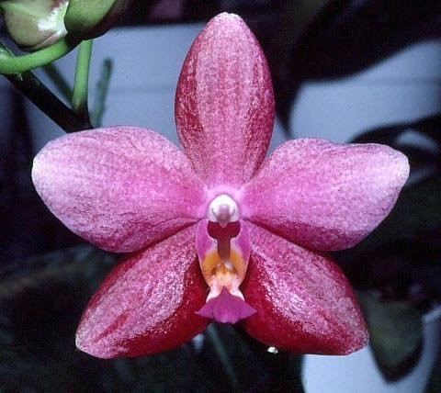
Seventy-five flowers and twenty buds on seven 36 cm average branched inflorescences on a 9 leaf pair plant grown 25 cm plastic pot; sepals dark plum; petals suffused plum, lighter distally; lip white, midlobe purple distal two thirds, sidelobes peach, distal half fuchia; column purple, anther cap white; substance firm; texture glossy.

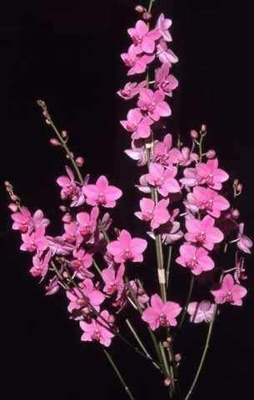
Phalaenopsis Red Coral AM/AOS 81 Points
Thirty-six flowers and seventeen buds on three, 32 cm branched inflorescences; sepals and petals rose pink; lip dark rose; column and anther car white; substance firm; texture matte.

Phalaenopsis Kathleen Ai HCC/AOS 76 Points
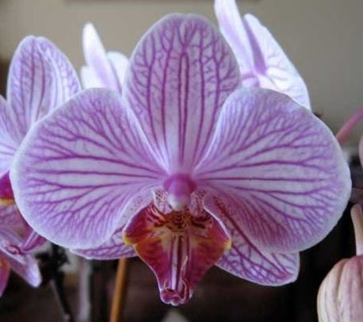
Twenty six flowers and six buds on two, 22 cm inflorescences; sepals and petals white, veined magenta; lip white, veined magenta and overlaid red-purple; column white, anther cap pink; substance firm; texture matte.

