Phalaenopsis Little One AM/AOS 86 Points
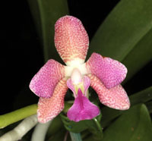
Seven flowers and five buds on one arched inflorescence; sepals chartreuse, overlaid orange pink, densely speckled maroon; petals overlaid rose pink, speckled maroon; lip chartreuse, mid lobe heavily overlaid amethyst, sidelobes overlaid pink; column and anther cap white; substance firm; texture matte.

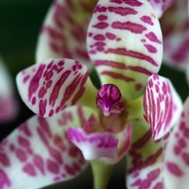
Rhynchonopsis Dragon Charmy AM/AOS 87 Points
Ten flowers and thirteen buds on one arching inflorescence; sepals and petals cupped, cream, barred and spotted magenta; lip cream, spotted light magenta; mentum olive green; column and anther cap dark magenta; substance firm; texture matte; fragrant.

Phalaenopsis Amblearis HCC/AOS 75 Points
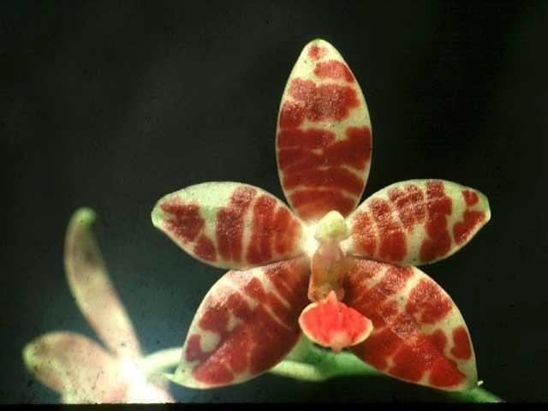
Six flat, stellate flowers and two buds on two arched inflorescences; sepals and petals yellow-chartreuse, broadly barred mahogany; lip chartreuse, midlobe overlaid orange-red, sidelobes spotted mahogany; column light mahogany, anther cap chartreuse; substance heavy; texture waxy.

Phalaenopsis cochlearis CCM/AOS 81 Points
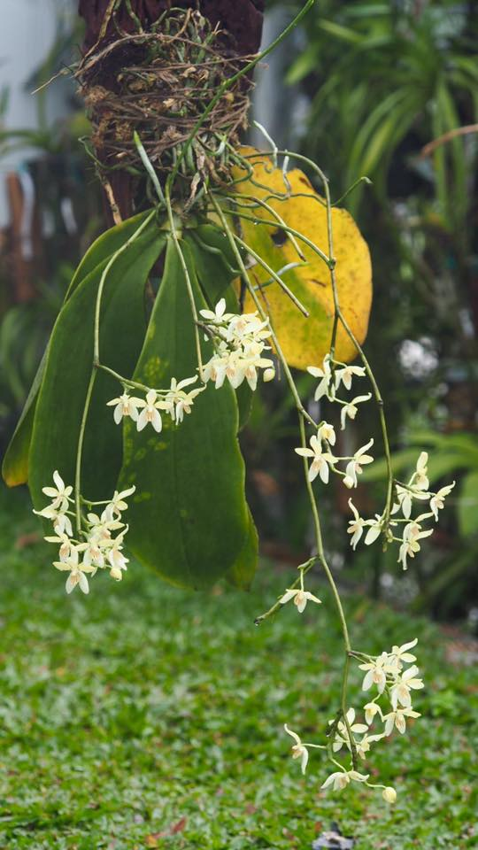
Forty-six flowers on three pendent, 24 cm average inflorescences on a four, 18 cm leaf plant grown on a treefern plaque; sepals and petals yellow, blotched light brown basally; lip golden yellow, longitudinally striped red-orange; substance firm; texture matte.

Phalaenopsis kunstleri HCC/AOS 76 Points
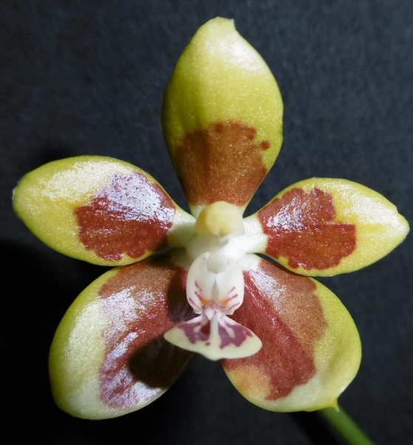
Eight flowers and four buds on two arching inflorescences; sepals and petals chartreuse, basal half to two-thirds medium brown; lip chartreuse, mid-lobe splotched maroon, side lobes striped light mahogany; column cream, anther cap chartreuse; substance firm; texture glossy.

