Phalaenopsis- Section Fuscatae Species

SPECIES PROGENY AWARDS AWARD TYPE RANGE TEMP/LHT BLOOM TIME
F-1/Total AOS Peak
cochlearis | 32/83 | 3 | 1 AM, 1CBM, 1CCM | Borneo | Hot/Lo | May
fuscata | 106/292 | 4 | 2 AM, 1HCC, 1CBM | Malaya, Borneo, Vietnam, Philippines | Warm/Lo | Jun
kunstleri | 14/16 | 2 | 2 HCC | Malaya, Burma | Hot/Lo | Jul
Viridis | 16/18 | 2 | 1 CBR, 1 CCM | Sumatra | Hot/Lo | Apr
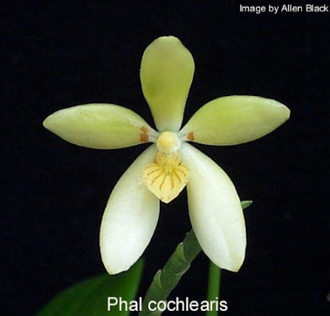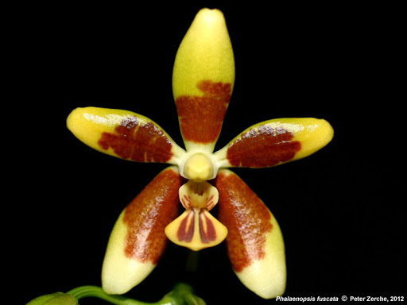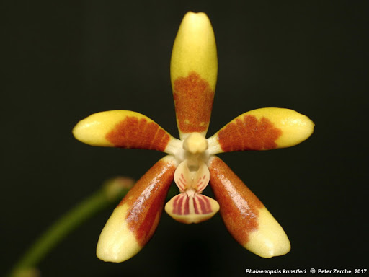

Phal cochlearis Phal fuscata Phal kunstleri

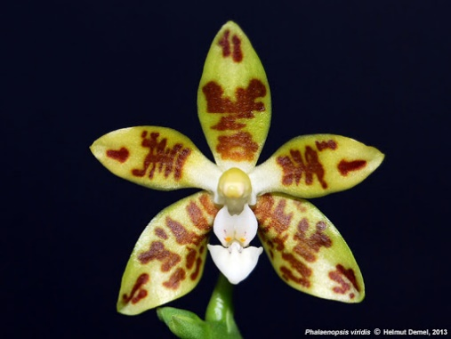

Phal viridis

